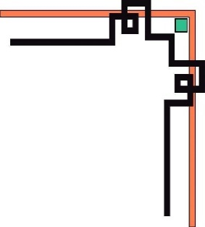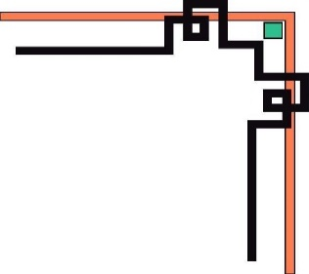

TRƯỜNG ĐẠI HỌC NHA TRANG

KHOA CÔNG NGHỆ THÔNG TIN

**Lập Trình Thiết Bị Nhúng**

**Báo Cáo Môn Học**

Giảng viên hướng dẫn:



* Người thực hiện :

Cao Thái Toàn Phong

# Bài 1: Blinking LED

## Mô tả

* Bài này thực hiện việc lập trình điều khiển 1 đèn LED

bật/tắt trong khoảng thời gian 0,2 giây, đèn LED được kết nối vào chân số 13 của board mạch.

## Sơ đồ mạch

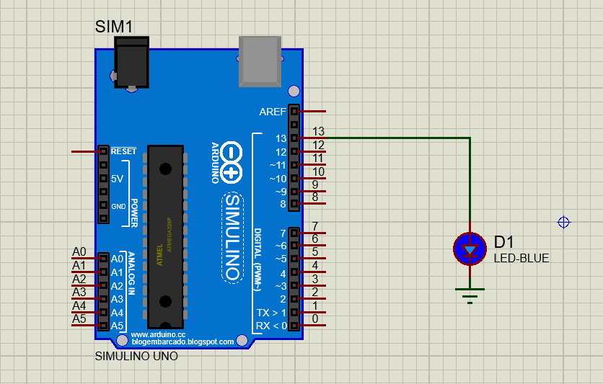

Sơ đồ kết nối của hệ thống

## Linh kiện

#### 1 mạch Arduino Uno

#### 1 đèn LED-BLUE

## Code chương trình

|  |
| --- |
| int pin=13;  void setup() {  // put your setup code here, to run once:  pinMode(pin,OUTPUT);  }  void loop() {  // main code  digitalWrite(pin,HIGH);  delay(200); // 0,2s  digitalWrite(pin,LOW);  delay(200);  } |

## Kết quả chạy chương trình

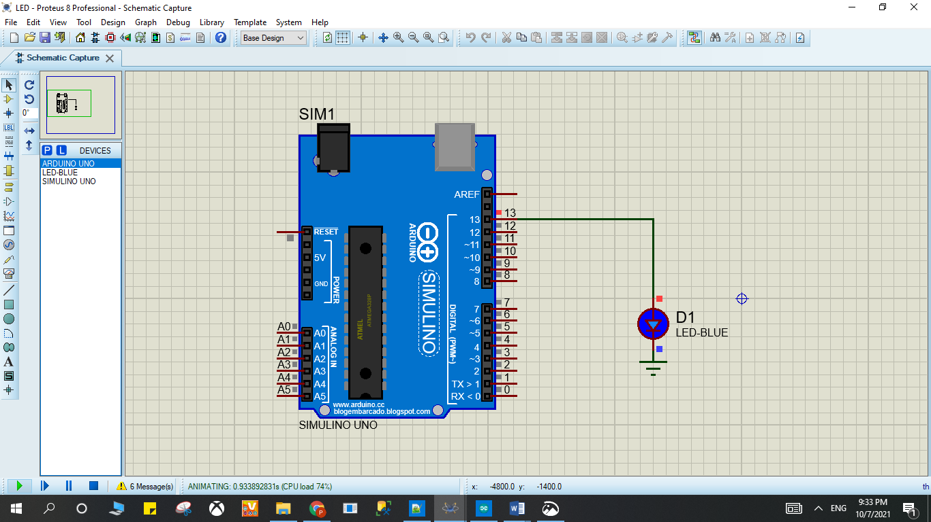

Sơ đồ kết nối của hệ thống

# Bài 2: Turn on LED with button

## Mô tả

* Bài này thực hiện việc bật/tắt 1 đèn LED trong khoảng thời gian 1 giây bằng button, đèn LED được kết nối vào chân số 13 của board mạch, button được kết nối vào chân số 2 của board mạch, đèn sáng khi nút nhấn và ngược lại.

## Sơ đồ mạch

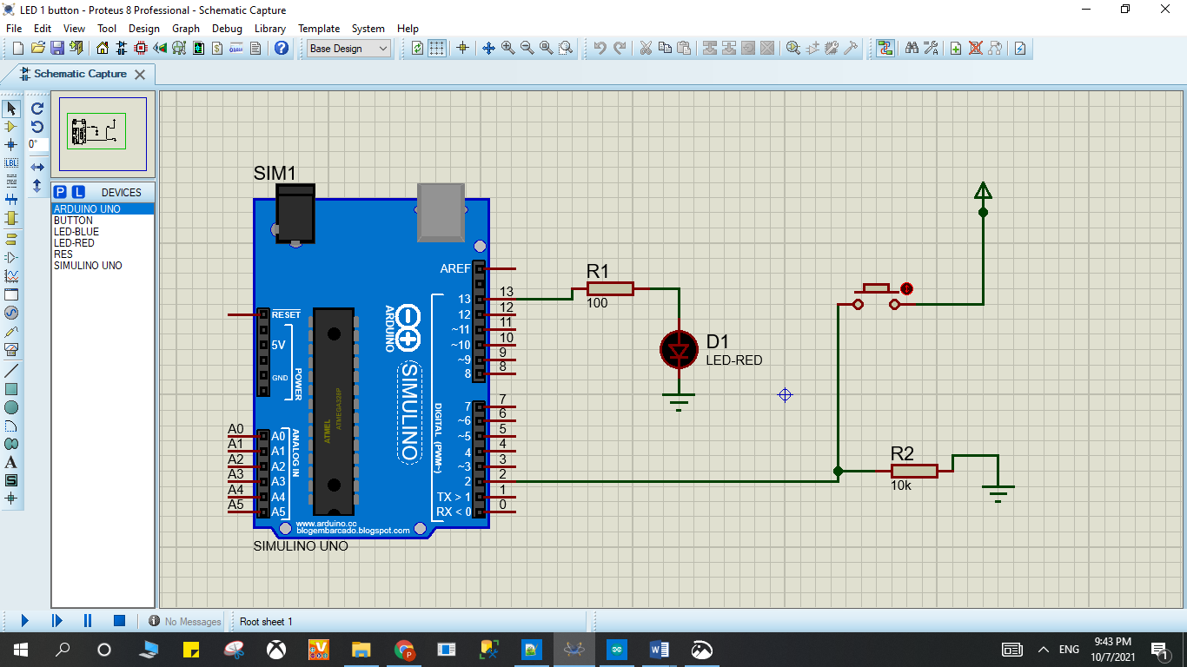

Sơ đồ kết nối của hệ thống

## Linh kiện

#### 1 mạch Arduino Uno

#### 1 đèn LED-RED

#### 1 điện trở 100Ω và 1 điện trở 10k Ω

## Code chương trình

|  |
| --- |
| int x = 0;  void setup() {  pinMode(2, INPUT);  pinMode(13, OUTPUT);  }  void loop()  {  // đọc cổng 2  x = digitalRead(2);  if (x == HIGH) {  digitalWrite(13, HIGH); // LED ON  } else {  digitalWrite(13, LOW); //LED OFF  }  delay(1000); // wait 1s  } |

## Kết quả chạy chương trình

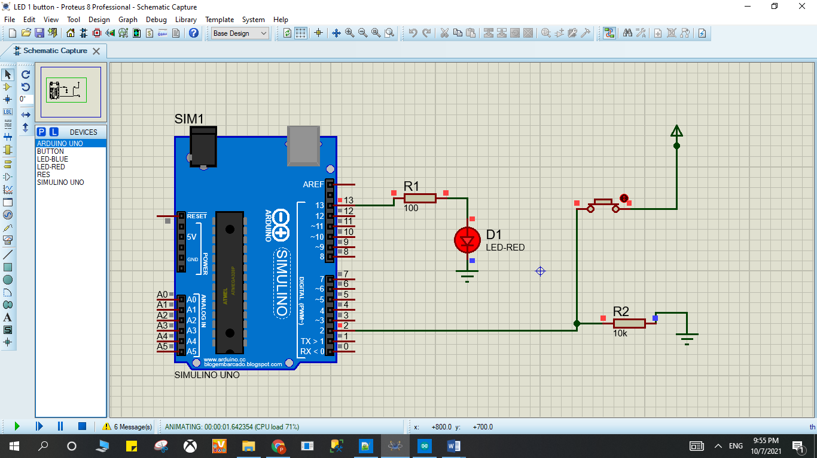

Sơ đồ kết nối của hệ thống

# Bài 3. LED RGB

## Mô tả

* Bài này thực hiện việc lập trình bật 1 đèn LED RGB với 3 điện trở R1, R2 R3, đèn LED được kết nối thông qua điện trở lần lượt vào chân số 9, 10,11 của board mạch.

## Sơ đồ mạch

### 

Sơ đồ kết nối của hệ thống

## Linh kiện

#### 1 mạch Arduino Uno

#### 1 đèn RGBLED-CC

#### 3 điện trở 10k Ω

## Code chương trình

|  |
| --- |
| int counter;  void setup()  {  pinMode(11, OUTPUT);  pinMode(10, OUTPUT);  pinMode(9, OUTPUT);  }  void loop()  {  analogWrite(11, 255);  analogWrite(10, 0);  analogWrite(9, 0);  delay(1000); // Wait for 1000 millisecond(s)  analogWrite(11, 255);  analogWrite(10, 255);  analogWrite(9, 255);  delay(1000); // Wait for 1000 millisecond(s)  for (counter = 0; counter < 10; ++counter) {  analogWrite(11, 255);  analogWrite(10, 255);  analogWrite(9, 0);  delay(1000); // Wait for 1000 millisecond(s)  analogWrite(11, 51);  analogWrite(10, 255);  analogWrite(9, 51);  delay(1000); // Wait for 1000 millisecond(s)  }  } |

## Kết quả chạy chương trình

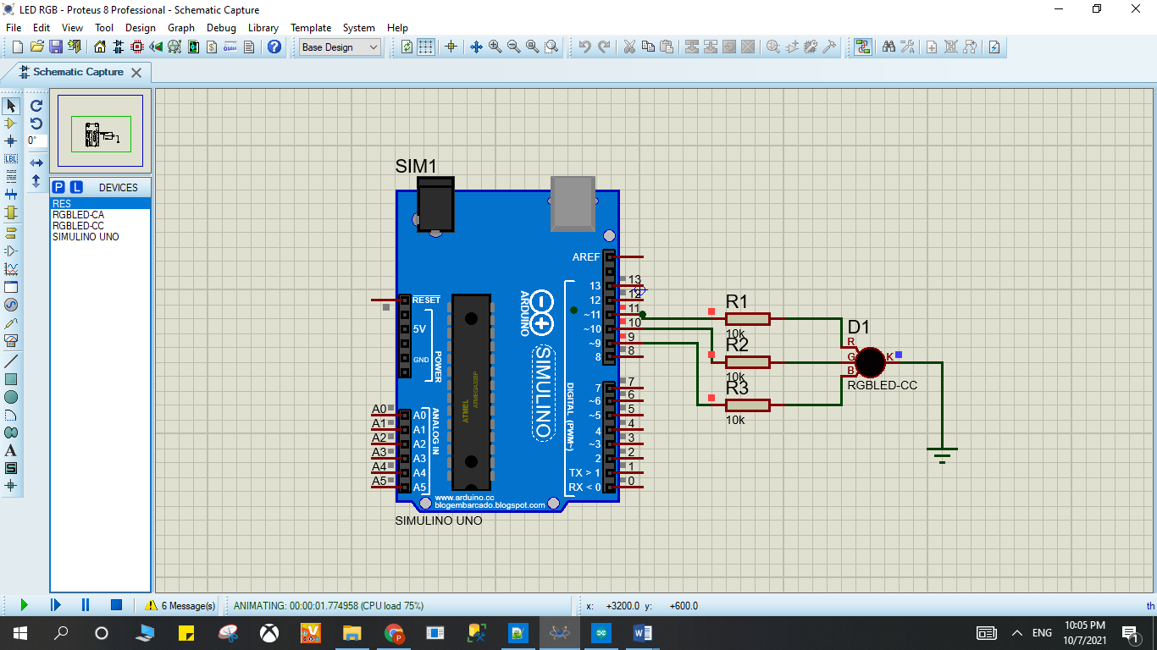

# Bài 4. LED 7-Segment

## Mô tả

* Bài này thực hiện việc lập trình 1 đèn LED 7 đoạn hiển thị các số từ 0 đến 9 trong khoảng thời gian 0,5 giây, đèn LED được kết nối vào các chân số 6, 7, 9, 10, 11,13 của board mạch.

## Sơ đồ mạch và kết quả chạy chương trình

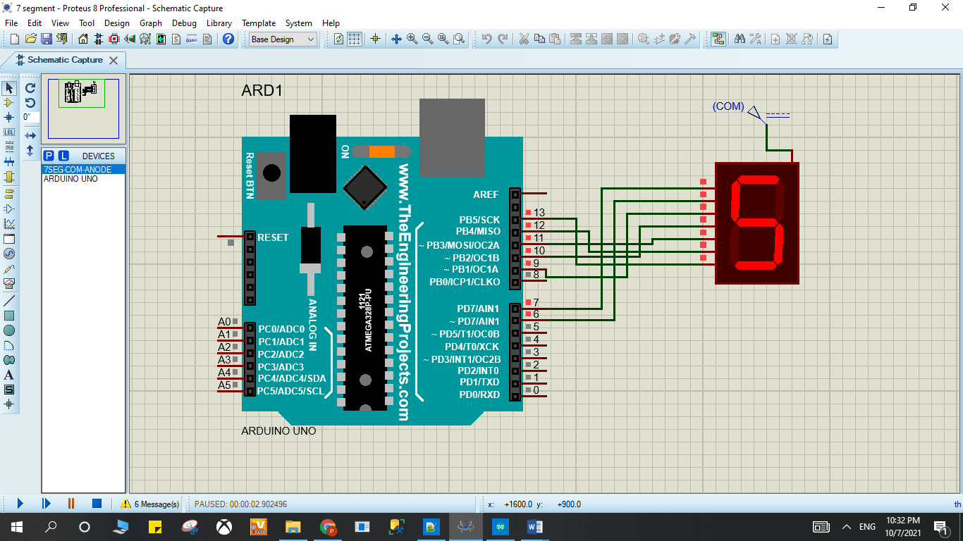

Sơ đồ kết nối của hệ thống

## Linh kiện

#### 1 mạch Arduino Uno

#### 1 đèn 7-SEG-COM-ANODE

## Code chương trình

|  |
| --- |
| int f = 13;  int g = 12;  int e = 11;  int d = 10;  int c = 9;  int b = 6;  int a = 7;  int hoan = 500;  void setup() {  pinMode(f, OUTPUT);  pinMode(g, OUTPUT);  pinMode(e, OUTPUT);  pinMode(d, OUTPUT);  pinMode(c, OUTPUT);  pinMode(b, OUTPUT);  pinMode(a, OUTPUT);  }  void loop()  {  // display from 0 to 9  digitalWrite(a,0);  digitalWrite(b,0);  digitalWrite(c,0);  digitalWrite(d,0);  digitalWrite(e,0);  digitalWrite(f,0);  digitalWrite(g,1);  delay(hoan);    digitalWrite(a,1);  digitalWrite(b,0);  digitalWrite(c,0);  digitalWrite(d,1);  digitalWrite(e,1);  digitalWrite(f,1);  digitalWrite(g,1);  delay(hoan);    digitalWrite(a,0);  digitalWrite(b,0);  digitalWrite(c,1);  digitalWrite(d,0);  digitalWrite(e,0);  digitalWrite(f,1);  digitalWrite(g,0);  delay(hoan);    digitalWrite(a,0);  digitalWrite(b,0);  digitalWrite(c,0);  digitalWrite(d,0);  digitalWrite(e,1);  digitalWrite(f,1);  digitalWrite(g,0);  delay(hoan);    digitalWrite(a,1);  digitalWrite(b,0);  digitalWrite(c,0);  digitalWrite(d,1);  digitalWrite(e,1);  digitalWrite(f,0);  digitalWrite(g,0);  delay(hoan);  digitalWrite(a,0);  digitalWrite(b,1);  digitalWrite(c,0);  digitalWrite(d,0);  digitalWrite(e,1);  digitalWrite(f,0);  digitalWrite(g,0);  delay(hoan);    digitalWrite(a,0);  digitalWrite(b,1);  digitalWrite(c,0);  digitalWrite(d,0);  digitalWrite(e,0);  digitalWrite(f,0);  digitalWrite(g,0);  delay(hoan);    digitalWrite(a,0);  digitalWrite(b,0);  digitalWrite(c,0);  digitalWrite(d,1);  digitalWrite(e,1);  digitalWrite(f,1);  digitalWrite(g,1);  delay(hoan);    digitalWrite(a,0);  digitalWrite(b,0);  digitalWrite(c,0);  digitalWrite(d,0);  digitalWrite(e,0);  digitalWrite(f,0);  digitalWrite(g,0);  delay(hoan);    digitalWrite(a,0);  digitalWrite(b,0);  digitalWrite(c,0);  digitalWrite(d,1);  digitalWrite(e,1);  digitalWrite(f,0);  digitalWrite(g,0);  delay(hoan);  } |

# Bài 8. LED MATRIX 8x8

## Mô tả

Bài này thực hiện việc lập trình 1 dãy đèn LED ma trận 8x8 màu xanh dương kèm 2 IC 78HC595 hiển thị các số và chữ theo lập trình ở các file

file code_test_1 : Tất cả ô đèn trong dãy đèn đều sáng

file code_test_2 : Các đèn trong dãy đèn sẽ sáng từng bit theo hàng dọc từ trái sáng phải

file code_test_3 : sáng từng bit giống câu 2 nhưng chậm hơn để dễ quan sát ( delay sẽ chỉnh từ 100 thành 1000)

file code_test_4 : Hiển thị chữ A trong dãy đèn

file code_test_5 : Chạy tất cả chữ từ a đến z và từ 0 đến 9 trong dãy đèn

file code_test_6 : Hiển thị dòng chữ chứa từ happy new year , dòng chữ chạy từ trái sáng phải

file code_test_7 : Hiển thị dòng chữ chứa tên sinh viên kèm mã số sinh viên, dòng chữ chạy từ trái sáng phải

## Sơ đồ mạch

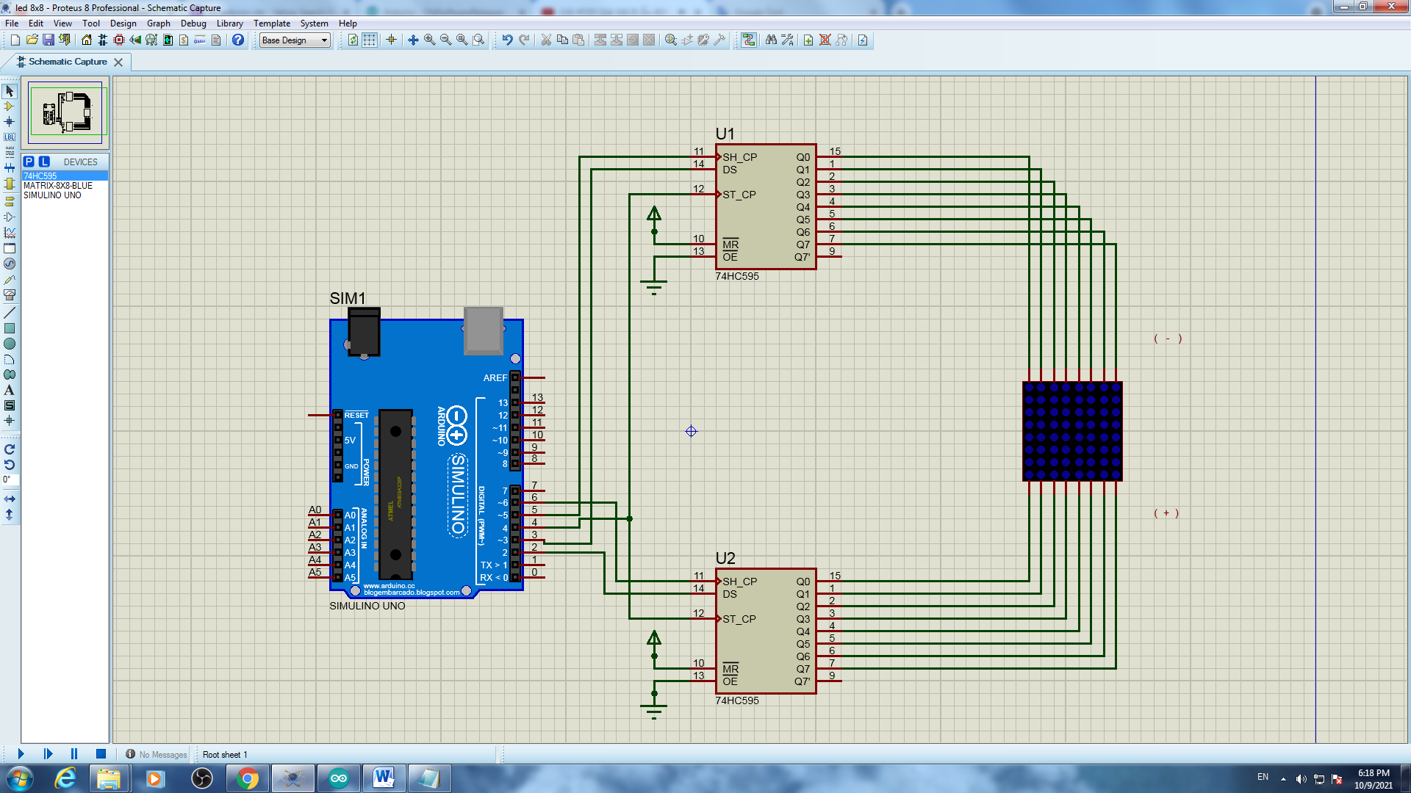

## Linh kiện

* 2 IC 78HC595
* 1 bảng đèn LED ma trận 8x8 màu xanh dương
* Mạch Arduino

## Code chương trình

* Code file code_test_1

|  |
| --- |
| #define DS_cot 2  #define DS_hang 3  #define SH_CP_hang 5  #define SH_CP_cot 6  #define ST_CP 4  byte cot = 0b10000000;  void setup() {  pinMode(ST_CP,OUTPUT);//RCLK    pinMode(DS_hang,OUTPUT);//SER hang  pinMode(SH_CP_hang,OUTPUT);//SRCLK hang  pinMode(SH_CP_cot,OUTPUT);//SRCLK cot  pinMode(DS_cot,OUTPUT);//SER cot  digitalWrite(ST_CP,LOW);  shiftOut(DS_hang,SH_CP_hang,LSBFIRST,0b00000000);// hang 8 - hang 1  digitalWrite(ST_CP,HIGH);  }  void loop() {  for(int i = 0; i < 8;i++){  digitalWrite(ST_CP,LOW);  shiftOut(DS_cot,SH_CP_cot,LSBFIRST,cot >> i); // cot 8 - cot 1  digitalWrite(ST_CP,HIGH);  delay(1);  }  } |

* Code file code_test_2

|  |
| --- |
| #define DS_cot 2  #define DS_hang 3  #define SH_CP_hang 5  #define SH_CP_cot 6  #define ST_CP 4  byte cot = 0b10000000;  void setup() {  pinMode(ST_CP,OUTPUT);//RCLK    pinMode(DS_hang,OUTPUT);//SER hang  pinMode(SH_CP_hang,OUTPUT);//SRCLK hang  pinMode(SH_CP_cot,OUTPUT);//SRCLK cot  pinMode(DS_cot,OUTPUT);//SER cot  digitalWrite(ST_CP,LOW);  shiftOut(DS_hang,SH_CP_hang,LSBFIRST,0b00000000);// hang 8 - hang 1  digitalWrite(ST_CP,HIGH);  }  void loop() {  for(int i = 0; i < 8;i++){  digitalWrite(ST_CP,LOW);  shiftOut(DS_cot,SH_CP_cot,LSBFIRST,cot >> i); // cot 8 - cot 1  digitalWrite(ST_CP,HIGH);  delay(100);  }  } |

* Code file code_test_3

|  |
| --- |
| // code giống câu 2 nhưng sửa delay ở câu 2 thành 1000  delay(1000); |

* Code file code_test_4

|  |
| --- |
| #define DS_cot 2  #define DS_hang 3  #define SH_CP_hang 5  #define SH_CP_cot 6  #define ST_CP 4  byte chu[][8] = {  {0xFF,0xC0,0x80,0xB7,0xB7,0x80,0xC0,0xFF} //A  };  byte cot = 0b10000000;  void setup() {  Serial.begin(9600);  pinMode(ST_CP,OUTPUT);//RCLK    pinMode(DS_hang,OUTPUT);//SER hang  pinMode(SH_CP_hang,OUTPUT);//SRCLK hang  pinMode(SH_CP_cot,OUTPUT);//SRCLK cot  pinMode(DS_cot,OUTPUT);//SER cot  }  void loop() {  for(int i = 0; i < 8;i++){  digitalWrite(ST_CP,LOW);  shiftOut(DS_hang,SH_CP_hang,LSBFIRST,chu[0][i]);// hang 8 - hang 1  shiftOut(DS_cot,SH_CP_cot,LSBFIRST,cot >> i); // cot 8 - cot 1  digitalWrite(ST_CP,HIGH);  delay(1);  }  } |

* Code file code_test_5

|  |
| --- |
| #define DS_cot 2  #define DS_hang 3  #define SH_CP_hang 5  #define SH_CP_cot 6  #define ST_CP 4  byte chu[][8] = {  {0xFF,0xC0,0x80,0xB7,0xB7,0x80,0xC0,0xFF}, //A  {0xFF,0x80,0x80,0xB6,0xB6,0x80,0xC9,0xFF}, //B  {0xFF,0xC1,0x80,0xBE,0xBE,0x9C,0xDD,0xFF}, //C  {0xFF,0x80,0x80,0xBE,0xBE,0x80,0xC1,0xFF}, //D  {0xFF,0x80,0x80,0xB6,0xB6,0xBE,0xBE,0xFF},//E  {0xFF,0x80,0x80,0xB7,0xB7,0xBF,0xBF,0xFF},//F  {0xFF,0xC1,0x80,0xBE,0xBA,0x98,0xD9,0xFF},//G  {0xFF,0x80,0x80,0xF7,0xF7,0x80,0x80,0xFF},//H  {0xFF,0xFF,0xBE,0x80,0x80,0xBE,0xFF,0xFF},//I  {0xFF,0xF9,0xF8,0xBE,0x80,0x81,0xBF,0xFF},//J  {0xFF,0x80,0x80,0xE3,0xC9,0x9C,0xBE,0xFF},//K  {0xFF,0x80,0x80,0xFE,0xFE,0xFE,0xFE,0xFF},//L  {0xFF,0x80,0x80,0xCF,0xE7,0xCF,0x80,0x80},//M  {0xFF,0x80,0x80,0xCF,0xE7,0xF3,0x80,0x80},//N  {0xFF,0xC1,0x80,0xBE,0xBE,0x80,0xC1,0xFF},//O  {0xFF,0x80,0x80,0xBB,0xBB,0x83,0xC7,0xFF},//P  {0xFF,0xC3,0x81,0xBD,0xBD,0x80,0xC2,0xFF},//Q  {0xFF,0x80,0x80,0xB3,0xB1,0x84,0xCE,0xFF},//R  {0xFF,0xCD,0x84,0xB6,0xB6,0x90,0xD9,0xFF},//S  {0xFF,0x9F,0xBF,0x80,0x80,0xBF,0x9F,0xFF},//T  {0xFF,0x81,0x80,0xFE,0xFE,0x80,0x80,0xFF},//U  {0xFF,0x83,0x81,0xFC,0xFC,0x81,0x83,0xFF},//V  {0xFF,0x80,0x80,0xF9,0xF3,0xF9,0x80,0x80},//W  {0xFF,0x9C,0x88,0xE3,0xF7,0xE3,0x88,0x9C},//X  {0xFF,0x8F,0x87,0xF0,0xF0,0x87,0x8F,0xFF},//Y  {0xFF,0xBC,0xB8,0xB2,0xA6,0x8E,0x9E,0xFF},//Z  {0xFF,0xFE,0xEE,0x80,0x80,0xFE,0xFE,0xFF},//1  {0xFF,0xDC,0x98,0xBA,0xB6,0x86,0xCE,0xFF},//2  {0xFF,0xDD,0x9C,0xB6,0xB6,0x80,0xC9,0xFF},//3  {0xFF,0xF3,0xEB,0xDB,0x80,0x80,0xFB,0xFF},//4  {0xFF,0x8D,0x8C,0xAE,0xAE,0xA0,0xB1,0xFF},//5  {0xFF,0xC1,0x80,0xB6,0xB6,0x90,0xD9,0xFF},//6  {0xFF,0x9F,0x9F,0xB8,0xA0,0x87,0x9F,0xFF},//7  {0xFF,0xC9,0x80,0xB6,0xB6,0x80,0xC9,0xFF},//8  {0xFF,0xCD,0x84,0xB6,0xB6,0x80,0xC1,0xFF},//9  {0xFF,0xC1,0x80,0xAE,0xB6,0x80,0xC1,0xFF},//0  {0xFF,0xFF,0xFF,0xFF,0xFF,0xFF,0xFF,0xFF},//space    };  byte cot = 0b10000000;  void setup() {  Serial.begin(9600);  pinMode(ST_CP,OUTPUT);//RCLK    pinMode(DS_hang,OUTPUT);//SER hang  pinMode(SH_CP_hang,OUTPUT);//SRCLK hang  pinMode(SH_CP_cot,OUTPUT);//SRCLK cot  pinMode(DS_cot,OUTPUT);//SER cot  }  void loop() {  for(int j = 0; j<37;j++){  for(int z = 0;z<50;z++){  for(int i = 0; i < 8;i++){  digitalWrite(ST_CP,LOW);  shiftOut(DS_hang,SH_CP_hang,LSBFIRST,chu[j][i]);// hang 8 - hang 1  shiftOut(DS_cot,SH_CP_cot,LSBFIRST,cot >> i); // cot 8 - cot 1  digitalWrite(ST_CP,HIGH);  delay(1);  }  }  }  } |

* Code file code_test_6

|  |
| --- |
| #define DS_cot 2  #define DS_hang 3  #define SH_CP_hang 5  #define SH_CP_cot 6  #define ST_CP 4  byte chu[][8] = {  {0xFF,0xC0,0x80,0xB7,0xB7,0x80,0xC0,0xFF}, //A  {0xFF,0x80,0x80,0xB6,0xB6,0x80,0xC9,0xFF}, //B  {0xFF,0xC1,0x80,0xBE,0xBE,0x9C,0xDD,0xFF}, //C  {0xFF,0x80,0x80,0xBE,0xBE,0x80,0xC1,0xFF}, //D  {0xFF,0x80,0x80,0xB6,0xB6,0xBE,0xBE,0xFF},//E  {0xFF,0x80,0x80,0xB7,0xB7,0xBF,0xBF,0xFF},//F  {0xFF,0xC1,0x80,0xBE,0xBA,0x98,0xD9,0xFF},//G  {0xFF,0x80,0x80,0xF7,0xF7,0x80,0x80,0xFF},//H  {0xFF,0xFF,0xBE,0x80,0x80,0xBE,0xFF,0xFF},//I  {0xFF,0xF9,0xF8,0xBE,0x80,0x81,0xBF,0xFF},//J  {0xFF,0x80,0x80,0xE3,0xC9,0x9C,0xBE,0xFF},//K  {0xFF,0x80,0x80,0xFE,0xFE,0xFE,0xFE,0xFF},//L  {0xFF,0x80,0x80,0xCF,0xE7,0xCF,0x80,0x80},//M  {0xFF,0x80,0x80,0xCF,0xE7,0xF3,0x80,0x80},//N  {0xFF,0xC1,0x80,0xBE,0xBE,0x80,0xC1,0xFF},//O  {0xFF,0x80,0x80,0xBB,0xBB,0x83,0xC7,0xFF},//P  {0xFF,0xC3,0x81,0xBD,0xBD,0x80,0xC2,0xFF},//Q  {0xFF,0x80,0x80,0xB3,0xB1,0x84,0xCE,0xFF},//R  {0xFF,0xCD,0x84,0xB6,0xB6,0x90,0xD9,0xFF},//S  {0xFF,0x9F,0xBF,0x80,0x80,0xBF,0x9F,0xFF},//T  {0xFF,0x81,0x80,0xFE,0xFE,0x80,0x80,0xFF},//U  {0xFF,0x83,0x81,0xFC,0xFC,0x81,0x83,0xFF},//V  {0xFF,0x80,0x80,0xF9,0xF3,0xF9,0x80,0x80},//W  {0xFF,0x9C,0x88,0xE3,0xF7,0xE3,0x88,0x9C},//X  {0xFF,0x8F,0x87,0xF0,0xF0,0x87,0x8F,0xFF},//Y  {0xFF,0xBC,0xB8,0xB2,0xA6,0x8E,0x9E,0xFF},//Z  {0xFF,0xFE,0xEE,0x80,0x80,0xFE,0xFE,0xFF},//1  {0xFF,0xDC,0x98,0xBA,0xB6,0x86,0xCE,0xFF},//2  {0xFF,0xDD,0x9C,0xB6,0xB6,0x80,0xC9,0xFF},//3  {0xFF,0xF3,0xEB,0xDB,0x80,0x80,0xFB,0xFF},//4  {0xFF,0x8D,0x8C,0xAE,0xAE,0xA0,0xB1,0xFF},//5  {0xFF,0xC1,0x80,0xB6,0xB6,0x90,0xD9,0xFF},//6  {0xFF,0x9F,0x9F,0xB8,0xA0,0x87,0x9F,0xFF},//7  {0xFF,0xC9,0x80,0xB6,0xB6,0x80,0xC9,0xFF},//8  {0xFF,0xCD,0x84,0xB6,0xB6,0x80,0xC1,0xFF},//9  {0xFF,0xC1,0x80,0xAE,0xB6,0x80,0xC1,0xFF},//0  {0xFF,0xFF,0xFF,0xFF,0xFF,0xFF,0xFF,0xFF},//space    };  byte cot[8]={0b10000000,0b01000000,0b00100000,0b00010000,0b00001000,0b00000100,0b00000010,0b00000001};  char character[]={'A','B','C','D','E','F','G','H','I','J','K','L','M','N','O','P','Q','R','S','T','U','V','W','X','Y','Z','1','2','3','4','5','6','7','8','9','0',' '};  //String hienthi = "HAPPY NEW YEAR";  byte led[][8] = {  {0xFF,0xFF,0xFF,0xFF,0xFF,0xFF,0xFF,0xFF},  {0xFF,0xFF,0xFF,0xFF,0xFF,0xFF,0xFF,0xFF},  {0xFF,0xFF,0xFF,0xFF,0xFF,0xFF,0xFF,0xFF},  };  byte nho;  void setup() {  Serial.begin(9600);  pinMode(ST_CP,OUTPUT);//RCLK    pinMode(DS_hang,OUTPUT);//SER hang  pinMode(SH_CP_hang,OUTPUT);//SRCLK hang  pinMode(SH_CP_cot,OUTPUT);//SRCLK cot  pinMode(DS_cot,OUTPUT);//SER cot  }  void loop() {  hienthi("HAPPY NEW YEAR",20);  }  void hienthi(String tukhoa, unsigned int tocdo){  for(int q=0;q<tukhoa.length();q++){  for(int e=0;e<sizeof(character);e++){  if(tukhoa.charAt(q)==character[e]){  for(byte h=0;h<8;h++){    for(byte j=0;j<7;j++){  led[0][j] = led[0][j+1];  }  led[0][7]=chu[e][h];  for(byte w = 0; w<tocdo;w++){  for(byte i=0;i<8;i++){  digitalWrite(ST_CP,LOW);  shiftOut(DS_hang,SH_CP_hang,LSBFIRST,led[0][i]);// hang 8 - hang 1  shiftOut(DS_hang,SH_CP_hang,LSBFIRST,led[1][i]);// hang 8 - hang 1  shiftOut(DS_hang,SH_CP_hang,LSBFIRST,led[2][i]);// hang 8 - hang 1  shiftOut(DS_cot,SH_CP_cot,LSBFIRST,cot[i]); // cot 8 - cot 1  digitalWrite(ST_CP,HIGH);  }  }  for(byte j=0;j<7;j++){  led[2][j] = led[2][j+1];  }  led[2][7]=led[1][0];  for(byte j=0;j<7;j++){  led[1][j] = led[1][j+1];  }  led[1][7]=led[0][0];    }  if(q==tukhoa.length()-1){ ///// tao khoang trong  for(byte h=0;h<24;h++){  for(byte j=0;j<7;j++){  led[0][j] = led[0][j+1];  }  led[0][7]=0xFF;  for(byte w = 0; w<tocdo;w++){  for(byte i=0;i<8;i++){  digitalWrite(ST_CP,LOW);  shiftOut(DS_hang,SH_CP_hang,LSBFIRST,led[0][i]);// hang 8 - hang 1  shiftOut(DS_hang,SH_CP_hang,LSBFIRST,led[1][i]);// hang 8 - hang 1  shiftOut(DS_hang,SH_CP_hang,LSBFIRST,led[2][i]);// hang 8 - hang 1  shiftOut(DS_cot,SH_CP_cot,LSBFIRST,cot[i]); // cot 8 - cot 1  digitalWrite(ST_CP,HIGH);  }  }  for(byte j=0;j<7;j++){  led[2][j] = led[2][j+1];  }  led[2][7]=led[1][0];  for(byte j=0;j<7;j++){  led[1][j] = led[1][j+1];  }  led[1][7]=led[0][0];  }  }  }  }  }  } |

* Code file code_test_7

|  |
| --- |
| #define DS_cot 2  #define DS_hang 3  #define SH_CP_hang 5  #define SH_CP_cot 6  #define ST_CP 4  byte chu[][8] = {  {0xFF,0xC0,0x80,0xB7,0xB7,0x80,0xC0,0xFF}, //A  {0xFF,0x80,0x80,0xB6,0xB6,0x80,0xC9,0xFF}, //B  {0xFF,0xC1,0x80,0xBE,0xBE,0x9C,0xDD,0xFF}, //C  {0xFF,0x80,0x80,0xBE,0xBE,0x80,0xC1,0xFF}, //D  {0xFF,0x80,0x80,0xB6,0xB6,0xBE,0xBE,0xFF},//E  {0xFF,0x80,0x80,0xB7,0xB7,0xBF,0xBF,0xFF},//F  {0xFF,0xC1,0x80,0xBE,0xBA,0x98,0xD9,0xFF},//G  {0xFF,0x80,0x80,0xF7,0xF7,0x80,0x80,0xFF},//H  {0xFF,0xFF,0xBE,0x80,0x80,0xBE,0xFF,0xFF},//I  {0xFF,0xF9,0xF8,0xBE,0x80,0x81,0xBF,0xFF},//J  {0xFF,0x80,0x80,0xE3,0xC9,0x9C,0xBE,0xFF},//K  {0xFF,0x80,0x80,0xFE,0xFE,0xFE,0xFE,0xFF},//L  {0xFF,0x80,0x80,0xCF,0xE7,0xCF,0x80,0x80},//M  {0xFF,0x80,0x80,0xCF,0xE7,0xF3,0x80,0x80},//N  {0xFF,0xC1,0x80,0xBE,0xBE,0x80,0xC1,0xFF},//O  {0xFF,0x80,0x80,0xBB,0xBB,0x83,0xC7,0xFF},//P  {0xFF,0xC3,0x81,0xBD,0xBD,0x80,0xC2,0xFF},//Q  {0xFF,0x80,0x80,0xB3,0xB1,0x84,0xCE,0xFF},//R  {0xFF,0xCD,0x84,0xB6,0xB6,0x90,0xD9,0xFF},//S  {0xFF,0x9F,0xBF,0x80,0x80,0xBF,0x9F,0xFF},//T  {0xFF,0x81,0x80,0xFE,0xFE,0x80,0x80,0xFF},//U  {0xFF,0x83,0x81,0xFC,0xFC,0x81,0x83,0xFF},//V  {0xFF,0x80,0x80,0xF9,0xF3,0xF9,0x80,0x80},//W  {0xFF,0x9C,0x88,0xE3,0xF7,0xE3,0x88,0x9C},//X  {0xFF,0x8F,0x87,0xF0,0xF0,0x87,0x8F,0xFF},//Y  {0xFF,0xBC,0xB8,0xB2,0xA6,0x8E,0x9E,0xFF},//Z  {0xFF,0xFE,0xEE,0x80,0x80,0xFE,0xFE,0xFF},//1  {0xFF,0xDC,0x98,0xBA,0xB6,0x86,0xCE,0xFF},//2  {0xFF,0xDD,0x9C,0xB6,0xB6,0x80,0xC9,0xFF},//3  {0xFF,0xF3,0xEB,0xDB,0x80,0x80,0xFB,0xFF},//4  {0xFF,0x8D,0x8C,0xAE,0xAE,0xA0,0xB1,0xFF},//5  {0xFF,0xC1,0x80,0xB6,0xB6,0x90,0xD9,0xFF},//6  {0xFF,0x9F,0x9F,0xB8,0xA0,0x87,0x9F,0xFF},//7  {0xFF,0xC9,0x80,0xB6,0xB6,0x80,0xC9,0xFF},//8  {0xFF,0xCD,0x84,0xB6,0xB6,0x80,0xC1,0xFF},//9  {0xFF,0xC1,0x80,0xAE,0xB6,0x80,0xC1,0xFF},//0  {0xFF,0xFF,0xFF,0xFF,0xFF,0xFF,0xFF,0xFF},//space  };  byte cot[8]={0b10000000,0b01000000,0b00100000,0b00010000,0b00001000,0b00000100,0b00000010,0b00000001};  char character[]={'A','B','C','D','E','F','G','H','I','J','K','L','M','N','O','P','Q','R','S','T','U','V','W','X','Y','Z','1','2','3','4','5','6','7','8','9','0',' '};  //String hienthi = "HAPPY NEW YEAR";  byte led[][8] = {  {0xFF,0xFF,0xFF,0xFF,0xFF,0xFF,0xFF,0xFF},  {0xFF,0xFF,0xFF,0xFF,0xFF,0xFF,0xFF,0xFF},  {0xFF,0xFF,0xFF,0xFF,0xFF,0xFF,0xFF,0xFF},  };  byte nho;  void setup() {  Serial.begin(9600);  pinMode(ST_CP,OUTPUT);//RCLK    pinMode(DS_hang,OUTPUT);//SER hang  pinMode(SH_CP_hang,OUTPUT);//SRCLK hang  pinMode(SH_CP_cot,OUTPUT);//SRCLK cot  pinMode(DS_cot,OUTPUT);//SER cot  }  void loop() {  hienthi("CAO THAI TOAN PHONG MSSV 60136530 ",20);  }  void hienthi(String tukhoa, unsigned int tocdo){  for(int q=0;q<tukhoa.length();q++){  for(int e=0;e<sizeof(character);e++){  if(tukhoa.charAt(q)==character[e]){  for(byte h=0;h<8;h++){    for(byte j=0;j<7;j++){  led[0][j] = led[0][j+1];  }  led[0][7]=chu[e][h];  for(byte w = 0; w<tocdo;w++){  for(byte i=0;i<8;i++){  digitalWrite(ST_CP,LOW);  shiftOut(DS_hang,SH_CP_hang,LSBFIRST,led[0][i]);// hang 8 - hang 1  shiftOut(DS_hang,SH_CP_hang,LSBFIRST,led[1][i]);// hang 8 - hang 1  shiftOut(DS_hang,SH_CP_hang,LSBFIRST,led[2][i]);// hang 8 - hang 1  shiftOut(DS_cot,SH_CP_cot,LSBFIRST,cot[i]); // cot 8 - cot 1  digitalWrite(ST_CP,HIGH);  }  }  for(byte j=0;j<7;j++){  led[2][j] = led[2][j+1];  }  led[2][7]=led[1][0];  for(byte j=0;j<7;j++){  led[1][j] = led[1][j+1];  }  led[1][7]=led[0][0];  }  if(q==tukhoa.length()-1){ ///// tao khoang trong  for(byte h=0;h<24;h++){  for(byte j=0;j<7;j++){  led[0][j] = led[0][j+1];  }  led[0][7]=0xFF;  for(byte w = 0; w<tocdo;w++){  for(byte i=0;i<8;i++){  digitalWrite(ST_CP,LOW);  shiftOut(DS_hang,SH_CP_hang,LSBFIRST,led[0][i]);// hang 8 - hang 1  shiftOut(DS_hang,SH_CP_hang,LSBFIRST,led[1][i]);// hang 8 - hang 1  shiftOut(DS_hang,SH_CP_hang,LSBFIRST,led[2][i]);// hang 8 - hang 1  shiftOut(DS_cot,SH_CP_cot,LSBFIRST,cot[i]); // cot 8 - cot 1  digitalWrite(ST_CP,HIGH);  }  }  for(byte j=0;j<7;j++){  led[2][j] = led[2][j+1];  }  led[2][7]=led[1][0];  for(byte j=0;j<7;j++){  led[1][j] = led[1][j+1];  }  led[1][7]=led[0][0];  }  }  }  }  }  } |

## Kết quả chạy chương trình

* Kết quả file Test 1

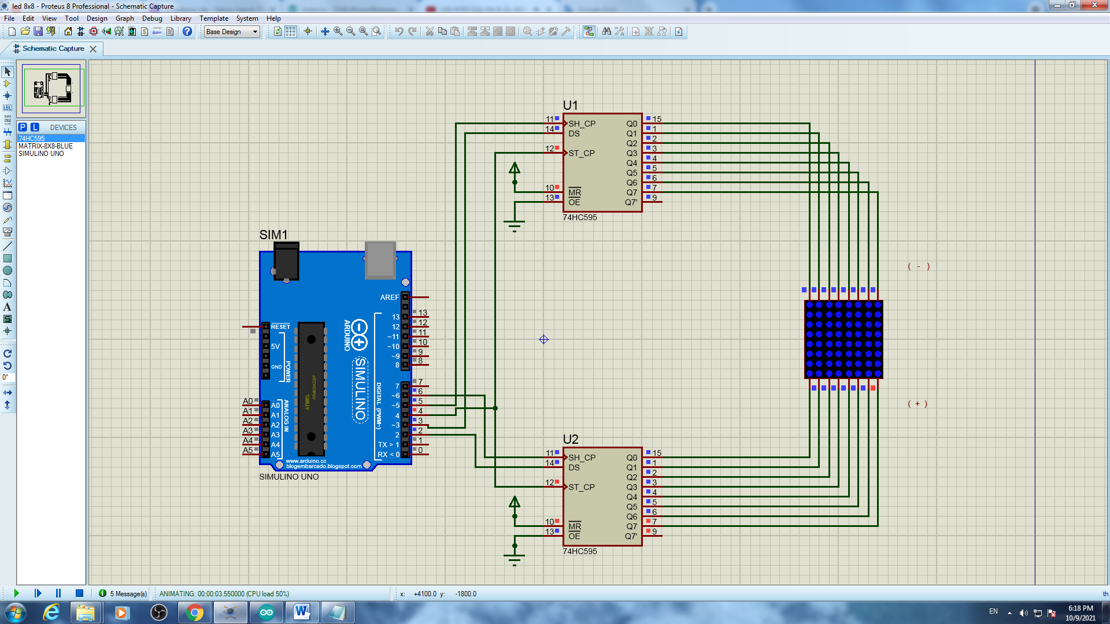

KQ test_ 1

* Kết quả file Test 2

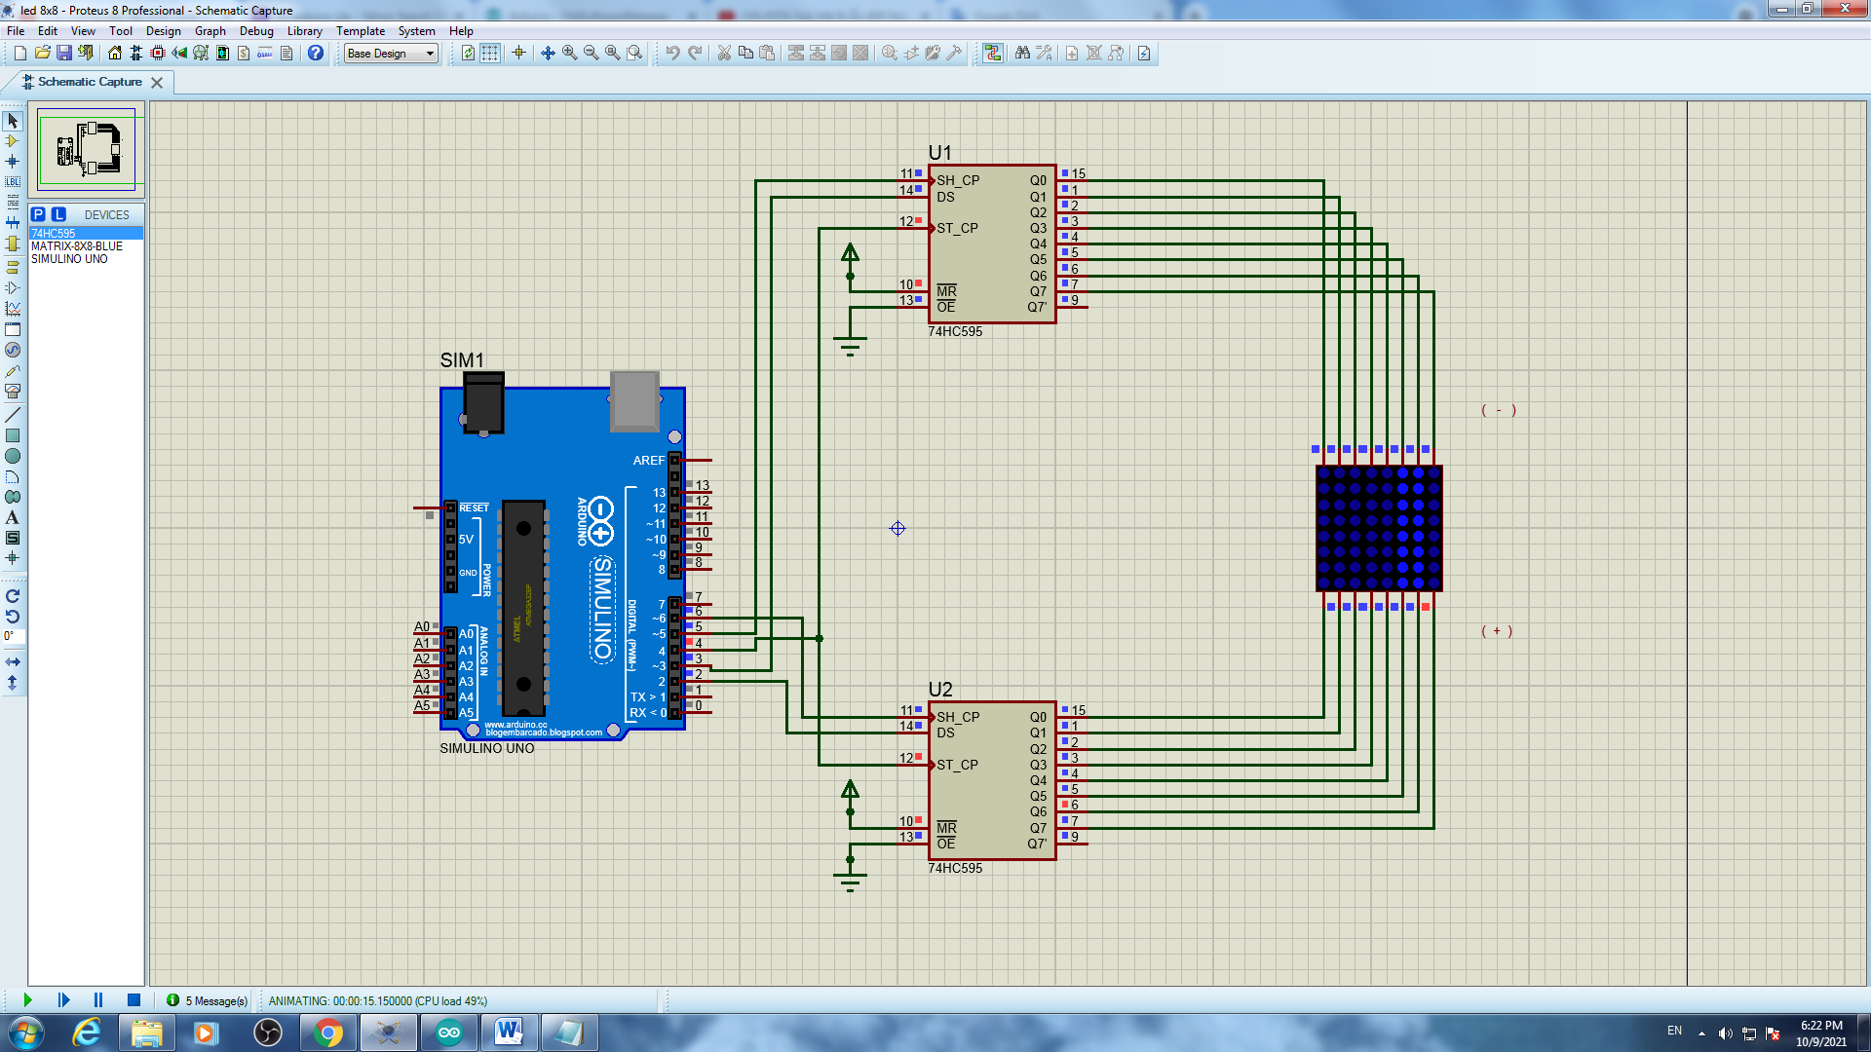

KQ test_ 2

* Kết quả file Test 3

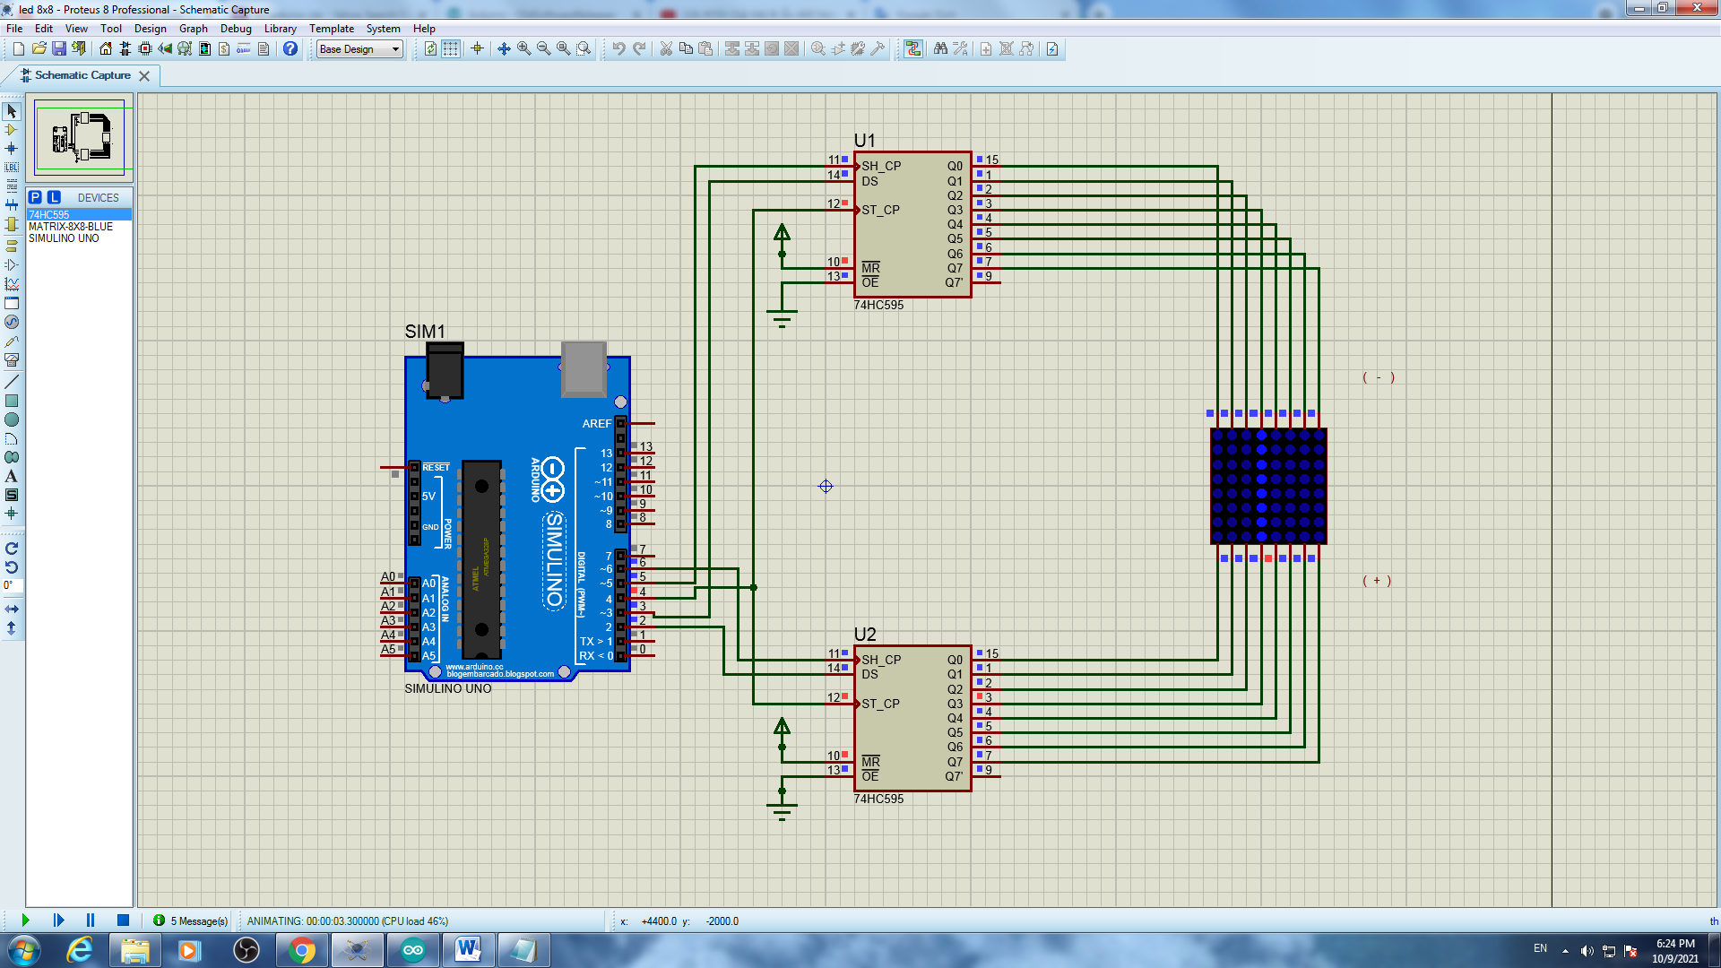

KQ test_ 3

* Kết quả file Test 4

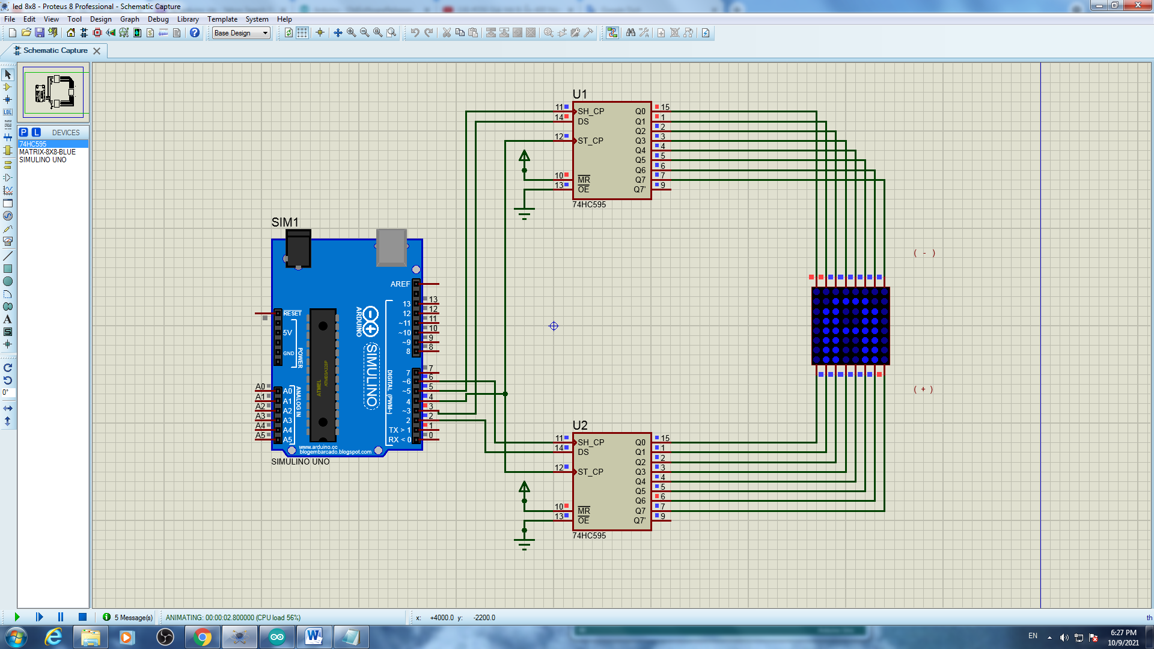

KQ test_ 4

* Kết quả file Test 5

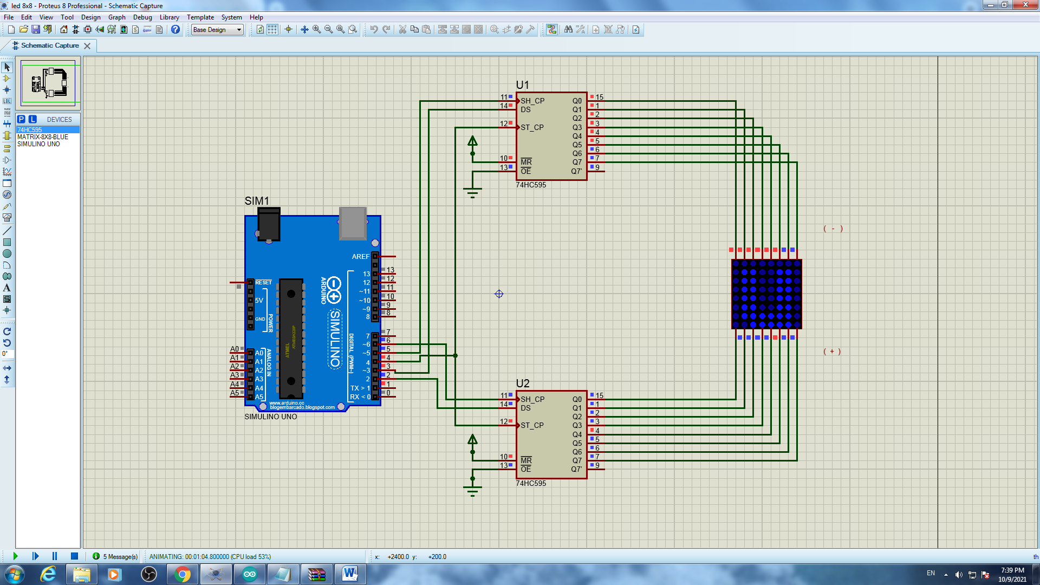

KQ test_ 5

* Kết quả file Test 6

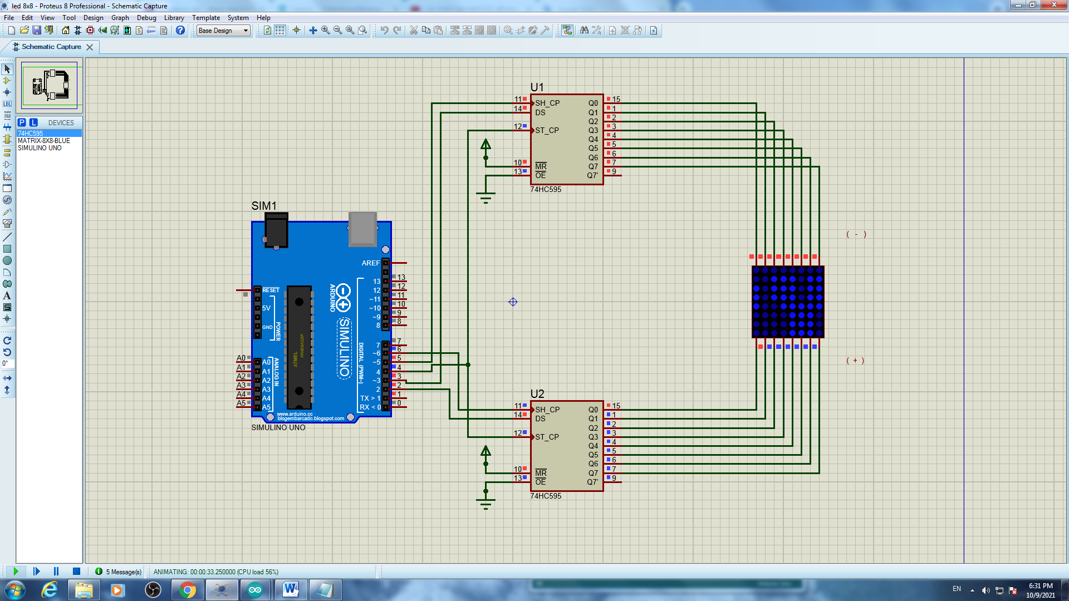

KQ test_ 6

* Kết quả file Test 7

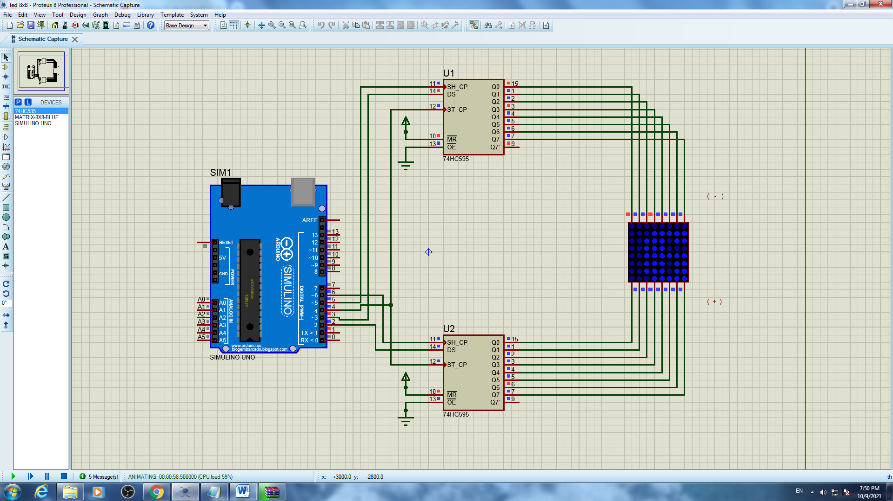

KQ test_ 7

# Bài 9 : LED MATRIX 24x8

## Mô tả

Bài này thực hiện việc lập trình 1 dãy đèn LED ma trận 24x8 màu xanh dương kèm 4 IC 78HC595 hiển thị các số và chữ theo lập trình ở các file

file test_1 : Hiển thị chữ A trong dãy đèn chạy từ trái sang phải và đổi chiều

file test_2 : Hiển thị dòng chữ chứa từ happy new year , dòng chữ chạy từ trái sáng phải

file test_3 : Chạy tất cả chữ từ a đến z và từ 0 đến 9 trong dãy đèn

file test_4 : Hiển thị dòng chữ chứa tên sinh viên kèm mã số sinh viên, dòng chữ chạy từ trái sáng phải

## Linh kiện

#### 4 IC 78HC595

#### 1 bảng đèn LED ma trận 8x8 màu xanh dương

#### Mạch Arduino

## Code chương trình

* Code file test_1:

|  |
| --- |
| #define DS_cot 2  #define DS_hang 3  #define SH_CP_hang 5  #define SH_CP_cot 6  #define ST_CP 4  byte chu[][8] = {  {0xFF,0xC0,0x80,0xB7,0xB7,0x80,0xC0,0xFF}, //A  {0xFF,0x80,0x80,0xB6,0xB6,0x80,0xC9,0xFF}, //B  {0xFF,0xC1,0x80,0xBE,0xBE,0x9C,0xDD,0xFF}, //C  {0xFF,0x80,0x80,0xBE,0xBE,0x80,0xC1,0xFF}, //D  {0xFF,0x80,0x80,0xB6,0xB6,0xBE,0xBE,0xFF},//E  {0xFF,0x80,0x80,0xB7,0xB7,0xBF,0xBF,0xFF},//F  {0xFF,0xC1,0x80,0xBE,0xBA,0x98,0xD9,0xFF},//G  {0xFF,0x80,0x80,0xF7,0xF7,0x80,0x80,0xFF},//H  {0xFF,0xFF,0xBE,0x80,0x80,0xBE,0xFF,0xFF},//I  {0xFF,0xF9,0xF8,0xBE,0x80,0x81,0xBF,0xFF},//J  {0xFF,0x80,0x80,0xE3,0xC9,0x9C,0xBE,0xFF},//K  {0xFF,0x80,0x80,0xFE,0xFE,0xFE,0xFE,0xFF},//L  {0xFF,0x80,0x80,0xCF,0xE7,0xCF,0x80,0x80},//M  {0xFF,0x80,0x80,0xCF,0xE7,0xF3,0x80,0x80},//N  {0xFF,0xC1,0x80,0xBE,0xBE,0x80,0xC1,0xFF},//O  {0xFF,0x80,0x80,0xBB,0xBB,0x83,0xC7,0xFF},//P  {0xFF,0xC3,0x81,0xBD,0xBD,0x80,0xC2,0xFF},//Q  {0xFF,0x80,0x80,0xB3,0xB1,0x84,0xCE,0xFF},//R  {0xFF,0xCD,0x84,0xB6,0xB6,0x90,0xD9,0xFF},//S  {0xFF,0x9F,0xBF,0x80,0x80,0xBF,0x9F,0xFF},//T  {0xFF,0x81,0x80,0xFE,0xFE,0x80,0x80,0xFF},//U  {0xFF,0x83,0x81,0xFC,0xFC,0x81,0x83,0xFF},//V  {0xFF,0x80,0x80,0xF9,0xF3,0xF9,0x80,0x80},//W  {0xFF,0x9C,0x88,0xE3,0xF7,0xE3,0x88,0x9C},//X  {0xFF,0x8F,0x87,0xF0,0xF0,0x87,0x8F,0xFF},//Y  {0xFF,0xBC,0xB8,0xB2,0xA6,0x8E,0x9E,0xFF},//Z  {0xFF,0xFE,0xEE,0x80,0x80,0xFE,0xFE,0xFF},//1  {0xFF,0xDC,0x98,0xBA,0xB6,0x86,0xCE,0xFF},//2  {0xFF,0xDD,0x9C,0xB6,0xB6,0x80,0xC9,0xFF},//3  {0xFF,0xF3,0xEB,0xDB,0x80,0x80,0xFB,0xFF},//4  {0xFF,0x8D,0x8C,0xAE,0xAE,0xA0,0xB1,0xFF},//5  {0xFF,0xC1,0x80,0xB6,0xB6,0x90,0xD9,0xFF},//6  {0xFF,0x9F,0x9F,0xB8,0xA0,0x87,0x9F,0xFF},//7  {0xFF,0xC9,0x80,0xB6,0xB6,0x80,0xC9,0xFF},//8  {0xFF,0xCD,0x84,0xB6,0xB6,0x80,0xC1,0xFF},//9  {0xFF,0xC1,0x80,0xAE,0xB6,0x80,0xC1,0xFF},//0  {0xFF,0xFF,0xFF,0xFF,0xFF,0xFF,0xFF,0xFF},//space    };  byte cot = 0b10000000;  void setup() {  Serial.begin(9600);  pinMode(ST_CP,OUTPUT);//RCLK    pinMode(DS_hang,OUTPUT);//SER hang  pinMode(SH_CP_hang,OUTPUT);//SRCLK hang  pinMode(SH_CP_cot,OUTPUT);//SRCLK cot  pinMode(DS_cot,OUTPUT);//SER cot  }  void loop() {  for(int j = 0;j<10;j++){  digitalWrite(ST_CP,LOW);  shiftOut(DS_hang,SH_CP_hang,LSBFIRST,0b11111111);// hang 8 - hang 1  shiftOut(DS_hang,SH_CP_hang,LSBFIRST,0b11111111);// hang 8 - hang 1  shiftOut(DS_hang,SH_CP_hang,LSBFIRST,0xC0);// hang 8 - hang 1  shiftOut(DS_cot,SH_CP_cot,LSBFIRST,0b10000000); // cot 8 - cot 1  digitalWrite(ST_CP,HIGH);  delay(1);  digitalWrite(ST_CP,LOW);  shiftOut(DS_hang,SH_CP_hang,LSBFIRST,0b11111111);// hang 8 - hang 1  shiftOut(DS_hang,SH_CP_hang,LSBFIRST,0b11111111);// hang 8 - hang 1  shiftOut(DS_hang,SH_CP_hang,LSBFIRST,0xFF);// hang 8 - hang 1  shiftOut(DS_cot,SH_CP_cot,LSBFIRST,0b01000000); // cot 8 - cot 1  digitalWrite(ST_CP,HIGH);  delay(1);    digitalWrite(ST_CP,LOW);  shiftOut(DS_hang,SH_CP_hang,LSBFIRST,0b11111111);// hang 8 - hang 1  shiftOut(DS_hang,SH_CP_hang,LSBFIRST,0b11111111);// hang 8 - hang 1  shiftOut(DS_hang,SH_CP_hang,LSBFIRST,0xFF);// hang 8 - hang 1  shiftOut(DS_cot,SH_CP_cot,LSBFIRST,0b00100000); // cot 8 - cot 1  digitalWrite(ST_CP,HIGH);  delay(1);  digitalWrite(ST_CP,LOW);  shiftOut(DS_hang,SH_CP_hang,LSBFIRST,0b11111111);// hang 8 - hang 1  shiftOut(DS_hang,SH_CP_hang,LSBFIRST,0b11111111);// hang 8 - hang 1  shiftOut(DS_hang,SH_CP_hang,LSBFIRST,0xFF);// hang 8 - hang 1  shiftOut(DS_cot,SH_CP_cot,LSBFIRST,0b00010000); // cot 8 - cot 1  digitalWrite(ST_CP,HIGH);  delay(1);  digitalWrite(ST_CP,LOW);  shiftOut(DS_hang,SH_CP_hang,LSBFIRST,0b11111111);// hang 8 - hang 1  shiftOut(DS_hang,SH_CP_hang,LSBFIRST,0b11111111);// hang 8 - hang 1  shiftOut(DS_hang,SH_CP_hang,LSBFIRST,0xFF);// hang 8 - hang 1  shiftOut(DS_cot,SH_CP_cot,LSBFIRST,0b00001000); // cot 8 - cot 1  digitalWrite(ST_CP,HIGH);  delay(1);    digitalWrite(ST_CP,LOW);  shiftOut(DS_hang,SH_CP_hang,LSBFIRST,0b11111111);// hang 8 - hang 1  shiftOut(DS_hang,SH_CP_hang,LSBFIRST,0b11111111);// hang 8 - hang 1  shiftOut(DS_hang,SH_CP_hang,LSBFIRST,0xFF);// hang 8 - hang 1  shiftOut(DS_cot,SH_CP_cot,LSBFIRST,0b00000100); // cot 8 - cot 1  digitalWrite(ST_CP,HIGH);  delay(1);  digitalWrite(ST_CP,LOW);  shiftOut(DS_hang,SH_CP_hang,LSBFIRST,0b11111111);// hang 8 - hang 1  shiftOut(DS_hang,SH_CP_hang,LSBFIRST,0b11111111);// hang 8 - hang 1  shiftOut(DS_hang,SH_CP_hang,LSBFIRST,0xFF);// hang 8 - hang 1  shiftOut(DS_cot,SH_CP_cot,LSBFIRST,0b00000010); // cot 8 - cot 1  digitalWrite(ST_CP,HIGH);  delay(1);  digitalWrite(ST_CP,LOW);  shiftOut(DS_hang,SH_CP_hang,LSBFIRST,0b11111111);// hang 8 - hang 1  shiftOut(DS_hang,SH_CP_hang,LSBFIRST,0b11111111);// hang 8 - hang 1  shiftOut(DS_hang,SH_CP_hang,LSBFIRST,0xFF);// hang 8 - hang 1  shiftOut(DS_cot,SH_CP_cot,LSBFIRST,0b00000001); // cot 8 - cot 1  digitalWrite(ST_CP,HIGH);  delay(1);  }  for(int j = 0;j<10;j++){  digitalWrite(ST_CP,LOW);  shiftOut(DS_hang,SH_CP_hang,LSBFIRST,0b11111111);// hang 8 - hang 1  shiftOut(DS_hang,SH_CP_hang,LSBFIRST,0b11111111);// hang 8 - hang 1  shiftOut(DS_hang,SH_CP_hang,LSBFIRST,0x80);// hang 8 - hang 1  shiftOut(DS_cot,SH_CP_cot,LSBFIRST,0b10000000); // cot 8 - cot 1  digitalWrite(ST_CP,HIGH);  delay(1);  digitalWrite(ST_CP,LOW);  shiftOut(DS_hang,SH_CP_hang,LSBFIRST,0b11111111);// hang 8 - hang 1  shiftOut(DS_hang,SH_CP_hang,LSBFIRST,0b11111111);// hang 8 - hang 1  shiftOut(DS_hang,SH_CP_hang,LSBFIRST,0xC0);// hang 8 - hang 1  shiftOut(DS_cot,SH_CP_cot,LSBFIRST,0b01000000); // cot 8 - cot 1  digitalWrite(ST_CP,HIGH);  delay(1);    digitalWrite(ST_CP,LOW);  shiftOut(DS_hang,SH_CP_hang,LSBFIRST,0b11111111);// hang 8 - hang 1  shiftOut(DS_hang,SH_CP_hang,LSBFIRST,0b11111111);// hang 8 - hang 1  shiftOut(DS_hang,SH_CP_hang,LSBFIRST,0xFF);// hang 8 - hang 1  shiftOut(DS_cot,SH_CP_cot,LSBFIRST,0b00100000); // cot 8 - cot 1  digitalWrite(ST_CP,HIGH);  delay(1);  digitalWrite(ST_CP,LOW);  shiftOut(DS_hang,SH_CP_hang,LSBFIRST,0b11111111);// hang 8 - hang 1  shiftOut(DS_hang,SH_CP_hang,LSBFIRST,0b11111111);// hang 8 - hang 1  shiftOut(DS_hang,SH_CP_hang,LSBFIRST,0xFF);// hang 8 - hang 1  shiftOut(DS_cot,SH_CP_cot,LSBFIRST,0b00010000); // cot 8 - cot 1  digitalWrite(ST_CP,HIGH);  delay(1);  digitalWrite(ST_CP,LOW);  shiftOut(DS_hang,SH_CP_hang,LSBFIRST,0b11111111);// hang 8 - hang 1  shiftOut(DS_hang,SH_CP_hang,LSBFIRST,0b11111111);// hang 8 - hang 1  shiftOut(DS_hang,SH_CP_hang,LSBFIRST,0xFF);// hang 8 - hang 1  shiftOut(DS_cot,SH_CP_cot,LSBFIRST,0b00001000); // cot 8 - cot 1  digitalWrite(ST_CP,HIGH);  delay(1);    digitalWrite(ST_CP,LOW);  shiftOut(DS_hang,SH_CP_hang,LSBFIRST,0b11111111);// hang 8 - hang 1  shiftOut(DS_hang,SH_CP_hang,LSBFIRST,0b11111111);// hang 8 - hang 1  shiftOut(DS_hang,SH_CP_hang,LSBFIRST,0xFF);// hang 8 - hang 1  shiftOut(DS_cot,SH_CP_cot,LSBFIRST,0b00000100); // cot 8 - cot 1  digitalWrite(ST_CP,HIGH);  delay(1);  digitalWrite(ST_CP,LOW);  shiftOut(DS_hang,SH_CP_hang,LSBFIRST,0b11111111);// hang 8 - hang 1  shiftOut(DS_hang,SH_CP_hang,LSBFIRST,0b11111111);// hang 8 - hang 1  shiftOut(DS_hang,SH_CP_hang,LSBFIRST,0xFF);// hang 8 - hang 1  shiftOut(DS_cot,SH_CP_cot,LSBFIRST,0b00000010); // cot 8 - cot 1  digitalWrite(ST_CP,HIGH);  delay(1);  digitalWrite(ST_CP,LOW);  shiftOut(DS_hang,SH_CP_hang,LSBFIRST,0b11111111);// hang 8 - hang 1  shiftOut(DS_hang,SH_CP_hang,LSBFIRST,0b11111111);// hang 8 - hang 1  shiftOut(DS_hang,SH_CP_hang,LSBFIRST,0xFF);// hang 8 - hang 1  shiftOut(DS_cot,SH_CP_cot,LSBFIRST,0b00000001); // cot 8 - cot 1  digitalWrite(ST_CP,HIGH);  delay(1);  }  for(int j = 0;j<10;j++){  digitalWrite(ST_CP,LOW);  shiftOut(DS_hang,SH_CP_hang,LSBFIRST,0b11111111);// hang 8 - hang 1  shiftOut(DS_hang,SH_CP_hang,LSBFIRST,0b11111111);// hang 8 - hang 1  shiftOut(DS_hang,SH_CP_hang,LSBFIRST,0xB7);// hang 8 - hang 1  shiftOut(DS_cot,SH_CP_cot,LSBFIRST,0b10000000); // cot 8 - cot 1  digitalWrite(ST_CP,HIGH);  delay(1);  digitalWrite(ST_CP,LOW);  shiftOut(DS_hang,SH_CP_hang,LSBFIRST,0b11111111);// hang 8 - hang 1  shiftOut(DS_hang,SH_CP_hang,LSBFIRST,0b11111111);// hang 8 - hang 1  shiftOut(DS_hang,SH_CP_hang,LSBFIRST,0x80);// hang 8 - hang 1  shiftOut(DS_cot,SH_CP_cot,LSBFIRST,0b01000000); // cot 8 - cot 1  digitalWrite(ST_CP,HIGH);  delay(1);    digitalWrite(ST_CP,LOW);  shiftOut(DS_hang,SH_CP_hang,LSBFIRST,0b11111111);// hang 8 - hang 1  shiftOut(DS_hang,SH_CP_hang,LSBFIRST,0b11111111);// hang 8 - hang 1  shiftOut(DS_hang,SH_CP_hang,LSBFIRST,0xC0);// hang 8 - hang 1  shiftOut(DS_cot,SH_CP_cot,LSBFIRST,0b00100000); // cot 8 - cot 1  digitalWrite(ST_CP,HIGH);  delay(1);  digitalWrite(ST_CP,LOW);  shiftOut(DS_hang,SH_CP_hang,LSBFIRST,0b11111111);// hang 8 - hang 1  shiftOut(DS_hang,SH_CP_hang,LSBFIRST,0b11111111);// hang 8 - hang 1  shiftOut(DS_hang,SH_CP_hang,LSBFIRST,0xFF);// hang 8 - hang 1  shiftOut(DS_cot,SH_CP_cot,LSBFIRST,0b00010000); // cot 8 - cot 1  digitalWrite(ST_CP,HIGH);  delay(1);  digitalWrite(ST_CP,LOW);  shiftOut(DS_hang,SH_CP_hang,LSBFIRST,0b11111111);// hang 8 - hang 1  shiftOut(DS_hang,SH_CP_hang,LSBFIRST,0b11111111);// hang 8 - hang 1  shiftOut(DS_hang,SH_CP_hang,LSBFIRST,0xFF);// hang 8 - hang 1  shiftOut(DS_cot,SH_CP_cot,LSBFIRST,0b00001000); // cot 8 - cot 1  digitalWrite(ST_CP,HIGH);  delay(1);    digitalWrite(ST_CP,LOW);  shiftOut(DS_hang,SH_CP_hang,LSBFIRST,0b11111111);// hang 8 - hang 1  shiftOut(DS_hang,SH_CP_hang,LSBFIRST,0b11111111);// hang 8 - hang 1  shiftOut(DS_hang,SH_CP_hang,LSBFIRST,0xFF);// hang 8 - hang 1  shiftOut(DS_cot,SH_CP_cot,LSBFIRST,0b00000100); // cot 8 - cot 1  digitalWrite(ST_CP,HIGH);  delay(1);  digitalWrite(ST_CP,LOW);  shiftOut(DS_hang,SH_CP_hang,LSBFIRST,0b11111111);// hang 8 - hang 1  shiftOut(DS_hang,SH_CP_hang,LSBFIRST,0b11111111);// hang 8 - hang 1  shiftOut(DS_hang,SH_CP_hang,LSBFIRST,0xFF);// hang 8 - hang 1  shiftOut(DS_cot,SH_CP_cot,LSBFIRST,0b00000010); // cot 8 - cot 1  digitalWrite(ST_CP,HIGH);  delay(1);  digitalWrite(ST_CP,LOW);  shiftOut(DS_hang,SH_CP_hang,LSBFIRST,0b11111111);// hang 8 - hang 1  shiftOut(DS_hang,SH_CP_hang,LSBFIRST,0b11111111);// hang 8 - hang 1  shiftOut(DS_hang,SH_CP_hang,LSBFIRST,0xFF);// hang 8 - hang 1  shiftOut(DS_cot,SH_CP_cot,LSBFIRST,0b00000001); // cot 8 - cot 1  digitalWrite(ST_CP,HIGH);  delay(1);  }  for(int j = 0;j<10;j++){  digitalWrite(ST_CP,LOW);  shiftOut(DS_hang,SH_CP_hang,LSBFIRST,0b11111111);// hang 8 - hang 1  shiftOut(DS_hang,SH_CP_hang,LSBFIRST,0b11111111);// hang 8 - hang 1  shiftOut(DS_hang,SH_CP_hang,LSBFIRST,0xB7);// hang 8 - hang 1  shiftOut(DS_cot,SH_CP_cot,LSBFIRST,0b10000000); // cot 8 - cot 1  digitalWrite(ST_CP,HIGH);  delay(1);  digitalWrite(ST_CP,LOW);  shiftOut(DS_hang,SH_CP_hang,LSBFIRST,0b11111111);// hang 8 - hang 1  shiftOut(DS_hang,SH_CP_hang,LSBFIRST,0b11111111);// hang 8 - hang 1  shiftOut(DS_hang,SH_CP_hang,LSBFIRST,0xB7);// hang 8 - hang 1  shiftOut(DS_cot,SH_CP_cot,LSBFIRST,0b01000000); // cot 8 - cot 1  digitalWrite(ST_CP,HIGH);  delay(1);    digitalWrite(ST_CP,LOW);  shiftOut(DS_hang,SH_CP_hang,LSBFIRST,0b11111111);// hang 8 - hang 1  shiftOut(DS_hang,SH_CP_hang,LSBFIRST,0b11111111);// hang 8 - hang 1  shiftOut(DS_hang,SH_CP_hang,LSBFIRST,0x80);// hang 8 - hang 1  shiftOut(DS_cot,SH_CP_cot,LSBFIRST,0b00100000); // cot 8 - cot 1  digitalWrite(ST_CP,HIGH);  delay(1);  digitalWrite(ST_CP,LOW);  shiftOut(DS_hang,SH_CP_hang,LSBFIRST,0b11111111);// hang 8 - hang 1  shiftOut(DS_hang,SH_CP_hang,LSBFIRST,0b11111111);// hang 8 - hang 1  shiftOut(DS_hang,SH_CP_hang,LSBFIRST,0xC0);// hang 8 - hang 1  shiftOut(DS_cot,SH_CP_cot,LSBFIRST,0b00010000); // cot 8 - cot 1  digitalWrite(ST_CP,HIGH);  delay(1);  digitalWrite(ST_CP,LOW);  shiftOut(DS_hang,SH_CP_hang,LSBFIRST,0b11111111);// hang 8 - hang 1  shiftOut(DS_hang,SH_CP_hang,LSBFIRST,0b11111111);// hang 8 - hang 1  shiftOut(DS_hang,SH_CP_hang,LSBFIRST,0xFF);// hang 8 - hang 1  shiftOut(DS_cot,SH_CP_cot,LSBFIRST,0b00001000); // cot 8 - cot 1  digitalWrite(ST_CP,HIGH);  delay(1);    digitalWrite(ST_CP,LOW);  shiftOut(DS_hang,SH_CP_hang,LSBFIRST,0b11111111);// hang 8 - hang 1  shiftOut(DS_hang,SH_CP_hang,LSBFIRST,0b11111111);// hang 8 - hang 1  shiftOut(DS_hang,SH_CP_hang,LSBFIRST,0xFF);// hang 8 - hang 1  shiftOut(DS_cot,SH_CP_cot,LSBFIRST,0b00000100); // cot 8 - cot 1  digitalWrite(ST_CP,HIGH);  delay(1);  digitalWrite(ST_CP,LOW);  shiftOut(DS_hang,SH_CP_hang,LSBFIRST,0b11111111);// hang 8 - hang 1  shiftOut(DS_hang,SH_CP_hang,LSBFIRST,0b11111111);// hang 8 - hang 1  shiftOut(DS_hang,SH_CP_hang,LSBFIRST,0xFF);// hang 8 - hang 1  shiftOut(DS_cot,SH_CP_cot,LSBFIRST,0b00000010); // cot 8 - cot 1  digitalWrite(ST_CP,HIGH);  delay(1);  digitalWrite(ST_CP,LOW);  shiftOut(DS_hang,SH_CP_hang,LSBFIRST,0b11111111);// hang 8 - hang 1  shiftOut(DS_hang,SH_CP_hang,LSBFIRST,0b11111111);// hang 8 - hang 1  shiftOut(DS_hang,SH_CP_hang,LSBFIRST,0xFF);// hang 8 - hang 1  shiftOut(DS_cot,SH_CP_cot,LSBFIRST,0b00000001); // cot 8 - cot 1  digitalWrite(ST_CP,HIGH);  delay(1);  }  /////////////////////////////////////////////////  for(int j = 0;j<10;j++){  digitalWrite(ST_CP,LOW);  shiftOut(DS_hang,SH_CP_hang,LSBFIRST,0b11111111);// hang 8 - hang 1  shiftOut(DS_hang,SH_CP_hang,LSBFIRST,0b11111111);// hang 8 - hang 1  shiftOut(DS_hang,SH_CP_hang,LSBFIRST,0x80);// hang 8 - hang 1  shiftOut(DS_cot,SH_CP_cot,LSBFIRST,0b10000000); // cot 8 - cot 1  digitalWrite(ST_CP,HIGH);  delay(1);  digitalWrite(ST_CP,LOW);  shiftOut(DS_hang,SH_CP_hang,LSBFIRST,0b11111111);// hang 8 - hang 1  shiftOut(DS_hang,SH_CP_hang,LSBFIRST,0b11111111);// hang 8 - hang 1  shiftOut(DS_hang,SH_CP_hang,LSBFIRST,0xB7);// hang 8 - hang 1  shiftOut(DS_cot,SH_CP_cot,LSBFIRST,0b01000000); // cot 8 - cot 1  digitalWrite(ST_CP,HIGH);  delay(1);    digitalWrite(ST_CP,LOW);  shiftOut(DS_hang,SH_CP_hang,LSBFIRST,0b11111111);// hang 8 - hang 1  shiftOut(DS_hang,SH_CP_hang,LSBFIRST,0b11111111);// hang 8 - hang 1  shiftOut(DS_hang,SH_CP_hang,LSBFIRST,0xB7);// hang 8 - hang 1  shiftOut(DS_cot,SH_CP_cot,LSBFIRST,0b00100000); // cot 8 - cot 1  digitalWrite(ST_CP,HIGH);  delay(1);  digitalWrite(ST_CP,LOW);  shiftOut(DS_hang,SH_CP_hang,LSBFIRST,0b11111111);// hang 8 - hang 1  shiftOut(DS_hang,SH_CP_hang,LSBFIRST,0b11111111);// hang 8 - hang 1  shiftOut(DS_hang,SH_CP_hang,LSBFIRST,0x80);// hang 8 - hang 1  shiftOut(DS_cot,SH_CP_cot,LSBFIRST,0b00010000); // cot 8 - cot 1  digitalWrite(ST_CP,HIGH);  delay(1);  digitalWrite(ST_CP,LOW);  shiftOut(DS_hang,SH_CP_hang,LSBFIRST,0b11111111);// hang 8 - hang 1  shiftOut(DS_hang,SH_CP_hang,LSBFIRST,0b11111111);// hang 8 - hang 1  shiftOut(DS_hang,SH_CP_hang,LSBFIRST,0xC0);// hang 8 - hang 1  shiftOut(DS_cot,SH_CP_cot,LSBFIRST,0b00001000); // cot 8 - cot 1  digitalWrite(ST_CP,HIGH);  delay(1);    digitalWrite(ST_CP,LOW);  shiftOut(DS_hang,SH_CP_hang,LSBFIRST,0b11111111);// hang 8 - hang 1  shiftOut(DS_hang,SH_CP_hang,LSBFIRST,0b11111111);// hang 8 - hang 1  shiftOut(DS_hang,SH_CP_hang,LSBFIRST,0xFF);// hang 8 - hang 1  shiftOut(DS_cot,SH_CP_cot,LSBFIRST,0b00000100); // cot 8 - cot 1  digitalWrite(ST_CP,HIGH);  delay(1);  digitalWrite(ST_CP,LOW);  shiftOut(DS_hang,SH_CP_hang,LSBFIRST,0b11111111);// hang 8 - hang 1  shiftOut(DS_hang,SH_CP_hang,LSBFIRST,0b11111111);// hang 8 - hang 1  shiftOut(DS_hang,SH_CP_hang,LSBFIRST,0xFF);// hang 8 - hang 1  shiftOut(DS_cot,SH_CP_cot,LSBFIRST,0b00000010); // cot 8 - cot 1  digitalWrite(ST_CP,HIGH);  delay(1);  digitalWrite(ST_CP,LOW);  shiftOut(DS_hang,SH_CP_hang,LSBFIRST,0b11111111);// hang 8 - hang 1  shiftOut(DS_hang,SH_CP_hang,LSBFIRST,0b11111111);// hang 8 - hang 1  shiftOut(DS_hang,SH_CP_hang,LSBFIRST,0xFF);// hang 8 - hang 1  shiftOut(DS_cot,SH_CP_cot,LSBFIRST,0b00000001); // cot 8 - cot 1  digitalWrite(ST_CP,HIGH);  delay(1);  }  /////////////////////////////////////////////////////////////////////  for(int j = 0;j<10;j++){  digitalWrite(ST_CP,LOW);  shiftOut(DS_hang,SH_CP_hang,LSBFIRST,0b11111111);// hang 8 - hang 1  shiftOut(DS_hang,SH_CP_hang,LSBFIRST,0b11111111);// hang 8 - hang 1  shiftOut(DS_hang,SH_CP_hang,LSBFIRST,0xC0);// hang 8 - hang 1  shiftOut(DS_cot,SH_CP_cot,LSBFIRST,0b10000000); // cot 8 - cot 1  digitalWrite(ST_CP,HIGH);  delay(1);  digitalWrite(ST_CP,LOW);  shiftOut(DS_hang,SH_CP_hang,LSBFIRST,0b11111111);// hang 8 - hang 1  shiftOut(DS_hang,SH_CP_hang,LSBFIRST,0b11111111);// hang 8 - hang 1  shiftOut(DS_hang,SH_CP_hang,LSBFIRST,0x80);// hang 8 - hang 1  shiftOut(DS_cot,SH_CP_cot,LSBFIRST,0b01000000); // cot 8 - cot 1  digitalWrite(ST_CP,HIGH);  delay(1);    digitalWrite(ST_CP,LOW);  shiftOut(DS_hang,SH_CP_hang,LSBFIRST,0b11111111);// hang 8 - hang 1  shiftOut(DS_hang,SH_CP_hang,LSBFIRST,0b11111111);// hang 8 - hang 1  shiftOut(DS_hang,SH_CP_hang,LSBFIRST,0xB7);// hang 8 - hang 1  shiftOut(DS_cot,SH_CP_cot,LSBFIRST,0b00100000); // cot 8 - cot 1  digitalWrite(ST_CP,HIGH);  delay(1);  digitalWrite(ST_CP,LOW);  shiftOut(DS_hang,SH_CP_hang,LSBFIRST,0b11111111);// hang 8 - hang 1  shiftOut(DS_hang,SH_CP_hang,LSBFIRST,0b11111111);// hang 8 - hang 1  shiftOut(DS_hang,SH_CP_hang,LSBFIRST,0xB7);// hang 8 - hang 1  shiftOut(DS_cot,SH_CP_cot,LSBFIRST,0b00010000); // cot 8 - cot 1  digitalWrite(ST_CP,HIGH);  delay(1);  digitalWrite(ST_CP,LOW);  shiftOut(DS_hang,SH_CP_hang,LSBFIRST,0b11111111);// hang 8 - hang 1  shiftOut(DS_hang,SH_CP_hang,LSBFIRST,0b11111111);// hang 8 - hang 1  shiftOut(DS_hang,SH_CP_hang,LSBFIRST,0x80);// hang 8 - hang 1  shiftOut(DS_cot,SH_CP_cot,LSBFIRST,0b00001000); // cot 8 - cot 1  digitalWrite(ST_CP,HIGH);  delay(1);    digitalWrite(ST_CP,LOW);  shiftOut(DS_hang,SH_CP_hang,LSBFIRST,0b11111111);// hang 8 - hang 1  shiftOut(DS_hang,SH_CP_hang,LSBFIRST,0b11111111);// hang 8 - hang 1  shiftOut(DS_hang,SH_CP_hang,LSBFIRST,0xC0);// hang 8 - hang 1  shiftOut(DS_cot,SH_CP_cot,LSBFIRST,0b00000100); // cot 8 - cot 1  digitalWrite(ST_CP,HIGH);  delay(1);  digitalWrite(ST_CP,LOW);  shiftOut(DS_hang,SH_CP_hang,LSBFIRST,0b11111111);// hang 8 - hang 1  shiftOut(DS_hang,SH_CP_hang,LSBFIRST,0b11111111);// hang 8 - hang 1  shiftOut(DS_hang,SH_CP_hang,LSBFIRST,0xFF);// hang 8 - hang 1  shiftOut(DS_cot,SH_CP_cot,LSBFIRST,0b00000010); // cot 8 - cot 1  digitalWrite(ST_CP,HIGH);  delay(1);  digitalWrite(ST_CP,LOW);  shiftOut(DS_hang,SH_CP_hang,LSBFIRST,0b11111111);// hang 8 - hang 1  shiftOut(DS_hang,SH_CP_hang,LSBFIRST,0b11111111);// hang 8 - hang 1  shiftOut(DS_hang,SH_CP_hang,LSBFIRST,0xFF);// hang 8 - hang 1  shiftOut(DS_cot,SH_CP_cot,LSBFIRST,0b00000001); // cot 8 - cot 1  digitalWrite(ST_CP,HIGH);  delay(1);  }  //////////////////////////////  for(int j = 0;j<10;j++){  digitalWrite(ST_CP,LOW);  shiftOut(DS_hang,SH_CP_hang,LSBFIRST,0b11111111);// hang 8 - hang 1  shiftOut(DS_hang,SH_CP_hang,LSBFIRST,0b11111111);// hang 8 - hang 1  shiftOut(DS_hang,SH_CP_hang,LSBFIRST,0xFF);// hang 8 - hang 1  shiftOut(DS_cot,SH_CP_cot,LSBFIRST,0b10000000); // cot 8 - cot 1  digitalWrite(ST_CP,HIGH);  delay(1);  digitalWrite(ST_CP,LOW);  shiftOut(DS_hang,SH_CP_hang,LSBFIRST,0b11111111);// hang 8 - hang 1  shiftOut(DS_hang,SH_CP_hang,LSBFIRST,0b11111111);// hang 8 - hang 1  shiftOut(DS_hang,SH_CP_hang,LSBFIRST,0xC0);// hang 8 - hang 1  shiftOut(DS_cot,SH_CP_cot,LSBFIRST,0b01000000); // cot 8 - cot 1  digitalWrite(ST_CP,HIGH);  delay(1);    digitalWrite(ST_CP,LOW);  shiftOut(DS_hang,SH_CP_hang,LSBFIRST,0b11111111);// hang 8 - hang 1  shiftOut(DS_hang,SH_CP_hang,LSBFIRST,0b11111111);// hang 8 - hang 1  shiftOut(DS_hang,SH_CP_hang,LSBFIRST,0x80);// hang 8 - hang 1  shiftOut(DS_cot,SH_CP_cot,LSBFIRST,0b00100000); // cot 8 - cot 1  digitalWrite(ST_CP,HIGH);  delay(1);  digitalWrite(ST_CP,LOW);  shiftOut(DS_hang,SH_CP_hang,LSBFIRST,0b11111111);// hang 8 - hang 1  shiftOut(DS_hang,SH_CP_hang,LSBFIRST,0b11111111);// hang 8 - hang 1  shiftOut(DS_hang,SH_CP_hang,LSBFIRST,0xB7);// hang 8 - hang 1  shiftOut(DS_cot,SH_CP_cot,LSBFIRST,0b00010000); // cot 8 - cot 1  digitalWrite(ST_CP,HIGH);  delay(1);  digitalWrite(ST_CP,LOW);  shiftOut(DS_hang,SH_CP_hang,LSBFIRST,0b11111111);// hang 8 - hang 1  shiftOut(DS_hang,SH_CP_hang,LSBFIRST,0b11111111);// hang 8 - hang 1  shiftOut(DS_hang,SH_CP_hang,LSBFIRST,0xB7);// hang 8 - hang 1  shiftOut(DS_cot,SH_CP_cot,LSBFIRST,0b00001000); // cot 8 - cot 1  digitalWrite(ST_CP,HIGH);  delay(1);    digitalWrite(ST_CP,LOW);  shiftOut(DS_hang,SH_CP_hang,LSBFIRST,0b11111111);// hang 8 - hang 1  shiftOut(DS_hang,SH_CP_hang,LSBFIRST,0b11111111);// hang 8 - hang 1  shiftOut(DS_hang,SH_CP_hang,LSBFIRST,0x80);// hang 8 - hang 1  shiftOut(DS_cot,SH_CP_cot,LSBFIRST,0b00000100); // cot 8 - cot 1  digitalWrite(ST_CP,HIGH);  delay(1);  digitalWrite(ST_CP,LOW);  shiftOut(DS_hang,SH_CP_hang,LSBFIRST,0b11111111);// hang 8 - hang 1  shiftOut(DS_hang,SH_CP_hang,LSBFIRST,0b11111111);// hang 8 - hang 1  shiftOut(DS_hang,SH_CP_hang,LSBFIRST,0xC0);// hang 8 - hang 1  shiftOut(DS_cot,SH_CP_cot,LSBFIRST,0b00000010); // cot 8 - cot 1  digitalWrite(ST_CP,HIGH);  delay(1);  digitalWrite(ST_CP,LOW);  shiftOut(DS_hang,SH_CP_hang,LSBFIRST,0b11111111);// hang 8 - hang 1  shiftOut(DS_hang,SH_CP_hang,LSBFIRST,0b11111111);// hang 8 - hang 1  shiftOut(DS_hang,SH_CP_hang,LSBFIRST,0xFF);// hang 8 - hang 1  shiftOut(DS_cot,SH_CP_cot,LSBFIRST,0b00000001); // cot 8 - cot 1  digitalWrite(ST_CP,HIGH);  delay(1);  }  /////////////////////////////  for(int j = 0;j<10;j++){  digitalWrite(ST_CP,LOW);  shiftOut(DS_hang,SH_CP_hang,LSBFIRST,0b11111111);// hang 8 - hang 1  shiftOut(DS_hang,SH_CP_hang,LSBFIRST,0b11111111);// hang 8 - hang 1  shiftOut(DS_hang,SH_CP_hang,LSBFIRST,0xFF);// hang 8 - hang 1  shiftOut(DS_cot,SH_CP_cot,LSBFIRST,0b10000000); // cot 8 - cot 1  digitalWrite(ST_CP,HIGH);  delay(1);  digitalWrite(ST_CP,LOW);  shiftOut(DS_hang,SH_CP_hang,LSBFIRST,0b11111111);// hang 8 - hang 1  shiftOut(DS_hang,SH_CP_hang,LSBFIRST,0b11111111);// hang 8 - hang 1  shiftOut(DS_hang,SH_CP_hang,LSBFIRST,0xFF);// hang 8 - hang 1  shiftOut(DS_cot,SH_CP_cot,LSBFIRST,0b01000000); // cot 8 - cot 1  digitalWrite(ST_CP,HIGH);  delay(1);    digitalWrite(ST_CP,LOW);  shiftOut(DS_hang,SH_CP_hang,LSBFIRST,0b11111111);// hang 8 - hang 1  shiftOut(DS_hang,SH_CP_hang,LSBFIRST,0b11111111);// hang 8 - hang 1  shiftOut(DS_hang,SH_CP_hang,LSBFIRST,0xC0);// hang 8 - hang 1  shiftOut(DS_cot,SH_CP_cot,LSBFIRST,0b00100000); // cot 8 - cot 1  digitalWrite(ST_CP,HIGH);  delay(1);  digitalWrite(ST_CP,LOW);  shiftOut(DS_hang,SH_CP_hang,LSBFIRST,0b11111111);// hang 8 - hang 1  shiftOut(DS_hang,SH_CP_hang,LSBFIRST,0b11111111);// hang 8 - hang 1  shiftOut(DS_hang,SH_CP_hang,LSBFIRST,0x80);// hang 8 - hang 1  shiftOut(DS_cot,SH_CP_cot,LSBFIRST,0b00010000); // cot 8 - cot 1  digitalWrite(ST_CP,HIGH);  delay(1);  digitalWrite(ST_CP,LOW);  shiftOut(DS_hang,SH_CP_hang,LSBFIRST,0b11111111);// hang 8 - hang 1  shiftOut(DS_hang,SH_CP_hang,LSBFIRST,0b11111111);// hang 8 - hang 1  shiftOut(DS_hang,SH_CP_hang,LSBFIRST,0xB7);// hang 8 - hang 1  shiftOut(DS_cot,SH_CP_cot,LSBFIRST,0b00001000); // cot 8 - cot 1  digitalWrite(ST_CP,HIGH);  delay(1);    digitalWrite(ST_CP,LOW);  shiftOut(DS_hang,SH_CP_hang,LSBFIRST,0b11111111);// hang 8 - hang 1  shiftOut(DS_hang,SH_CP_hang,LSBFIRST,0b11111111);// hang 8 - hang 1  shiftOut(DS_hang,SH_CP_hang,LSBFIRST,0xB7);// hang 8 - hang 1  shiftOut(DS_cot,SH_CP_cot,LSBFIRST,0b00000100); // cot 8 - cot 1  digitalWrite(ST_CP,HIGH);  delay(1);  digitalWrite(ST_CP,LOW);  shiftOut(DS_hang,SH_CP_hang,LSBFIRST,0b11111111);// hang 8 - hang 1  shiftOut(DS_hang,SH_CP_hang,LSBFIRST,0b11111111);// hang 8 - hang 1  shiftOut(DS_hang,SH_CP_hang,LSBFIRST,0x80);// hang 8 - hang 1  shiftOut(DS_cot,SH_CP_cot,LSBFIRST,0b00000010); // cot 8 - cot 1  digitalWrite(ST_CP,HIGH);  delay(1);  digitalWrite(ST_CP,LOW);  shiftOut(DS_hang,SH_CP_hang,LSBFIRST,0b11111111);// hang 8 - hang 1  shiftOut(DS_hang,SH_CP_hang,LSBFIRST,0b11111111);// hang 8 - hang 1  shiftOut(DS_hang,SH_CP_hang,LSBFIRST,0xC0);// hang 8 - hang 1  shiftOut(DS_cot,SH_CP_cot,LSBFIRST,0b00000001); // cot 8 - cot 1  digitalWrite(ST_CP,HIGH);  delay(1);  }  //////////////////////////////////////    for(int j = 0;j<10;j++){  digitalWrite(ST_CP,LOW);  shiftOut(DS_hang,SH_CP_hang,LSBFIRST,0b11111111);// hang 8 - hang 1  shiftOut(DS_hang,SH_CP_hang,LSBFIRST,0xC0);// hang 8 - hang 1  shiftOut(DS_hang,SH_CP_hang,LSBFIRST,0xFF);// hang 8 - hang 1  shiftOut(DS_cot,SH_CP_cot,LSBFIRST,0b10000000); // cot 8 - cot 1  digitalWrite(ST_CP,HIGH);  delay(1);  digitalWrite(ST_CP,LOW);  shiftOut(DS_hang,SH_CP_hang,LSBFIRST,0b11111111);// hang 8 - hang 1  shiftOut(DS_hang,SH_CP_hang,LSBFIRST,0b11111111);// hang 8 - hang 1  shiftOut(DS_hang,SH_CP_hang,LSBFIRST,0xFF);// hang 8 - hang 1  shiftOut(DS_cot,SH_CP_cot,LSBFIRST,0b01000000); // cot 8 - cot 1  digitalWrite(ST_CP,HIGH);  delay(1);    digitalWrite(ST_CP,LOW);  shiftOut(DS_hang,SH_CP_hang,LSBFIRST,0b11111111);// hang 8 - hang 1  shiftOut(DS_hang,SH_CP_hang,LSBFIRST,0b11111111);// hang 8 - hang 1  shiftOut(DS_hang,SH_CP_hang,LSBFIRST,0xFF);// hang 8 - hang 1  shiftOut(DS_cot,SH_CP_cot,LSBFIRST,0b00100000); // cot 8 - cot 1  digitalWrite(ST_CP,HIGH);  delay(1);  digitalWrite(ST_CP,LOW);  shiftOut(DS_hang,SH_CP_hang,LSBFIRST,0b11111111);// hang 8 - hang 1  shiftOut(DS_hang,SH_CP_hang,LSBFIRST,0b11111111);// hang 8 - hang 1  shiftOut(DS_hang,SH_CP_hang,LSBFIRST,0xC0);// hang 8 - hang 1  shiftOut(DS_cot,SH_CP_cot,LSBFIRST,0b00010000); // cot 8 - cot 1  digitalWrite(ST_CP,HIGH);  delay(1);  digitalWrite(ST_CP,LOW);  shiftOut(DS_hang,SH_CP_hang,LSBFIRST,0b11111111);// hang 8 - hang 1  shiftOut(DS_hang,SH_CP_hang,LSBFIRST,0b11111111);// hang 8 - hang 1  shiftOut(DS_hang,SH_CP_hang,LSBFIRST,0x80);// hang 8 - hang 1  shiftOut(DS_cot,SH_CP_cot,LSBFIRST,0b00001000); // cot 8 - cot 1  digitalWrite(ST_CP,HIGH);  delay(1);    digitalWrite(ST_CP,LOW);  shiftOut(DS_hang,SH_CP_hang,LSBFIRST,0b11111111);// hang 8 - hang 1  shiftOut(DS_hang,SH_CP_hang,LSBFIRST,0b11111111);// hang 8 - hang 1  shiftOut(DS_hang,SH_CP_hang,LSBFIRST,0xB7);// hang 8 - hang 1  shiftOut(DS_cot,SH_CP_cot,LSBFIRST,0b00000100); // cot 8 - cot 1  digitalWrite(ST_CP,HIGH);  delay(1);  digitalWrite(ST_CP,LOW);  shiftOut(DS_hang,SH_CP_hang,LSBFIRST,0b11111111);// hang 8 - hang 1  shiftOut(DS_hang,SH_CP_hang,LSBFIRST,0b11111111);// hang 8 - hang 1  shiftOut(DS_hang,SH_CP_hang,LSBFIRST,0xB7);// hang 8 - hang 1  shiftOut(DS_cot,SH_CP_cot,LSBFIRST,0b00000010); // cot 8 - cot 1  digitalWrite(ST_CP,HIGH);  delay(1);  digitalWrite(ST_CP,LOW);  shiftOut(DS_hang,SH_CP_hang,LSBFIRST,0b11111111);// hang 8 - hang 1  shiftOut(DS_hang,SH_CP_hang,LSBFIRST,0b11111111);// hang 8 - hang 1  shiftOut(DS_hang,SH_CP_hang,LSBFIRST,0x80);// hang 8 - hang 1  shiftOut(DS_cot,SH_CP_cot,LSBFIRST,0b00000001); // cot 8 - cot 1  digitalWrite(ST_CP,HIGH);  delay(1);  }  /////////////////////////////////  for(int j = 0;j<10;j++){  digitalWrite(ST_CP,LOW);  shiftOut(DS_hang,SH_CP_hang,LSBFIRST,0b11111111);// hang 8 - hang 1  shiftOut(DS_hang,SH_CP_hang,LSBFIRST,0x80);// hang 8 - hang 1  shiftOut(DS_hang,SH_CP_hang,LSBFIRST,0xFF);// hang 8 - hang 1  shiftOut(DS_cot,SH_CP_cot,LSBFIRST,0b10000000); // cot 8 - cot 1  digitalWrite(ST_CP,HIGH);  delay(1);  digitalWrite(ST_CP,LOW);  shiftOut(DS_hang,SH_CP_hang,LSBFIRST,0b11111111);// hang 8 - hang 1  shiftOut(DS_hang,SH_CP_hang,LSBFIRST,0xC0);// hang 8 - hang 1  shiftOut(DS_hang,SH_CP_hang,LSBFIRST,0xFF);// hang 8 - hang 1  shiftOut(DS_cot,SH_CP_cot,LSBFIRST,0b01000000); // cot 8 - cot 1  digitalWrite(ST_CP,HIGH);  delay(1);    digitalWrite(ST_CP,LOW);  shiftOut(DS_hang,SH_CP_hang,LSBFIRST,0b11111111);// hang 8 - hang 1  shiftOut(DS_hang,SH_CP_hang,LSBFIRST,0b11111111);// hang 8 - hang 1  shiftOut(DS_hang,SH_CP_hang,LSBFIRST,0xFF);// hang 8 - hang 1  shiftOut(DS_cot,SH_CP_cot,LSBFIRST,0b00100000); // cot 8 - cot 1  digitalWrite(ST_CP,HIGH);  delay(1);  digitalWrite(ST_CP,LOW);  shiftOut(DS_hang,SH_CP_hang,LSBFIRST,0b11111111);// hang 8 - hang 1  shiftOut(DS_hang,SH_CP_hang,LSBFIRST,0b11111111);// hang 8 - hang 1  shiftOut(DS_hang,SH_CP_hang,LSBFIRST,0xFF);// hang 8 - hang 1  shiftOut(DS_cot,SH_CP_cot,LSBFIRST,0b00010000); // cot 8 - cot 1  digitalWrite(ST_CP,HIGH);  delay(1);  digitalWrite(ST_CP,LOW);  shiftOut(DS_hang,SH_CP_hang,LSBFIRST,0b11111111);// hang 8 - hang 1  shiftOut(DS_hang,SH_CP_hang,LSBFIRST,0b11111111);// hang 8 - hang 1  shiftOut(DS_hang,SH_CP_hang,LSBFIRST,0xC0);// hang 8 - hang 1  shiftOut(DS_cot,SH_CP_cot,LSBFIRST,0b00001000); // cot 8 - cot 1  digitalWrite(ST_CP,HIGH);  delay(1);    digitalWrite(ST_CP,LOW);  shiftOut(DS_hang,SH_CP_hang,LSBFIRST,0b11111111);// hang 8 - hang 1  shiftOut(DS_hang,SH_CP_hang,LSBFIRST,0b11111111);// hang 8 - hang 1  shiftOut(DS_hang,SH_CP_hang,LSBFIRST,0x80);// hang 8 - hang 1  shiftOut(DS_cot,SH_CP_cot,LSBFIRST,0b00000100); // cot 8 - cot 1  digitalWrite(ST_CP,HIGH);  delay(1);  digitalWrite(ST_CP,LOW);  shiftOut(DS_hang,SH_CP_hang,LSBFIRST,0b11111111);// hang 8 - hang 1  shiftOut(DS_hang,SH_CP_hang,LSBFIRST,0b11111111);// hang 8 - hang 1  shiftOut(DS_hang,SH_CP_hang,LSBFIRST,0xB7);// hang 8 - hang 1  shiftOut(DS_cot,SH_CP_cot,LSBFIRST,0b00000010); // cot 8 - cot 1  digitalWrite(ST_CP,HIGH);  delay(1);  digitalWrite(ST_CP,LOW);  shiftOut(DS_hang,SH_CP_hang,LSBFIRST,0b11111111);// hang 8 - hang 1  shiftOut(DS_hang,SH_CP_hang,LSBFIRST,0b11111111);// hang 8 - hang 1  shiftOut(DS_hang,SH_CP_hang,LSBFIRST,0xB7);// hang 8 - hang 1  shiftOut(DS_cot,SH_CP_cot,LSBFIRST,0b00000001); // cot 8 - cot 1  digitalWrite(ST_CP,HIGH);  delay(1);  }  ////  for(int j = 0;j<10;j++){  digitalWrite(ST_CP,LOW);  shiftOut(DS_hang,SH_CP_hang,LSBFIRST,0b11111111);// hang 8 - hang 1  shiftOut(DS_hang,SH_CP_hang,LSBFIRST,0xB7);// hang 8 - hang 1  shiftOut(DS_hang,SH_CP_hang,LSBFIRST,0xFF);// hang 8 - hang 1  shiftOut(DS_cot,SH_CP_cot,LSBFIRST,0b10000000); // cot 8 - cot 1  digitalWrite(ST_CP,HIGH);  delay(1);  digitalWrite(ST_CP,LOW);  shiftOut(DS_hang,SH_CP_hang,LSBFIRST,0b11111111);// hang 8 - hang 1  shiftOut(DS_hang,SH_CP_hang,LSBFIRST,0x80);// hang 8 - hang 1  shiftOut(DS_hang,SH_CP_hang,LSBFIRST,0xFF);// hang 8 - hang 1  shiftOut(DS_cot,SH_CP_cot,LSBFIRST,0b01000000); // cot 8 - cot 1  digitalWrite(ST_CP,HIGH);  delay(1);    digitalWrite(ST_CP,LOW);  shiftOut(DS_hang,SH_CP_hang,LSBFIRST,0b11111111);// hang 8 - hang 1  shiftOut(DS_hang,SH_CP_hang,LSBFIRST,0xC0);// hang 8 - hang 1  shiftOut(DS_hang,SH_CP_hang,LSBFIRST,0xFF);// hang 8 - hang 1  shiftOut(DS_cot,SH_CP_cot,LSBFIRST,0b00100000); // cot 8 - cot 1  digitalWrite(ST_CP,HIGH);  delay(1);  digitalWrite(ST_CP,LOW);  shiftOut(DS_hang,SH_CP_hang,LSBFIRST,0b11111111);// hang 8 - hang 1  shiftOut(DS_hang,SH_CP_hang,LSBFIRST,0b11111111);// hang 8 - hang 1  shiftOut(DS_hang,SH_CP_hang,LSBFIRST,0xFF);// hang 8 - hang 1  shiftOut(DS_cot,SH_CP_cot,LSBFIRST,0b00010000); // cot 8 - cot 1  digitalWrite(ST_CP,HIGH);  delay(1);  digitalWrite(ST_CP,LOW);  shiftOut(DS_hang,SH_CP_hang,LSBFIRST,0b11111111);// hang 8 - hang 1  shiftOut(DS_hang,SH_CP_hang,LSBFIRST,0b11111111);// hang 8 - hang 1  shiftOut(DS_hang,SH_CP_hang,LSBFIRST,0xFF);// hang 8 - hang 1  shiftOut(DS_cot,SH_CP_cot,LSBFIRST,0b00001000); // cot 8 - cot 1  digitalWrite(ST_CP,HIGH);  delay(1);    digitalWrite(ST_CP,LOW);  shiftOut(DS_hang,SH_CP_hang,LSBFIRST,0b11111111);// hang 8 - hang 1  shiftOut(DS_hang,SH_CP_hang,LSBFIRST,0b11111111);// hang 8 - hang 1  shiftOut(DS_hang,SH_CP_hang,LSBFIRST,0xC0);// hang 8 - hang 1  shiftOut(DS_cot,SH_CP_cot,LSBFIRST,0b00000100); // cot 8 - cot 1  digitalWrite(ST_CP,HIGH);  delay(1);  digitalWrite(ST_CP,LOW);  shiftOut(DS_hang,SH_CP_hang,LSBFIRST,0b11111111);// hang 8 - hang 1  shiftOut(DS_hang,SH_CP_hang,LSBFIRST,0b11111111);// hang 8 - hang 1  shiftOut(DS_hang,SH_CP_hang,LSBFIRST,0x80);// hang 8 - hang 1  shiftOut(DS_cot,SH_CP_cot,LSBFIRST,0b00000010); // cot 8 - cot 1  digitalWrite(ST_CP,HIGH);  delay(1);  digitalWrite(ST_CP,LOW);  shiftOut(DS_hang,SH_CP_hang,LSBFIRST,0b11111111);// hang 8 - hang 1  shiftOut(DS_hang,SH_CP_hang,LSBFIRST,0b11111111);// hang 8 - hang 1  shiftOut(DS_hang,SH_CP_hang,LSBFIRST,0xB7);// hang 8 - hang 1  shiftOut(DS_cot,SH_CP_cot,LSBFIRST,0b00000001); // cot 8 - cot 1  digitalWrite(ST_CP,HIGH);  delay(1);  }  ////  for(int j = 0;j<10;j++){  digitalWrite(ST_CP,LOW);  shiftOut(DS_hang,SH_CP_hang,LSBFIRST,0b11111111);// hang 8 - hang 1  shiftOut(DS_hang,SH_CP_hang,LSBFIRST,0xB7);// hang 8 - hang 1  shiftOut(DS_hang,SH_CP_hang,LSBFIRST,0xFF);// hang 8 - hang 1  shiftOut(DS_cot,SH_CP_cot,LSBFIRST,0b10000000); // cot 8 - cot 1  digitalWrite(ST_CP,HIGH);  delay(1);  digitalWrite(ST_CP,LOW);  shiftOut(DS_hang,SH_CP_hang,LSBFIRST,0b11111111);// hang 8 - hang 1  shiftOut(DS_hang,SH_CP_hang,LSBFIRST,0xB7);// hang 8 - hang 1  shiftOut(DS_hang,SH_CP_hang,LSBFIRST,0xFF);// hang 8 - hang 1  shiftOut(DS_cot,SH_CP_cot,LSBFIRST,0b01000000); // cot 8 - cot 1  digitalWrite(ST_CP,HIGH);  delay(1);    digitalWrite(ST_CP,LOW);  shiftOut(DS_hang,SH_CP_hang,LSBFIRST,0b11111111);// hang 8 - hang 1  shiftOut(DS_hang,SH_CP_hang,LSBFIRST,0x80);// hang 8 - hang 1  shiftOut(DS_hang,SH_CP_hang,LSBFIRST,0xFF);// hang 8 - hang 1  shiftOut(DS_cot,SH_CP_cot,LSBFIRST,0b00100000); // cot 8 - cot 1  digitalWrite(ST_CP,HIGH);  delay(1);  digitalWrite(ST_CP,LOW);  shiftOut(DS_hang,SH_CP_hang,LSBFIRST,0b11111111);// hang 8 - hang 1  shiftOut(DS_hang,SH_CP_hang,LSBFIRST,0xC0);// hang 8 - hang 1  shiftOut(DS_hang,SH_CP_hang,LSBFIRST,0xFF);// hang 8 - hang 1  shiftOut(DS_cot,SH_CP_cot,LSBFIRST,0b00010000); // cot 8 - cot 1  digitalWrite(ST_CP,HIGH);  delay(1);  digitalWrite(ST_CP,LOW);  shiftOut(DS_hang,SH_CP_hang,LSBFIRST,0b11111111);// hang 8 - hang 1  shiftOut(DS_hang,SH_CP_hang,LSBFIRST,0b11111111);// hang 8 - hang 1  shiftOut(DS_hang,SH_CP_hang,LSBFIRST,0xFF);// hang 8 - hang 1  shiftOut(DS_cot,SH_CP_cot,LSBFIRST,0b00001000); // cot 8 - cot 1  digitalWrite(ST_CP,HIGH);  delay(1);    digitalWrite(ST_CP,LOW);  shiftOut(DS_hang,SH_CP_hang,LSBFIRST,0b11111111);// hang 8 - hang 1  shiftOut(DS_hang,SH_CP_hang,LSBFIRST,0b11111111);// hang 8 - hang 1  shiftOut(DS_hang,SH_CP_hang,LSBFIRST,0xFF);// hang 8 - hang 1  shiftOut(DS_cot,SH_CP_cot,LSBFIRST,0b00000100); // cot 8 - cot 1  digitalWrite(ST_CP,HIGH);  delay(1);  digitalWrite(ST_CP,LOW);  shiftOut(DS_hang,SH_CP_hang,LSBFIRST,0b11111111);// hang 8 - hang 1  shiftOut(DS_hang,SH_CP_hang,LSBFIRST,0b11111111);// hang 8 - hang 1  shiftOut(DS_hang,SH_CP_hang,LSBFIRST,0xC0);// hang 8 - hang 1  shiftOut(DS_cot,SH_CP_cot,LSBFIRST,0b00000010); // cot 8 - cot 1  digitalWrite(ST_CP,HIGH);  delay(1);  digitalWrite(ST_CP,LOW);  shiftOut(DS_hang,SH_CP_hang,LSBFIRST,0b11111111);// hang 8 - hang 1  shiftOut(DS_hang,SH_CP_hang,LSBFIRST,0b11111111);// hang 8 - hang 1  shiftOut(DS_hang,SH_CP_hang,LSBFIRST,0x80);// hang 8 - hang 1  shiftOut(DS_cot,SH_CP_cot,LSBFIRST,0b00000001); // cot 8 - cot 1  digitalWrite(ST_CP,HIGH);  delay(1);  }  /////  for(int j = 0;j<10;j++){  digitalWrite(ST_CP,LOW);  shiftOut(DS_hang,SH_CP_hang,LSBFIRST,0b11111111);// hang 8 - hang 1  shiftOut(DS_hang,SH_CP_hang,LSBFIRST,0x80);// hang 8 - hang 1  shiftOut(DS_hang,SH_CP_hang,LSBFIRST,0xFF);// hang 8 - hang 1  shiftOut(DS_cot,SH_CP_cot,LSBFIRST,0b10000000); // cot 8 - cot 1  digitalWrite(ST_CP,HIGH);  delay(1);  digitalWrite(ST_CP,LOW);  shiftOut(DS_hang,SH_CP_hang,LSBFIRST,0b11111111);// hang 8 - hang 1  shiftOut(DS_hang,SH_CP_hang,LSBFIRST,0xB7);// hang 8 - hang 1  shiftOut(DS_hang,SH_CP_hang,LSBFIRST,0xFF);// hang 8 - hang 1  shiftOut(DS_cot,SH_CP_cot,LSBFIRST,0b01000000); // cot 8 - cot 1  digitalWrite(ST_CP,HIGH);  delay(1);    digitalWrite(ST_CP,LOW);  shiftOut(DS_hang,SH_CP_hang,LSBFIRST,0b11111111);// hang 8 - hang 1  shiftOut(DS_hang,SH_CP_hang,LSBFIRST,0xB7);// hang 8 - hang 1  shiftOut(DS_hang,SH_CP_hang,LSBFIRST,0xFF);// hang 8 - hang 1  shiftOut(DS_cot,SH_CP_cot,LSBFIRST,0b00100000); // cot 8 - cot 1  digitalWrite(ST_CP,HIGH);  delay(1);  digitalWrite(ST_CP,LOW);  shiftOut(DS_hang,SH_CP_hang,LSBFIRST,0b11111111);// hang 8 - hang 1  shiftOut(DS_hang,SH_CP_hang,LSBFIRST,0x80);// hang 8 - hang 1  shiftOut(DS_hang,SH_CP_hang,LSBFIRST,0xFF);// hang 8 - hang 1  shiftOut(DS_cot,SH_CP_cot,LSBFIRST,0b00010000); // cot 8 - cot 1  digitalWrite(ST_CP,HIGH);  delay(1);  digitalWrite(ST_CP,LOW);  shiftOut(DS_hang,SH_CP_hang,LSBFIRST,0b11111111);// hang 8 - hang 1  shiftOut(DS_hang,SH_CP_hang,LSBFIRST,0xC0);// hang 8 - hang 1  shiftOut(DS_hang,SH_CP_hang,LSBFIRST,0xFF);// hang 8 - hang 1  shiftOut(DS_cot,SH_CP_cot,LSBFIRST,0b00001000); // cot 8 - cot 1  digitalWrite(ST_CP,HIGH);  delay(1);    digitalWrite(ST_CP,LOW);  shiftOut(DS_hang,SH_CP_hang,LSBFIRST,0b11111111);// hang 8 - hang 1  shiftOut(DS_hang,SH_CP_hang,LSBFIRST,0b11111111);// hang 8 - hang 1  shiftOut(DS_hang,SH_CP_hang,LSBFIRST,0xFF);// hang 8 - hang 1  shiftOut(DS_cot,SH_CP_cot,LSBFIRST,0b00000100); // cot 8 - cot 1  digitalWrite(ST_CP,HIGH);  delay(1);  digitalWrite(ST_CP,LOW);  shiftOut(DS_hang,SH_CP_hang,LSBFIRST,0b11111111);// hang 8 - hang 1  shiftOut(DS_hang,SH_CP_hang,LSBFIRST,0b11111111);// hang 8 - hang 1  shiftOut(DS_hang,SH_CP_hang,LSBFIRST,0xFF);// hang 8 - hang 1  shiftOut(DS_cot,SH_CP_cot,LSBFIRST,0b00000010); // cot 8 - cot 1  digitalWrite(ST_CP,HIGH);  delay(1);  digitalWrite(ST_CP,LOW);  shiftOut(DS_hang,SH_CP_hang,LSBFIRST,0b11111111);// hang 8 - hang 1  shiftOut(DS_hang,SH_CP_hang,LSBFIRST,0b11111111);// hang 8 - hang 1  shiftOut(DS_hang,SH_CP_hang,LSBFIRST,0xC0);// hang 8 - hang 1  shiftOut(DS_cot,SH_CP_cot,LSBFIRST,0b00000001); // cot 8 - cot 1  digitalWrite(ST_CP,HIGH);  delay(1);  }  /////  for(int j = 0;j<10;j++){  digitalWrite(ST_CP,LOW);  shiftOut(DS_hang,SH_CP_hang,LSBFIRST,0b11111111);// hang 8 - hang 1  shiftOut(DS_hang,SH_CP_hang,LSBFIRST,0xC0);// hang 8 - hang 1  shiftOut(DS_hang,SH_CP_hang,LSBFIRST,0xFF);// hang 8 - hang 1  shiftOut(DS_cot,SH_CP_cot,LSBFIRST,0b10000000); // cot 8 - cot 1  digitalWrite(ST_CP,HIGH);  delay(1);  digitalWrite(ST_CP,LOW);  shiftOut(DS_hang,SH_CP_hang,LSBFIRST,0b11111111);// hang 8 - hang 1  shiftOut(DS_hang,SH_CP_hang,LSBFIRST,0x80);// hang 8 - hang 1  shiftOut(DS_hang,SH_CP_hang,LSBFIRST,0xFF);// hang 8 - hang 1  shiftOut(DS_cot,SH_CP_cot,LSBFIRST,0b01000000); // cot 8 - cot 1  digitalWrite(ST_CP,HIGH);  delay(1);    digitalWrite(ST_CP,LOW);  shiftOut(DS_hang,SH_CP_hang,LSBFIRST,0b11111111);// hang 8 - hang 1  shiftOut(DS_hang,SH_CP_hang,LSBFIRST,0xB7);// hang 8 - hang 1  shiftOut(DS_hang,SH_CP_hang,LSBFIRST,0xFF);// hang 8 - hang 1  shiftOut(DS_cot,SH_CP_cot,LSBFIRST,0b00100000); // cot 8 - cot 1  digitalWrite(ST_CP,HIGH);  delay(1);  digitalWrite(ST_CP,LOW);  shiftOut(DS_hang,SH_CP_hang,LSBFIRST,0b11111111);// hang 8 - hang 1  shiftOut(DS_hang,SH_CP_hang,LSBFIRST,0xB7);// hang 8 - hang 1  shiftOut(DS_hang,SH_CP_hang,LSBFIRST,0xFF);// hang 8 - hang 1  shiftOut(DS_cot,SH_CP_cot,LSBFIRST,0b00010000); // cot 8 - cot 1  digitalWrite(ST_CP,HIGH);  delay(1);  digitalWrite(ST_CP,LOW);  shiftOut(DS_hang,SH_CP_hang,LSBFIRST,0b11111111);// hang 8 - hang 1  shiftOut(DS_hang,SH_CP_hang,LSBFIRST,0x80);// hang 8 - hang 1  shiftOut(DS_hang,SH_CP_hang,LSBFIRST,0xFF);// hang 8 - hang 1  shiftOut(DS_cot,SH_CP_cot,LSBFIRST,0b00001000); // cot 8 - cot 1  digitalWrite(ST_CP,HIGH);  delay(1);    digitalWrite(ST_CP,LOW);  shiftOut(DS_hang,SH_CP_hang,LSBFIRST,0b11111111);// hang 8 - hang 1  shiftOut(DS_hang,SH_CP_hang,LSBFIRST,0xC0);// hang 8 - hang 1  shiftOut(DS_hang,SH_CP_hang,LSBFIRST,0xFF);// hang 8 - hang 1  shiftOut(DS_cot,SH_CP_cot,LSBFIRST,0b00000100); // cot 8 - cot 1  digitalWrite(ST_CP,HIGH);  delay(1);  digitalWrite(ST_CP,LOW);  shiftOut(DS_hang,SH_CP_hang,LSBFIRST,0b11111111);// hang 8 - hang 1  shiftOut(DS_hang,SH_CP_hang,LSBFIRST,0b11111111);// hang 8 - hang 1  shiftOut(DS_hang,SH_CP_hang,LSBFIRST,0xFF);// hang 8 - hang 1  shiftOut(DS_cot,SH_CP_cot,LSBFIRST,0b00000010); // cot 8 - cot 1  digitalWrite(ST_CP,HIGH);  delay(1);  digitalWrite(ST_CP,LOW);  shiftOut(DS_hang,SH_CP_hang,LSBFIRST,0b11111111);// hang 8 - hang 1  shiftOut(DS_hang,SH_CP_hang,LSBFIRST,0b11111111);// hang 8 - hang 1  shiftOut(DS_hang,SH_CP_hang,LSBFIRST,0xFF);// hang 8 - hang 1  shiftOut(DS_cot,SH_CP_cot,LSBFIRST,0b00000001); // cot 8 - cot 1  digitalWrite(ST_CP,HIGH);  delay(1);  }  /////  for(int j = 0;j<10;j++){  digitalWrite(ST_CP,LOW);  shiftOut(DS_hang,SH_CP_hang,LSBFIRST,0b11111111);// hang 8 - hang 1  shiftOut(DS_hang,SH_CP_hang,LSBFIRST,0xFF);// hang 8 - hang 1  shiftOut(DS_hang,SH_CP_hang,LSBFIRST,0xFF);// hang 8 - hang 1  shiftOut(DS_cot,SH_CP_cot,LSBFIRST,0b10000000); // cot 8 - cot 1  digitalWrite(ST_CP,HIGH);  delay(1);  digitalWrite(ST_CP,LOW);  shiftOut(DS_hang,SH_CP_hang,LSBFIRST,0b11111111);// hang 8 - hang 1  shiftOut(DS_hang,SH_CP_hang,LSBFIRST,0xC0);// hang 8 - hang 1  shiftOut(DS_hang,SH_CP_hang,LSBFIRST,0xFF);// hang 8 - hang 1  shiftOut(DS_cot,SH_CP_cot,LSBFIRST,0b01000000); // cot 8 - cot 1  digitalWrite(ST_CP,HIGH);  delay(1);    digitalWrite(ST_CP,LOW);  shiftOut(DS_hang,SH_CP_hang,LSBFIRST,0b11111111);// hang 8 - hang 1  shiftOut(DS_hang,SH_CP_hang,LSBFIRST,0x80);// hang 8 - hang 1  shiftOut(DS_hang,SH_CP_hang,LSBFIRST,0xFF);// hang 8 - hang 1  shiftOut(DS_cot,SH_CP_cot,LSBFIRST,0b00100000); // cot 8 - cot 1  digitalWrite(ST_CP,HIGH);  delay(1);  digitalWrite(ST_CP,LOW);  shiftOut(DS_hang,SH_CP_hang,LSBFIRST,0b11111111);// hang 8 - hang 1  shiftOut(DS_hang,SH_CP_hang,LSBFIRST,0xB7);// hang 8 - hang 1  shiftOut(DS_hang,SH_CP_hang,LSBFIRST,0xFF);// hang 8 - hang 1  shiftOut(DS_cot,SH_CP_cot,LSBFIRST,0b00010000); // cot 8 - cot 1  digitalWrite(ST_CP,HIGH);  delay(1);  digitalWrite(ST_CP,LOW);  shiftOut(DS_hang,SH_CP_hang,LSBFIRST,0b11111111);// hang 8 - hang 1  shiftOut(DS_hang,SH_CP_hang,LSBFIRST,0xB7);// hang 8 - hang 1  shiftOut(DS_hang,SH_CP_hang,LSBFIRST,0xFF);// hang 8 - hang 1  shiftOut(DS_cot,SH_CP_cot,LSBFIRST,0b00001000); // cot 8 - cot 1  digitalWrite(ST_CP,HIGH);  delay(1);    digitalWrite(ST_CP,LOW);  shiftOut(DS_hang,SH_CP_hang,LSBFIRST,0b11111111);// hang 8 - hang 1  shiftOut(DS_hang,SH_CP_hang,LSBFIRST,0x80);// hang 8 - hang 1  shiftOut(DS_hang,SH_CP_hang,LSBFIRST,0xFF);// hang 8 - hang 1  shiftOut(DS_cot,SH_CP_cot,LSBFIRST,0b00000100); // cot 8 - cot 1  digitalWrite(ST_CP,HIGH);  delay(1);  digitalWrite(ST_CP,LOW);  shiftOut(DS_hang,SH_CP_hang,LSBFIRST,0b11111111);// hang 8 - hang 1  shiftOut(DS_hang,SH_CP_hang,LSBFIRST,0xC0);// hang 8 - hang 1  shiftOut(DS_hang,SH_CP_hang,LSBFIRST,0xFF);// hang 8 - hang 1  shiftOut(DS_cot,SH_CP_cot,LSBFIRST,0b00000010); // cot 8 - cot 1  digitalWrite(ST_CP,HIGH);  delay(1);  digitalWrite(ST_CP,LOW);  shiftOut(DS_hang,SH_CP_hang,LSBFIRST,0b11111111);// hang 8 - hang 1  shiftOut(DS_hang,SH_CP_hang,LSBFIRST,0b11111111);// hang 8 - hang 1  shiftOut(DS_hang,SH_CP_hang,LSBFIRST,0xFF);// hang 8 - hang 1  shiftOut(DS_cot,SH_CP_cot,LSBFIRST,0b00000001); // cot 8 - cot 1  digitalWrite(ST_CP,HIGH);  delay(1);  }  /////  for(int j = 0;j<10;j++){  digitalWrite(ST_CP,LOW);  shiftOut(DS_hang,SH_CP_hang,LSBFIRST,0b11111111);// hang 8 - hang 1  shiftOut(DS_hang,SH_CP_hang,LSBFIRST,0xFF);// hang 8 - hang 1  shiftOut(DS_hang,SH_CP_hang,LSBFIRST,0xFF);// hang 8 - hang 1  shiftOut(DS_cot,SH_CP_cot,LSBFIRST,0b10000000); // cot 8 - cot 1  digitalWrite(ST_CP,HIGH);  delay(1);  digitalWrite(ST_CP,LOW);  shiftOut(DS_hang,SH_CP_hang,LSBFIRST,0b11111111);// hang 8 - hang 1  shiftOut(DS_hang,SH_CP_hang,LSBFIRST,0xFF);// hang 8 - hang 1  shiftOut(DS_hang,SH_CP_hang,LSBFIRST,0xFF);// hang 8 - hang 1  shiftOut(DS_cot,SH_CP_cot,LSBFIRST,0b01000000); // cot 8 - cot 1  digitalWrite(ST_CP,HIGH);  delay(1);    digitalWrite(ST_CP,LOW);  shiftOut(DS_hang,SH_CP_hang,LSBFIRST,0b11111111);// hang 8 - hang 1  shiftOut(DS_hang,SH_CP_hang,LSBFIRST,0xC0);// hang 8 - hang 1  shiftOut(DS_hang,SH_CP_hang,LSBFIRST,0xFF);// hang 8 - hang 1  shiftOut(DS_cot,SH_CP_cot,LSBFIRST,0b00100000); // cot 8 - cot 1  digitalWrite(ST_CP,HIGH);  delay(1);  digitalWrite(ST_CP,LOW);  shiftOut(DS_hang,SH_CP_hang,LSBFIRST,0b11111111);// hang 8 - hang 1  shiftOut(DS_hang,SH_CP_hang,LSBFIRST,0x80);// hang 8 - hang 1  shiftOut(DS_hang,SH_CP_hang,LSBFIRST,0xFF);// hang 8 - hang 1  shiftOut(DS_cot,SH_CP_cot,LSBFIRST,0b00010000); // cot 8 - cot 1  digitalWrite(ST_CP,HIGH);  delay(1);  digitalWrite(ST_CP,LOW);  shiftOut(DS_hang,SH_CP_hang,LSBFIRST,0b11111111);// hang 8 - hang 1  shiftOut(DS_hang,SH_CP_hang,LSBFIRST,0xB7);// hang 8 - hang 1  shiftOut(DS_hang,SH_CP_hang,LSBFIRST,0xFF);// hang 8 - hang 1  shiftOut(DS_cot,SH_CP_cot,LSBFIRST,0b00001000); // cot 8 - cot 1  digitalWrite(ST_CP,HIGH);  delay(1);    digitalWrite(ST_CP,LOW);  shiftOut(DS_hang,SH_CP_hang,LSBFIRST,0b11111111);// hang 8 - hang 1  shiftOut(DS_hang,SH_CP_hang,LSBFIRST,0xB7);// hang 8 - hang 1  shiftOut(DS_hang,SH_CP_hang,LSBFIRST,0xFF);// hang 8 - hang 1  shiftOut(DS_cot,SH_CP_cot,LSBFIRST,0b00000100); // cot 8 - cot 1  digitalWrite(ST_CP,HIGH);  delay(1);  digitalWrite(ST_CP,LOW);  shiftOut(DS_hang,SH_CP_hang,LSBFIRST,0b11111111);// hang 8 - hang 1  shiftOut(DS_hang,SH_CP_hang,LSBFIRST,0x80);// hang 8 - hang 1  shiftOut(DS_hang,SH_CP_hang,LSBFIRST,0xFF);// hang 8 - hang 1  shiftOut(DS_cot,SH_CP_cot,LSBFIRST,0b00000010); // cot 8 - cot 1  digitalWrite(ST_CP,HIGH);  delay(1);  digitalWrite(ST_CP,LOW);  shiftOut(DS_hang,SH_CP_hang,LSBFIRST,0b11111111);// hang 8 - hang 1  shiftOut(DS_hang,SH_CP_hang,LSBFIRST,0xC0);// hang 8 - hang 1  shiftOut(DS_hang,SH_CP_hang,LSBFIRST,0xFF);// hang 8 - hang 1  shiftOut(DS_cot,SH_CP_cot,LSBFIRST,0b00000001); // cot 8 - cot 1  digitalWrite(ST_CP,HIGH);  delay(1);  }  /////  for(int j = 0;j<10;j++){  digitalWrite(ST_CP,LOW);  shiftOut(DS_hang,SH_CP_hang,LSBFIRST,0xC0);// hang 8 - hang 1  shiftOut(DS_hang,SH_CP_hang,LSBFIRST,0xFF);// hang 8 - hang 1  shiftOut(DS_hang,SH_CP_hang,LSBFIRST,0xFF);// hang 8 - hang 1  shiftOut(DS_cot,SH_CP_cot,LSBFIRST,0b10000000); // cot 8 - cot 1  digitalWrite(ST_CP,HIGH);  delay(1);  digitalWrite(ST_CP,LOW);  shiftOut(DS_hang,SH_CP_hang,LSBFIRST,0b11111111);// hang 8 - hang 1  shiftOut(DS_hang,SH_CP_hang,LSBFIRST,0xFF);// hang 8 - hang 1  shiftOut(DS_hang,SH_CP_hang,LSBFIRST,0xFF);// hang 8 - hang 1  shiftOut(DS_cot,SH_CP_cot,LSBFIRST,0b01000000); // cot 8 - cot 1  digitalWrite(ST_CP,HIGH);  delay(1);    digitalWrite(ST_CP,LOW);  shiftOut(DS_hang,SH_CP_hang,LSBFIRST,0b11111111);// hang 8 - hang 1  shiftOut(DS_hang,SH_CP_hang,LSBFIRST,0xFF);// hang 8 - hang 1  shiftOut(DS_hang,SH_CP_hang,LSBFIRST,0xFF);// hang 8 - hang 1  shiftOut(DS_cot,SH_CP_cot,LSBFIRST,0b00100000); // cot 8 - cot 1  digitalWrite(ST_CP,HIGH);  delay(1);  digitalWrite(ST_CP,LOW);  shiftOut(DS_hang,SH_CP_hang,LSBFIRST,0b11111111);// hang 8 - hang 1  shiftOut(DS_hang,SH_CP_hang,LSBFIRST,0xC0);// hang 8 - hang 1  shiftOut(DS_hang,SH_CP_hang,LSBFIRST,0xFF);// hang 8 - hang 1  shiftOut(DS_cot,SH_CP_cot,LSBFIRST,0b00010000); // cot 8 - cot 1  digitalWrite(ST_CP,HIGH);  delay(1);  digitalWrite(ST_CP,LOW);  shiftOut(DS_hang,SH_CP_hang,LSBFIRST,0b11111111);// hang 8 - hang 1  shiftOut(DS_hang,SH_CP_hang,LSBFIRST,0x80);// hang 8 - hang 1  shiftOut(DS_hang,SH_CP_hang,LSBFIRST,0xFF);// hang 8 - hang 1  shiftOut(DS_cot,SH_CP_cot,LSBFIRST,0b00001000); // cot 8 - cot 1  digitalWrite(ST_CP,HIGH);  delay(1);    digitalWrite(ST_CP,LOW);  shiftOut(DS_hang,SH_CP_hang,LSBFIRST,0b11111111);// hang 8 - hang 1  shiftOut(DS_hang,SH_CP_hang,LSBFIRST,0xB7);// hang 8 - hang 1  shiftOut(DS_hang,SH_CP_hang,LSBFIRST,0xFF);// hang 8 - hang 1  shiftOut(DS_cot,SH_CP_cot,LSBFIRST,0b00000100); // cot 8 - cot 1  digitalWrite(ST_CP,HIGH);  delay(1);  digitalWrite(ST_CP,LOW);  shiftOut(DS_hang,SH_CP_hang,LSBFIRST,0b11111111);// hang 8 - hang 1  shiftOut(DS_hang,SH_CP_hang,LSBFIRST,0xB7);// hang 8 - hang 1  shiftOut(DS_hang,SH_CP_hang,LSBFIRST,0xFF);// hang 8 - hang 1  shiftOut(DS_cot,SH_CP_cot,LSBFIRST,0b00000010); // cot 8 - cot 1  digitalWrite(ST_CP,HIGH);  delay(1);  digitalWrite(ST_CP,LOW);  shiftOut(DS_hang,SH_CP_hang,LSBFIRST,0b11111111);// hang 8 - hang 1  shiftOut(DS_hang,SH_CP_hang,LSBFIRST,0x80);// hang 8 - hang 1  shiftOut(DS_hang,SH_CP_hang,LSBFIRST,0xFF);// hang 8 - hang 1  shiftOut(DS_cot,SH_CP_cot,LSBFIRST,0b00000001); // cot 8 - cot 1  digitalWrite(ST_CP,HIGH);  delay(1);  }  /////  for(int j = 0;j<10;j++){  digitalWrite(ST_CP,LOW);  shiftOut(DS_hang,SH_CP_hang,LSBFIRST,0x80);// hang 8 - hang 1  shiftOut(DS_hang,SH_CP_hang,LSBFIRST,0xFF);// hang 8 - hang 1  shiftOut(DS_hang,SH_CP_hang,LSBFIRST,0xFF);// hang 8 - hang 1  shiftOut(DS_cot,SH_CP_cot,LSBFIRST,0b10000000); // cot 8 - cot 1  digitalWrite(ST_CP,HIGH);  delay(1);  digitalWrite(ST_CP,LOW);  shiftOut(DS_hang,SH_CP_hang,LSBFIRST,0xC0);// hang 8 - hang 1  shiftOut(DS_hang,SH_CP_hang,LSBFIRST,0xFF);// hang 8 - hang 1  shiftOut(DS_hang,SH_CP_hang,LSBFIRST,0xFF);// hang 8 - hang 1  shiftOut(DS_cot,SH_CP_cot,LSBFIRST,0b01000000); // cot 8 - cot 1  digitalWrite(ST_CP,HIGH);  delay(1);    digitalWrite(ST_CP,LOW);  shiftOut(DS_hang,SH_CP_hang,LSBFIRST,0b11111111);// hang 8 - hang 1  shiftOut(DS_hang,SH_CP_hang,LSBFIRST,0xFF);// hang 8 - hang 1  shiftOut(DS_hang,SH_CP_hang,LSBFIRST,0xFF);// hang 8 - hang 1  shiftOut(DS_cot,SH_CP_cot,LSBFIRST,0b00100000); // cot 8 - cot 1  digitalWrite(ST_CP,HIGH);  delay(1);  digitalWrite(ST_CP,LOW);  shiftOut(DS_hang,SH_CP_hang,LSBFIRST,0b11111111);// hang 8 - hang 1  shiftOut(DS_hang,SH_CP_hang,LSBFIRST,0xFF);// hang 8 - hang 1  shiftOut(DS_hang,SH_CP_hang,LSBFIRST,0xFF);// hang 8 - hang 1  shiftOut(DS_cot,SH_CP_cot,LSBFIRST,0b00010000); // cot 8 - cot 1  digitalWrite(ST_CP,HIGH);  delay(1);  digitalWrite(ST_CP,LOW);  shiftOut(DS_hang,SH_CP_hang,LSBFIRST,0b11111111);// hang 8 - hang 1  shiftOut(DS_hang,SH_CP_hang,LSBFIRST,0xC0);// hang 8 - hang 1  shiftOut(DS_hang,SH_CP_hang,LSBFIRST,0xFF);// hang 8 - hang 1  shiftOut(DS_cot,SH_CP_cot,LSBFIRST,0b00001000); // cot 8 - cot 1  digitalWrite(ST_CP,HIGH);  delay(1);    digitalWrite(ST_CP,LOW);  shiftOut(DS_hang,SH_CP_hang,LSBFIRST,0b11111111);// hang 8 - hang 1  shiftOut(DS_hang,SH_CP_hang,LSBFIRST,0x80);// hang 8 - hang 1  shiftOut(DS_hang,SH_CP_hang,LSBFIRST,0xFF);// hang 8 - hang 1  shiftOut(DS_cot,SH_CP_cot,LSBFIRST,0b00000100); // cot 8 - cot 1  digitalWrite(ST_CP,HIGH);  delay(1);  digitalWrite(ST_CP,LOW);  shiftOut(DS_hang,SH_CP_hang,LSBFIRST,0b11111111);// hang 8 - hang 1  shiftOut(DS_hang,SH_CP_hang,LSBFIRST,0xB7);// hang 8 - hang 1  shiftOut(DS_hang,SH_CP_hang,LSBFIRST,0xFF);// hang 8 - hang 1  shiftOut(DS_cot,SH_CP_cot,LSBFIRST,0b00000010); // cot 8 - cot 1  digitalWrite(ST_CP,HIGH);  delay(1);  digitalWrite(ST_CP,LOW);  shiftOut(DS_hang,SH_CP_hang,LSBFIRST,0b11111111);// hang 8 - hang 1  shiftOut(DS_hang,SH_CP_hang,LSBFIRST,0xB7);// hang 8 - hang 1  shiftOut(DS_hang,SH_CP_hang,LSBFIRST,0xFF);// hang 8 - hang 1  shiftOut(DS_cot,SH_CP_cot,LSBFIRST,0b00000001); // cot 8 - cot 1  digitalWrite(ST_CP,HIGH);  delay(1);  }  /////  for(int j = 0;j<10;j++){  digitalWrite(ST_CP,LOW);  shiftOut(DS_hang,SH_CP_hang,LSBFIRST,0xB7);// hang 8 - hang 1  shiftOut(DS_hang,SH_CP_hang,LSBFIRST,0xFF);// hang 8 - hang 1  shiftOut(DS_hang,SH_CP_hang,LSBFIRST,0xFF);// hang 8 - hang 1  shiftOut(DS_cot,SH_CP_cot,LSBFIRST,0b10000000); // cot 8 - cot 1  digitalWrite(ST_CP,HIGH);  delay(1);  digitalWrite(ST_CP,LOW);  shiftOut(DS_hang,SH_CP_hang,LSBFIRST,0x80);// hang 8 - hang 1  shiftOut(DS_hang,SH_CP_hang,LSBFIRST,0xFF);// hang 8 - hang 1  shiftOut(DS_hang,SH_CP_hang,LSBFIRST,0xFF);// hang 8 - hang 1  shiftOut(DS_cot,SH_CP_cot,LSBFIRST,0b01000000); // cot 8 - cot 1  digitalWrite(ST_CP,HIGH);  delay(1);    digitalWrite(ST_CP,LOW);  shiftOut(DS_hang,SH_CP_hang,LSBFIRST,0xC0);// hang 8 - hang 1  shiftOut(DS_hang,SH_CP_hang,LSBFIRST,0xFF);// hang 8 - hang 1  shiftOut(DS_hang,SH_CP_hang,LSBFIRST,0xFF);// hang 8 - hang 1  shiftOut(DS_cot,SH_CP_cot,LSBFIRST,0b00100000); // cot 8 - cot 1  digitalWrite(ST_CP,HIGH);  delay(1);  digitalWrite(ST_CP,LOW);  shiftOut(DS_hang,SH_CP_hang,LSBFIRST,0b11111111);// hang 8 - hang 1  shiftOut(DS_hang,SH_CP_hang,LSBFIRST,0xFF);// hang 8 - hang 1  shiftOut(DS_hang,SH_CP_hang,LSBFIRST,0xFF);// hang 8 - hang 1  shiftOut(DS_cot,SH_CP_cot,LSBFIRST,0b00010000); // cot 8 - cot 1  digitalWrite(ST_CP,HIGH);  delay(1);  digitalWrite(ST_CP,LOW);  shiftOut(DS_hang,SH_CP_hang,LSBFIRST,0b11111111);// hang 8 - hang 1  shiftOut(DS_hang,SH_CP_hang,LSBFIRST,0xFF);// hang 8 - hang 1  shiftOut(DS_hang,SH_CP_hang,LSBFIRST,0xFF);// hang 8 - hang 1  shiftOut(DS_cot,SH_CP_cot,LSBFIRST,0b00001000); // cot 8 - cot 1  digitalWrite(ST_CP,HIGH);  delay(1);    digitalWrite(ST_CP,LOW);  shiftOut(DS_hang,SH_CP_hang,LSBFIRST,0b11111111);// hang 8 - hang 1  shiftOut(DS_hang,SH_CP_hang,LSBFIRST,0xC0);// hang 8 - hang 1  shiftOut(DS_hang,SH_CP_hang,LSBFIRST,0xFF);// hang 8 - hang 1  shiftOut(DS_cot,SH_CP_cot,LSBFIRST,0b00000100); // cot 8 - cot 1  digitalWrite(ST_CP,HIGH);  delay(1);  digitalWrite(ST_CP,LOW);  shiftOut(DS_hang,SH_CP_hang,LSBFIRST,0b11111111);// hang 8 - hang 1  shiftOut(DS_hang,SH_CP_hang,LSBFIRST,0x80);// hang 8 - hang 1  shiftOut(DS_hang,SH_CP_hang,LSBFIRST,0xFF);// hang 8 - hang 1  shiftOut(DS_cot,SH_CP_cot,LSBFIRST,0b00000010); // cot 8 - cot 1  digitalWrite(ST_CP,HIGH);  delay(1);  digitalWrite(ST_CP,LOW);  shiftOut(DS_hang,SH_CP_hang,LSBFIRST,0b11111111);// hang 8 - hang 1  shiftOut(DS_hang,SH_CP_hang,LSBFIRST,0xB7);// hang 8 - hang 1  shiftOut(DS_hang,SH_CP_hang,LSBFIRST,0xFF);// hang 8 - hang 1  shiftOut(DS_cot,SH_CP_cot,LSBFIRST,0b00000001); // cot 8 - cot 1  digitalWrite(ST_CP,HIGH);  delay(1);  }  /////  for(int j = 0;j<10;j++){  digitalWrite(ST_CP,LOW);  shiftOut(DS_hang,SH_CP_hang,LSBFIRST,0xB7);// hang 8 - hang 1  shiftOut(DS_hang,SH_CP_hang,LSBFIRST,0xFF);// hang 8 - hang 1  shiftOut(DS_hang,SH_CP_hang,LSBFIRST,0xFF);// hang 8 - hang 1  shiftOut(DS_cot,SH_CP_cot,LSBFIRST,0b10000000); // cot 8 - cot 1  digitalWrite(ST_CP,HIGH);  delay(1);  digitalWrite(ST_CP,LOW);  shiftOut(DS_hang,SH_CP_hang,LSBFIRST,0xB7);// hang 8 - hang 1  shiftOut(DS_hang,SH_CP_hang,LSBFIRST,0xFF);// hang 8 - hang 1  shiftOut(DS_hang,SH_CP_hang,LSBFIRST,0xFF);// hang 8 - hang 1  shiftOut(DS_cot,SH_CP_cot,LSBFIRST,0b01000000); // cot 8 - cot 1  digitalWrite(ST_CP,HIGH);  delay(1);    digitalWrite(ST_CP,LOW);  shiftOut(DS_hang,SH_CP_hang,LSBFIRST,0x80);// hang 8 - hang 1  shiftOut(DS_hang,SH_CP_hang,LSBFIRST,0xFF);// hang 8 - hang 1  shiftOut(DS_hang,SH_CP_hang,LSBFIRST,0xFF);// hang 8 - hang 1  shiftOut(DS_cot,SH_CP_cot,LSBFIRST,0b00100000); // cot 8 - cot 1  digitalWrite(ST_CP,HIGH);  delay(1);  digitalWrite(ST_CP,LOW);  shiftOut(DS_hang,SH_CP_hang,LSBFIRST,0xC0);// hang 8 - hang 1  shiftOut(DS_hang,SH_CP_hang,LSBFIRST,0xFF);// hang 8 - hang 1  shiftOut(DS_hang,SH_CP_hang,LSBFIRST,0xFF);// hang 8 - hang 1  shiftOut(DS_cot,SH_CP_cot,LSBFIRST,0b00010000); // cot 8 - cot 1  digitalWrite(ST_CP,HIGH);  delay(1);  digitalWrite(ST_CP,LOW);  shiftOut(DS_hang,SH_CP_hang,LSBFIRST,0b11111111);// hang 8 - hang 1  shiftOut(DS_hang,SH_CP_hang,LSBFIRST,0xFF);// hang 8 - hang 1  shiftOut(DS_hang,SH_CP_hang,LSBFIRST,0xFF);// hang 8 - hang 1  shiftOut(DS_cot,SH_CP_cot,LSBFIRST,0b00001000); // cot 8 - cot 1  digitalWrite(ST_CP,HIGH);  delay(1);    digitalWrite(ST_CP,LOW);  shiftOut(DS_hang,SH_CP_hang,LSBFIRST,0b11111111);// hang 8 - hang 1  shiftOut(DS_hang,SH_CP_hang,LSBFIRST,0xFF);// hang 8 - hang 1  shiftOut(DS_hang,SH_CP_hang,LSBFIRST,0xFF);// hang 8 - hang 1  shiftOut(DS_cot,SH_CP_cot,LSBFIRST,0b00000100); // cot 8 - cot 1  digitalWrite(ST_CP,HIGH);  delay(1);  digitalWrite(ST_CP,LOW);  shiftOut(DS_hang,SH_CP_hang,LSBFIRST,0b11111111);// hang 8 - hang 1  shiftOut(DS_hang,SH_CP_hang,LSBFIRST,0xC0);// hang 8 - hang 1  shiftOut(DS_hang,SH_CP_hang,LSBFIRST,0xFF);// hang 8 - hang 1  shiftOut(DS_cot,SH_CP_cot,LSBFIRST,0b00000010); // cot 8 - cot 1  digitalWrite(ST_CP,HIGH);  delay(1);  digitalWrite(ST_CP,LOW);  shiftOut(DS_hang,SH_CP_hang,LSBFIRST,0b11111111);// hang 8 - hang 1  shiftOut(DS_hang,SH_CP_hang,LSBFIRST,0x80);// hang 8 - hang 1  shiftOut(DS_hang,SH_CP_hang,LSBFIRST,0xFF);// hang 8 - hang 1  shiftOut(DS_cot,SH_CP_cot,LSBFIRST,0b00000001); // cot 8 - cot 1  digitalWrite(ST_CP,HIGH);  delay(1);  }  /////  for(int j = 0;j<10;j++){  digitalWrite(ST_CP,LOW);  shiftOut(DS_hang,SH_CP_hang,LSBFIRST,0x80);// hang 8 - hang 1  shiftOut(DS_hang,SH_CP_hang,LSBFIRST,0xFF);// hang 8 - hang 1  shiftOut(DS_hang,SH_CP_hang,LSBFIRST,0xFF);// hang 8 - hang 1  shiftOut(DS_cot,SH_CP_cot,LSBFIRST,0b10000000); // cot 8 - cot 1  digitalWrite(ST_CP,HIGH);  delay(1);  digitalWrite(ST_CP,LOW);  shiftOut(DS_hang,SH_CP_hang,LSBFIRST,0xB7);// hang 8 - hang 1  shiftOut(DS_hang,SH_CP_hang,LSBFIRST,0xFF);// hang 8 - hang 1  shiftOut(DS_hang,SH_CP_hang,LSBFIRST,0xFF);// hang 8 - hang 1  shiftOut(DS_cot,SH_CP_cot,LSBFIRST,0b01000000); // cot 8 - cot 1  digitalWrite(ST_CP,HIGH);  delay(1);    digitalWrite(ST_CP,LOW);  shiftOut(DS_hang,SH_CP_hang,LSBFIRST,0xB7);// hang 8 - hang 1  shiftOut(DS_hang,SH_CP_hang,LSBFIRST,0xFF);// hang 8 - hang 1  shiftOut(DS_hang,SH_CP_hang,LSBFIRST,0xFF);// hang 8 - hang 1  shiftOut(DS_cot,SH_CP_cot,LSBFIRST,0b00100000); // cot 8 - cot 1  digitalWrite(ST_CP,HIGH);  delay(1);  digitalWrite(ST_CP,LOW);  shiftOut(DS_hang,SH_CP_hang,LSBFIRST,0x80);// hang 8 - hang 1  shiftOut(DS_hang,SH_CP_hang,LSBFIRST,0xFF);// hang 8 - hang 1  shiftOut(DS_hang,SH_CP_hang,LSBFIRST,0xFF);// hang 8 - hang 1  shiftOut(DS_cot,SH_CP_cot,LSBFIRST,0b00010000); // cot 8 - cot 1  digitalWrite(ST_CP,HIGH);  delay(1);  digitalWrite(ST_CP,LOW);  shiftOut(DS_hang,SH_CP_hang,LSBFIRST,0xC0);// hang 8 - hang 1  shiftOut(DS_hang,SH_CP_hang,LSBFIRST,0xFF);// hang 8 - hang 1  shiftOut(DS_hang,SH_CP_hang,LSBFIRST,0xFF);// hang 8 - hang 1  shiftOut(DS_cot,SH_CP_cot,LSBFIRST,0b00001000); // cot 8 - cot 1  digitalWrite(ST_CP,HIGH);  delay(1);    digitalWrite(ST_CP,LOW);  shiftOut(DS_hang,SH_CP_hang,LSBFIRST,0b11111111);// hang 8 - hang 1  shiftOut(DS_hang,SH_CP_hang,LSBFIRST,0xFF);// hang 8 - hang 1  shiftOut(DS_hang,SH_CP_hang,LSBFIRST,0xFF);// hang 8 - hang 1  shiftOut(DS_cot,SH_CP_cot,LSBFIRST,0b00000100); // cot 8 - cot 1  digitalWrite(ST_CP,HIGH);  delay(1);  digitalWrite(ST_CP,LOW);  shiftOut(DS_hang,SH_CP_hang,LSBFIRST,0b11111111);// hang 8 - hang 1  shiftOut(DS_hang,SH_CP_hang,LSBFIRST,0xFF);// hang 8 - hang 1  shiftOut(DS_hang,SH_CP_hang,LSBFIRST,0xFF);// hang 8 - hang 1  shiftOut(DS_cot,SH_CP_cot,LSBFIRST,0b00000010); // cot 8 - cot 1  digitalWrite(ST_CP,HIGH);  delay(1);  digitalWrite(ST_CP,LOW);  shiftOut(DS_hang,SH_CP_hang,LSBFIRST,0b11111111);// hang 8 - hang 1  shiftOut(DS_hang,SH_CP_hang,LSBFIRST,0xC0);// hang 8 - hang 1  shiftOut(DS_hang,SH_CP_hang,LSBFIRST,0xFF);// hang 8 - hang 1  shiftOut(DS_cot,SH_CP_cot,LSBFIRST,0b00000001); // cot 8 - cot 1  digitalWrite(ST_CP,HIGH);  delay(1);  }  /////  for(int j = 0;j<10;j++){  digitalWrite(ST_CP,LOW);  shiftOut(DS_hang,SH_CP_hang,LSBFIRST,0xC0);// hang 8 - hang 1  shiftOut(DS_hang,SH_CP_hang,LSBFIRST,0xFF);// hang 8 - hang 1  shiftOut(DS_hang,SH_CP_hang,LSBFIRST,0xFF);// hang 8 - hang 1  shiftOut(DS_cot,SH_CP_cot,LSBFIRST,0b10000000); // cot 8 - cot 1  digitalWrite(ST_CP,HIGH);  delay(1);  digitalWrite(ST_CP,LOW);  shiftOut(DS_hang,SH_CP_hang,LSBFIRST,0x80);// hang 8 - hang 1  shiftOut(DS_hang,SH_CP_hang,LSBFIRST,0xFF);// hang 8 - hang 1  shiftOut(DS_hang,SH_CP_hang,LSBFIRST,0xFF);// hang 8 - hang 1  shiftOut(DS_cot,SH_CP_cot,LSBFIRST,0b01000000); // cot 8 - cot 1  digitalWrite(ST_CP,HIGH);  delay(1);    digitalWrite(ST_CP,LOW);  shiftOut(DS_hang,SH_CP_hang,LSBFIRST,0xB7);// hang 8 - hang 1  shiftOut(DS_hang,SH_CP_hang,LSBFIRST,0xFF);// hang 8 - hang 1  shiftOut(DS_hang,SH_CP_hang,LSBFIRST,0xFF);// hang 8 - hang 1  shiftOut(DS_cot,SH_CP_cot,LSBFIRST,0b00100000); // cot 8 - cot 1  digitalWrite(ST_CP,HIGH);  delay(1);  digitalWrite(ST_CP,LOW);  shiftOut(DS_hang,SH_CP_hang,LSBFIRST,0xB7);// hang 8 - hang 1  shiftOut(DS_hang,SH_CP_hang,LSBFIRST,0xFF);// hang 8 - hang 1  shiftOut(DS_hang,SH_CP_hang,LSBFIRST,0xFF);// hang 8 - hang 1  shiftOut(DS_cot,SH_CP_cot,LSBFIRST,0b00010000); // cot 8 - cot 1  digitalWrite(ST_CP,HIGH);  delay(1);  digitalWrite(ST_CP,LOW);  shiftOut(DS_hang,SH_CP_hang,LSBFIRST,0x80);// hang 8 - hang 1  shiftOut(DS_hang,SH_CP_hang,LSBFIRST,0xFF);// hang 8 - hang 1  shiftOut(DS_hang,SH_CP_hang,LSBFIRST,0xFF);// hang 8 - hang 1  shiftOut(DS_cot,SH_CP_cot,LSBFIRST,0b00001000); // cot 8 - cot 1  digitalWrite(ST_CP,HIGH);  delay(1);    digitalWrite(ST_CP,LOW);  shiftOut(DS_hang,SH_CP_hang,LSBFIRST,0xC0);// hang 8 - hang 1  shiftOut(DS_hang,SH_CP_hang,LSBFIRST,0xFF);// hang 8 - hang 1  shiftOut(DS_hang,SH_CP_hang,LSBFIRST,0xFF);// hang 8 - hang 1  shiftOut(DS_cot,SH_CP_cot,LSBFIRST,0b00000100); // cot 8 - cot 1  digitalWrite(ST_CP,HIGH);  delay(1);  digitalWrite(ST_CP,LOW);  shiftOut(DS_hang,SH_CP_hang,LSBFIRST,0b11111111);// hang 8 - hang 1  shiftOut(DS_hang,SH_CP_hang,LSBFIRST,0xFF);// hang 8 - hang 1  shiftOut(DS_hang,SH_CP_hang,LSBFIRST,0xFF);// hang 8 - hang 1  shiftOut(DS_cot,SH_CP_cot,LSBFIRST,0b00000010); // cot 8 - cot 1  digitalWrite(ST_CP,HIGH);  delay(1);  digitalWrite(ST_CP,LOW);  shiftOut(DS_hang,SH_CP_hang,LSBFIRST,0b11111111);// hang 8 - hang 1  shiftOut(DS_hang,SH_CP_hang,LSBFIRST,0xFF);// hang 8 - hang 1  shiftOut(DS_hang,SH_CP_hang,LSBFIRST,0xFF);// hang 8 - hang 1  shiftOut(DS_cot,SH_CP_cot,LSBFIRST,0b00000001); // cot 8 - cot 1  digitalWrite(ST_CP,HIGH);  delay(1);  }  /////  for(int j = 0;j<10;j++){  digitalWrite(ST_CP,LOW);  shiftOut(DS_hang,SH_CP_hang,LSBFIRST,0xFF);// hang 8 - hang 1  shiftOut(DS_hang,SH_CP_hang,LSBFIRST,0xFF);// hang 8 - hang 1  shiftOut(DS_hang,SH_CP_hang,LSBFIRST,0xFF);// hang 8 - hang 1  shiftOut(DS_cot,SH_CP_cot,LSBFIRST,0b10000000); // cot 8 - cot 1  digitalWrite(ST_CP,HIGH);  delay(1);  digitalWrite(ST_CP,LOW);  shiftOut(DS_hang,SH_CP_hang,LSBFIRST,0xC0);// hang 8 - hang 1  shiftOut(DS_hang,SH_CP_hang,LSBFIRST,0xFF);// hang 8 - hang 1  shiftOut(DS_hang,SH_CP_hang,LSBFIRST,0xFF);// hang 8 - hang 1  shiftOut(DS_cot,SH_CP_cot,LSBFIRST,0b01000000); // cot 8 - cot 1  digitalWrite(ST_CP,HIGH);  delay(1);    digitalWrite(ST_CP,LOW);  shiftOut(DS_hang,SH_CP_hang,LSBFIRST,0x80);// hang 8 - hang 1  shiftOut(DS_hang,SH_CP_hang,LSBFIRST,0xFF);// hang 8 - hang 1  shiftOut(DS_hang,SH_CP_hang,LSBFIRST,0xFF);// hang 8 - hang 1  shiftOut(DS_cot,SH_CP_cot,LSBFIRST,0b00100000); // cot 8 - cot 1  digitalWrite(ST_CP,HIGH);  delay(1);  digitalWrite(ST_CP,LOW);  shiftOut(DS_hang,SH_CP_hang,LSBFIRST,0xB7);// hang 8 - hang 1  shiftOut(DS_hang,SH_CP_hang,LSBFIRST,0xFF);// hang 8 - hang 1  shiftOut(DS_hang,SH_CP_hang,LSBFIRST,0xFF);// hang 8 - hang 1  shiftOut(DS_cot,SH_CP_cot,LSBFIRST,0b00010000); // cot 8 - cot 1  digitalWrite(ST_CP,HIGH);  delay(1);  digitalWrite(ST_CP,LOW);  shiftOut(DS_hang,SH_CP_hang,LSBFIRST,0xB7);// hang 8 - hang 1  shiftOut(DS_hang,SH_CP_hang,LSBFIRST,0xFF);// hang 8 - hang 1  shiftOut(DS_hang,SH_CP_hang,LSBFIRST,0xFF);// hang 8 - hang 1  shiftOut(DS_cot,SH_CP_cot,LSBFIRST,0b00001000); // cot 8 - cot 1  digitalWrite(ST_CP,HIGH);  delay(1);    digitalWrite(ST_CP,LOW);  shiftOut(DS_hang,SH_CP_hang,LSBFIRST,0x80);// hang 8 - hang 1  shiftOut(DS_hang,SH_CP_hang,LSBFIRST,0xFF);// hang 8 - hang 1  shiftOut(DS_hang,SH_CP_hang,LSBFIRST,0xFF);// hang 8 - hang 1  shiftOut(DS_cot,SH_CP_cot,LSBFIRST,0b00000100); // cot 8 - cot 1  digitalWrite(ST_CP,HIGH);  delay(1);  digitalWrite(ST_CP,LOW);  shiftOut(DS_hang,SH_CP_hang,LSBFIRST,0xC0);// hang 8 - hang 1  shiftOut(DS_hang,SH_CP_hang,LSBFIRST,0xFF);// hang 8 - hang 1  shiftOut(DS_hang,SH_CP_hang,LSBFIRST,0xFF);// hang 8 - hang 1  shiftOut(DS_cot,SH_CP_cot,LSBFIRST,0b00000010); // cot 8 - cot 1  digitalWrite(ST_CP,HIGH);  delay(1);  digitalWrite(ST_CP,LOW);  shiftOut(DS_hang,SH_CP_hang,LSBFIRST,0b11111111);// hang 8 - hang 1  shiftOut(DS_hang,SH_CP_hang,LSBFIRST,0xFF);// hang 8 - hang 1  shiftOut(DS_hang,SH_CP_hang,LSBFIRST,0xFF);// hang 8 - hang 1  shiftOut(DS_cot,SH_CP_cot,LSBFIRST,0b00000001); // cot 8 - cot 1  digitalWrite(ST_CP,HIGH);  delay(1);  }  /////  for(int j = 0;j<10;j++){  digitalWrite(ST_CP,LOW);  shiftOut(DS_hang,SH_CP_hang,LSBFIRST,0xFF);// hang 8 - hang 1  shiftOut(DS_hang,SH_CP_hang,LSBFIRST,0xFF);// hang 8 - hang 1  shiftOut(DS_hang,SH_CP_hang,LSBFIRST,0xFF);// hang 8 - hang 1  shiftOut(DS_cot,SH_CP_cot,LSBFIRST,0b10000000); // cot 8 - cot 1  digitalWrite(ST_CP,HIGH);  delay(1);  digitalWrite(ST_CP,LOW);  shiftOut(DS_hang,SH_CP_hang,LSBFIRST,0xFF);// hang 8 - hang 1  shiftOut(DS_hang,SH_CP_hang,LSBFIRST,0xFF);// hang 8 - hang 1  shiftOut(DS_hang,SH_CP_hang,LSBFIRST,0xFF);// hang 8 - hang 1  shiftOut(DS_cot,SH_CP_cot,LSBFIRST,0b01000000); // cot 8 - cot 1  digitalWrite(ST_CP,HIGH);  delay(1);    digitalWrite(ST_CP,LOW);  shiftOut(DS_hang,SH_CP_hang,LSBFIRST,0xC0);// hang 8 - hang 1  shiftOut(DS_hang,SH_CP_hang,LSBFIRST,0xFF);// hang 8 - hang 1  shiftOut(DS_hang,SH_CP_hang,LSBFIRST,0xFF);// hang 8 - hang 1  shiftOut(DS_cot,SH_CP_cot,LSBFIRST,0b00100000); // cot 8 - cot 1  digitalWrite(ST_CP,HIGH);  delay(1);  digitalWrite(ST_CP,LOW);  shiftOut(DS_hang,SH_CP_hang,LSBFIRST,0x80);// hang 8 - hang 1  shiftOut(DS_hang,SH_CP_hang,LSBFIRST,0xFF);// hang 8 - hang 1  shiftOut(DS_hang,SH_CP_hang,LSBFIRST,0xFF);// hang 8 - hang 1  shiftOut(DS_cot,SH_CP_cot,LSBFIRST,0b00010000); // cot 8 - cot 1  digitalWrite(ST_CP,HIGH);  delay(1);  digitalWrite(ST_CP,LOW);  shiftOut(DS_hang,SH_CP_hang,LSBFIRST,0xB7);// hang 8 - hang 1  shiftOut(DS_hang,SH_CP_hang,LSBFIRST,0xFF);// hang 8 - hang 1  shiftOut(DS_hang,SH_CP_hang,LSBFIRST,0xFF);// hang 8 - hang 1  shiftOut(DS_cot,SH_CP_cot,LSBFIRST,0b00001000); // cot 8 - cot 1  digitalWrite(ST_CP,HIGH);  delay(1);    digitalWrite(ST_CP,LOW);  shiftOut(DS_hang,SH_CP_hang,LSBFIRST,0xB7);// hang 8 - hang 1  shiftOut(DS_hang,SH_CP_hang,LSBFIRST,0xFF);// hang 8 - hang 1  shiftOut(DS_hang,SH_CP_hang,LSBFIRST,0xFF);// hang 8 - hang 1  shiftOut(DS_cot,SH_CP_cot,LSBFIRST,0b00000100); // cot 8 - cot 1  digitalWrite(ST_CP,HIGH);  delay(1);  digitalWrite(ST_CP,LOW);  shiftOut(DS_hang,SH_CP_hang,LSBFIRST,0x80);// hang 8 - hang 1  shiftOut(DS_hang,SH_CP_hang,LSBFIRST,0xFF);// hang 8 - hang 1  shiftOut(DS_hang,SH_CP_hang,LSBFIRST,0xFF);// hang 8 - hang 1  shiftOut(DS_cot,SH_CP_cot,LSBFIRST,0b00000010); // cot 8 - cot 1  digitalWrite(ST_CP,HIGH);  delay(1);  digitalWrite(ST_CP,LOW);  shiftOut(DS_hang,SH_CP_hang,LSBFIRST,0xC0);// hang 8 - hang 1  shiftOut(DS_hang,SH_CP_hang,LSBFIRST,0xFF);// hang 8 - hang 1  shiftOut(DS_hang,SH_CP_hang,LSBFIRST,0xFF);// hang 8 - hang 1  shiftOut(DS_cot,SH_CP_cot,LSBFIRST,0b00000001); // cot 8 - cot 1  digitalWrite(ST_CP,HIGH);  delay(1);  }  /////  for(int j = 0;j<10;j++){  digitalWrite(ST_CP,LOW);  shiftOut(DS_hang,SH_CP_hang,LSBFIRST,0xFF);// hang 8 - hang 1  shiftOut(DS_hang,SH_CP_hang,LSBFIRST,0xFF);// hang 8 - hang 1  shiftOut(DS_hang,SH_CP_hang,LSBFIRST,0xFF);// hang 8 - hang 1  shiftOut(DS_cot,SH_CP_cot,LSBFIRST,0b10000000); // cot 8 - cot 1  digitalWrite(ST_CP,HIGH);  delay(1);  digitalWrite(ST_CP,LOW);  shiftOut(DS_hang,SH_CP_hang,LSBFIRST,0xFF);// hang 8 - hang 1  shiftOut(DS_hang,SH_CP_hang,LSBFIRST,0xFF);// hang 8 - hang 1  shiftOut(DS_hang,SH_CP_hang,LSBFIRST,0xFF);// hang 8 - hang 1  shiftOut(DS_cot,SH_CP_cot,LSBFIRST,0b01000000); // cot 8 - cot 1  digitalWrite(ST_CP,HIGH);  delay(1);    digitalWrite(ST_CP,LOW);  shiftOut(DS_hang,SH_CP_hang,LSBFIRST,0xFF);// hang 8 - hang 1  shiftOut(DS_hang,SH_CP_hang,LSBFIRST,0xFF);// hang 8 - hang 1  shiftOut(DS_hang,SH_CP_hang,LSBFIRST,0xFF);// hang 8 - hang 1  shiftOut(DS_cot,SH_CP_cot,LSBFIRST,0b00100000); // cot 8 - cot 1  digitalWrite(ST_CP,HIGH);  delay(1);  digitalWrite(ST_CP,LOW);  shiftOut(DS_hang,SH_CP_hang,LSBFIRST,0xC0);// hang 8 - hang 1  shiftOut(DS_hang,SH_CP_hang,LSBFIRST,0xFF);// hang 8 - hang 1  shiftOut(DS_hang,SH_CP_hang,LSBFIRST,0xFF);// hang 8 - hang 1  shiftOut(DS_cot,SH_CP_cot,LSBFIRST,0b00010000); // cot 8 - cot 1  digitalWrite(ST_CP,HIGH);  delay(1);  digitalWrite(ST_CP,LOW);  shiftOut(DS_hang,SH_CP_hang,LSBFIRST,0x80);// hang 8 - hang 1  shiftOut(DS_hang,SH_CP_hang,LSBFIRST,0xFF);// hang 8 - hang 1  shiftOut(DS_hang,SH_CP_hang,LSBFIRST,0xFF);// hang 8 - hang 1  shiftOut(DS_cot,SH_CP_cot,LSBFIRST,0b00001000); // cot 8 - cot 1  digitalWrite(ST_CP,HIGH);  delay(1);    digitalWrite(ST_CP,LOW);  shiftOut(DS_hang,SH_CP_hang,LSBFIRST,0xB7);// hang 8 - hang 1  shiftOut(DS_hang,SH_CP_hang,LSBFIRST,0xFF);// hang 8 - hang 1  shiftOut(DS_hang,SH_CP_hang,LSBFIRST,0xFF);// hang 8 - hang 1  shiftOut(DS_cot,SH_CP_cot,LSBFIRST,0b00000100); // cot 8 - cot 1  digitalWrite(ST_CP,HIGH);  delay(1);  digitalWrite(ST_CP,LOW);  shiftOut(DS_hang,SH_CP_hang,LSBFIRST,0xB7);// hang 8 - hang 1  shiftOut(DS_hang,SH_CP_hang,LSBFIRST,0xFF);// hang 8 - hang 1  shiftOut(DS_hang,SH_CP_hang,LSBFIRST,0xFF);// hang 8 - hang 1  shiftOut(DS_cot,SH_CP_cot,LSBFIRST,0b00000010); // cot 8 - cot 1  digitalWrite(ST_CP,HIGH);  delay(1);  digitalWrite(ST_CP,LOW);  shiftOut(DS_hang,SH_CP_hang,LSBFIRST,0x80);// hang 8 - hang 1  shiftOut(DS_hang,SH_CP_hang,LSBFIRST,0xFF);// hang 8 - hang 1  shiftOut(DS_hang,SH_CP_hang,LSBFIRST,0xFF);// hang 8 - hang 1  shiftOut(DS_cot,SH_CP_cot,LSBFIRST,0b00000001); // cot 8 - cot 1  digitalWrite(ST_CP,HIGH);  delay(1);  }  /////  for(int j = 0;j<10;j++){  digitalWrite(ST_CP,LOW);  shiftOut(DS_hang,SH_CP_hang,LSBFIRST,0xFF);// hang 8 - hang 1  shiftOut(DS_hang,SH_CP_hang,LSBFIRST,0xFF);// hang 8 - hang 1  shiftOut(DS_hang,SH_CP_hang,LSBFIRST,0xFF);// hang 8 - hang 1  shiftOut(DS_cot,SH_CP_cot,LSBFIRST,0b10000000); // cot 8 - cot 1  digitalWrite(ST_CP,HIGH);  delay(1);  digitalWrite(ST_CP,LOW);  shiftOut(DS_hang,SH_CP_hang,LSBFIRST,0xFF);// hang 8 - hang 1  shiftOut(DS_hang,SH_CP_hang,LSBFIRST,0xFF);// hang 8 - hang 1  shiftOut(DS_hang,SH_CP_hang,LSBFIRST,0xFF);// hang 8 - hang 1  shiftOut(DS_cot,SH_CP_cot,LSBFIRST,0b01000000); // cot 8 - cot 1  digitalWrite(ST_CP,HIGH);  delay(1);    digitalWrite(ST_CP,LOW);  shiftOut(DS_hang,SH_CP_hang,LSBFIRST,0xFF);// hang 8 - hang 1  shiftOut(DS_hang,SH_CP_hang,LSBFIRST,0xFF);// hang 8 - hang 1  shiftOut(DS_hang,SH_CP_hang,LSBFIRST,0xFF);// hang 8 - hang 1  shiftOut(DS_cot,SH_CP_cot,LSBFIRST,0b00100000); // cot 8 - cot 1  digitalWrite(ST_CP,HIGH);  delay(1);  digitalWrite(ST_CP,LOW);  shiftOut(DS_hang,SH_CP_hang,LSBFIRST,0xFF);// hang 8 - hang 1  shiftOut(DS_hang,SH_CP_hang,LSBFIRST,0xFF);// hang 8 - hang 1  shiftOut(DS_hang,SH_CP_hang,LSBFIRST,0xFF);// hang 8 - hang 1  shiftOut(DS_cot,SH_CP_cot,LSBFIRST,0b00010000); // cot 8 - cot 1  digitalWrite(ST_CP,HIGH);  delay(1);  digitalWrite(ST_CP,LOW);  shiftOut(DS_hang,SH_CP_hang,LSBFIRST,0xC0);// hang 8 - hang 1  shiftOut(DS_hang,SH_CP_hang,LSBFIRST,0xFF);// hang 8 - hang 1  shiftOut(DS_hang,SH_CP_hang,LSBFIRST,0xFF);// hang 8 - hang 1  shiftOut(DS_cot,SH_CP_cot,LSBFIRST,0b00001000); // cot 8 - cot 1  digitalWrite(ST_CP,HIGH);  delay(1);    digitalWrite(ST_CP,LOW);  shiftOut(DS_hang,SH_CP_hang,LSBFIRST,0x80);// hang 8 - hang 1  shiftOut(DS_hang,SH_CP_hang,LSBFIRST,0xFF);// hang 8 - hang 1  shiftOut(DS_hang,SH_CP_hang,LSBFIRST,0xFF);// hang 8 - hang 1  shiftOut(DS_cot,SH_CP_cot,LSBFIRST,0b00000100); // cot 8 - cot 1  digitalWrite(ST_CP,HIGH);  delay(1);  digitalWrite(ST_CP,LOW);  shiftOut(DS_hang,SH_CP_hang,LSBFIRST,0xB7);// hang 8 - hang 1  shiftOut(DS_hang,SH_CP_hang,LSBFIRST,0xFF);// hang 8 - hang 1  shiftOut(DS_hang,SH_CP_hang,LSBFIRST,0xFF);// hang 8 - hang 1  shiftOut(DS_cot,SH_CP_cot,LSBFIRST,0b00000010); // cot 8 - cot 1  digitalWrite(ST_CP,HIGH);  delay(1);  digitalWrite(ST_CP,LOW);  shiftOut(DS_hang,SH_CP_hang,LSBFIRST,0xB7);// hang 8 - hang 1  shiftOut(DS_hang,SH_CP_hang,LSBFIRST,0xFF);// hang 8 - hang 1  shiftOut(DS_hang,SH_CP_hang,LSBFIRST,0xFF);// hang 8 - hang 1  shiftOut(DS_cot,SH_CP_cot,LSBFIRST,0b00000001); // cot 8 - cot 1  digitalWrite(ST_CP,HIGH);  delay(1);  }  /////  for(int j = 0;j<10;j++){  digitalWrite(ST_CP,LOW);  shiftOut(DS_hang,SH_CP_hang,LSBFIRST,0xFF);// hang 8 - hang 1  shiftOut(DS_hang,SH_CP_hang,LSBFIRST,0xFF);// hang 8 - hang 1  shiftOut(DS_hang,SH_CP_hang,LSBFIRST,0xFF);// hang 8 - hang 1  shiftOut(DS_cot,SH_CP_cot,LSBFIRST,0b10000000); // cot 8 - cot 1  digitalWrite(ST_CP,HIGH);  delay(1);  digitalWrite(ST_CP,LOW);  shiftOut(DS_hang,SH_CP_hang,LSBFIRST,0xFF);// hang 8 - hang 1  shiftOut(DS_hang,SH_CP_hang,LSBFIRST,0xFF);// hang 8 - hang 1  shiftOut(DS_hang,SH_CP_hang,LSBFIRST,0xFF);// hang 8 - hang 1  shiftOut(DS_cot,SH_CP_cot,LSBFIRST,0b01000000); // cot 8 - cot 1  digitalWrite(ST_CP,HIGH);  delay(1);    digitalWrite(ST_CP,LOW);  shiftOut(DS_hang,SH_CP_hang,LSBFIRST,0xFF);// hang 8 - hang 1  shiftOut(DS_hang,SH_CP_hang,LSBFIRST,0xFF);// hang 8 - hang 1  shiftOut(DS_hang,SH_CP_hang,LSBFIRST,0xFF);// hang 8 - hang 1  shiftOut(DS_cot,SH_CP_cot,LSBFIRST,0b00100000); // cot 8 - cot 1  digitalWrite(ST_CP,HIGH);  delay(1);  digitalWrite(ST_CP,LOW);  shiftOut(DS_hang,SH_CP_hang,LSBFIRST,0xFF);// hang 8 - hang 1  shiftOut(DS_hang,SH_CP_hang,LSBFIRST,0xFF);// hang 8 - hang 1  shiftOut(DS_hang,SH_CP_hang,LSBFIRST,0xFF);// hang 8 - hang 1  shiftOut(DS_cot,SH_CP_cot,LSBFIRST,0b00010000); // cot 8 - cot 1  digitalWrite(ST_CP,HIGH);  delay(1);  digitalWrite(ST_CP,LOW);  shiftOut(DS_hang,SH_CP_hang,LSBFIRST,0xFF);// hang 8 - hang 1  shiftOut(DS_hang,SH_CP_hang,LSBFIRST,0xFF);// hang 8 - hang 1  shiftOut(DS_hang,SH_CP_hang,LSBFIRST,0xFF);// hang 8 - hang 1  shiftOut(DS_cot,SH_CP_cot,LSBFIRST,0b00001000); // cot 8 - cot 1  digitalWrite(ST_CP,HIGH);  delay(1);    digitalWrite(ST_CP,LOW);  shiftOut(DS_hang,SH_CP_hang,LSBFIRST,0xC0);// hang 8 - hang 1  shiftOut(DS_hang,SH_CP_hang,LSBFIRST,0xFF);// hang 8 - hang 1  shiftOut(DS_hang,SH_CP_hang,LSBFIRST,0xFF);// hang 8 - hang 1  shiftOut(DS_cot,SH_CP_cot,LSBFIRST,0b00000100); // cot 8 - cot 1  digitalWrite(ST_CP,HIGH);  delay(1);  digitalWrite(ST_CP,LOW);  shiftOut(DS_hang,SH_CP_hang,LSBFIRST,0x80);// hang 8 - hang 1  shiftOut(DS_hang,SH_CP_hang,LSBFIRST,0xFF);// hang 8 - hang 1  shiftOut(DS_hang,SH_CP_hang,LSBFIRST,0xFF);// hang 8 - hang 1  shiftOut(DS_cot,SH_CP_cot,LSBFIRST,0b00000010); // cot 8 - cot 1  digitalWrite(ST_CP,HIGH);  delay(1);  digitalWrite(ST_CP,LOW);  shiftOut(DS_hang,SH_CP_hang,LSBFIRST,0xB7);// hang 8 - hang 1  shiftOut(DS_hang,SH_CP_hang,LSBFIRST,0xFF);// hang 8 - hang 1  shiftOut(DS_hang,SH_CP_hang,LSBFIRST,0xFF);// hang 8 - hang 1  shiftOut(DS_cot,SH_CP_cot,LSBFIRST,0b00000001); // cot 8 - cot 1  digitalWrite(ST_CP,HIGH);  delay(1);  }  /////  for(int j = 0;j<10;j++){  digitalWrite(ST_CP,LOW);  shiftOut(DS_hang,SH_CP_hang,LSBFIRST,0xFF);// hang 8 - hang 1  shiftOut(DS_hang,SH_CP_hang,LSBFIRST,0xFF);// hang 8 - hang 1  shiftOut(DS_hang,SH_CP_hang,LSBFIRST,0xFF);// hang 8 - hang 1  shiftOut(DS_cot,SH_CP_cot,LSBFIRST,0b10000000); // cot 8 - cot 1  digitalWrite(ST_CP,HIGH);  delay(1);  digitalWrite(ST_CP,LOW);  shiftOut(DS_hang,SH_CP_hang,LSBFIRST,0xFF);// hang 8 - hang 1  shiftOut(DS_hang,SH_CP_hang,LSBFIRST,0xFF);// hang 8 - hang 1  shiftOut(DS_hang,SH_CP_hang,LSBFIRST,0xFF);// hang 8 - hang 1  shiftOut(DS_cot,SH_CP_cot,LSBFIRST,0b01000000); // cot 8 - cot 1  digitalWrite(ST_CP,HIGH);  delay(1);    digitalWrite(ST_CP,LOW);  shiftOut(DS_hang,SH_CP_hang,LSBFIRST,0xFF);// hang 8 - hang 1  shiftOut(DS_hang,SH_CP_hang,LSBFIRST,0xFF);// hang 8 - hang 1  shiftOut(DS_hang,SH_CP_hang,LSBFIRST,0xFF);// hang 8 - hang 1  shiftOut(DS_cot,SH_CP_cot,LSBFIRST,0b00100000); // cot 8 - cot 1  digitalWrite(ST_CP,HIGH);  delay(1);  digitalWrite(ST_CP,LOW);  shiftOut(DS_hang,SH_CP_hang,LSBFIRST,0xFF);// hang 8 - hang 1  shiftOut(DS_hang,SH_CP_hang,LSBFIRST,0xFF);// hang 8 - hang 1  shiftOut(DS_hang,SH_CP_hang,LSBFIRST,0xFF);// hang 8 - hang 1  shiftOut(DS_cot,SH_CP_cot,LSBFIRST,0b00010000); // cot 8 - cot 1  digitalWrite(ST_CP,HIGH);  delay(1);  digitalWrite(ST_CP,LOW);  shiftOut(DS_hang,SH_CP_hang,LSBFIRST,0xFF);// hang 8 - hang 1  shiftOut(DS_hang,SH_CP_hang,LSBFIRST,0xFF);// hang 8 - hang 1  shiftOut(DS_hang,SH_CP_hang,LSBFIRST,0xFF);// hang 8 - hang 1  shiftOut(DS_cot,SH_CP_cot,LSBFIRST,0b00001000); // cot 8 - cot 1  digitalWrite(ST_CP,HIGH);  delay(1);    digitalWrite(ST_CP,LOW);  shiftOut(DS_hang,SH_CP_hang,LSBFIRST,0xFF);// hang 8 - hang 1  shiftOut(DS_hang,SH_CP_hang,LSBFIRST,0xFF);// hang 8 - hang 1  shiftOut(DS_hang,SH_CP_hang,LSBFIRST,0xFF);// hang 8 - hang 1  shiftOut(DS_cot,SH_CP_cot,LSBFIRST,0b00000100); // cot 8 - cot 1  digitalWrite(ST_CP,HIGH);  delay(1);  digitalWrite(ST_CP,LOW);  shiftOut(DS_hang,SH_CP_hang,LSBFIRST,0xC0);// hang 8 - hang 1  shiftOut(DS_hang,SH_CP_hang,LSBFIRST,0xFF);// hang 8 - hang 1  shiftOut(DS_hang,SH_CP_hang,LSBFIRST,0xFF);// hang 8 - hang 1  shiftOut(DS_cot,SH_CP_cot,LSBFIRST,0b00000010); // cot 8 - cot 1  digitalWrite(ST_CP,HIGH);  delay(1);  digitalWrite(ST_CP,LOW);  shiftOut(DS_hang,SH_CP_hang,LSBFIRST,0x80);// hang 8 - hang 1  shiftOut(DS_hang,SH_CP_hang,LSBFIRST,0xFF);// hang 8 - hang 1  shiftOut(DS_hang,SH_CP_hang,LSBFIRST,0xFF);// hang 8 - hang 1  shiftOut(DS_cot,SH_CP_cot,LSBFIRST,0b00000001); // cot 8 - cot 1  digitalWrite(ST_CP,HIGH);  delay(1);  }  /////  for(int j = 0;j<10;j++){  digitalWrite(ST_CP,LOW);  shiftOut(DS_hang,SH_CP_hang,LSBFIRST,0xFF);// hang 8 - hang 1  shiftOut(DS_hang,SH_CP_hang,LSBFIRST,0xFF);// hang 8 - hang 1  shiftOut(DS_hang,SH_CP_hang,LSBFIRST,0xFF);// hang 8 - hang 1  shiftOut(DS_cot,SH_CP_cot,LSBFIRST,0b10000000); // cot 8 - cot 1  digitalWrite(ST_CP,HIGH);  delay(1);  digitalWrite(ST_CP,LOW);  shiftOut(DS_hang,SH_CP_hang,LSBFIRST,0xFF);// hang 8 - hang 1  shiftOut(DS_hang,SH_CP_hang,LSBFIRST,0xFF);// hang 8 - hang 1  shiftOut(DS_hang,SH_CP_hang,LSBFIRST,0xFF);// hang 8 - hang 1  shiftOut(DS_cot,SH_CP_cot,LSBFIRST,0b01000000); // cot 8 - cot 1  digitalWrite(ST_CP,HIGH);  delay(1);    digitalWrite(ST_CP,LOW);  shiftOut(DS_hang,SH_CP_hang,LSBFIRST,0xFF);// hang 8 - hang 1  shiftOut(DS_hang,SH_CP_hang,LSBFIRST,0xFF);// hang 8 - hang 1  shiftOut(DS_hang,SH_CP_hang,LSBFIRST,0xFF);// hang 8 - hang 1  shiftOut(DS_cot,SH_CP_cot,LSBFIRST,0b00100000); // cot 8 - cot 1  digitalWrite(ST_CP,HIGH);  delay(1);  digitalWrite(ST_CP,LOW);  shiftOut(DS_hang,SH_CP_hang,LSBFIRST,0xFF);// hang 8 - hang 1  shiftOut(DS_hang,SH_CP_hang,LSBFIRST,0xFF);// hang 8 - hang 1  shiftOut(DS_hang,SH_CP_hang,LSBFIRST,0xFF);// hang 8 - hang 1  shiftOut(DS_cot,SH_CP_cot,LSBFIRST,0b00010000); // cot 8 - cot 1  digitalWrite(ST_CP,HIGH);  delay(1);  digitalWrite(ST_CP,LOW);  shiftOut(DS_hang,SH_CP_hang,LSBFIRST,0xFF);// hang 8 - hang 1  shiftOut(DS_hang,SH_CP_hang,LSBFIRST,0xFF);// hang 8 - hang 1  shiftOut(DS_hang,SH_CP_hang,LSBFIRST,0xFF);// hang 8 - hang 1  shiftOut(DS_cot,SH_CP_cot,LSBFIRST,0b00001000); // cot 8 - cot 1  digitalWrite(ST_CP,HIGH);  delay(1);    digitalWrite(ST_CP,LOW);  shiftOut(DS_hang,SH_CP_hang,LSBFIRST,0xFF);// hang 8 - hang 1  shiftOut(DS_hang,SH_CP_hang,LSBFIRST,0xFF);// hang 8 - hang 1  shiftOut(DS_hang,SH_CP_hang,LSBFIRST,0xFF);// hang 8 - hang 1  shiftOut(DS_cot,SH_CP_cot,LSBFIRST,0b00000100); // cot 8 - cot 1  digitalWrite(ST_CP,HIGH);  delay(1);  digitalWrite(ST_CP,LOW);  shiftOut(DS_hang,SH_CP_hang,LSBFIRST,0xFF);// hang 8 - hang 1  shiftOut(DS_hang,SH_CP_hang,LSBFIRST,0xFF);// hang 8 - hang 1  shiftOut(DS_hang,SH_CP_hang,LSBFIRST,0xFF);// hang 8 - hang 1  shiftOut(DS_cot,SH_CP_cot,LSBFIRST,0b00000010); // cot 8 - cot 1  digitalWrite(ST_CP,HIGH);  delay(1);  digitalWrite(ST_CP,LOW);  shiftOut(DS_hang,SH_CP_hang,LSBFIRST,0xC0);// hang 8 - hang 1  shiftOut(DS_hang,SH_CP_hang,LSBFIRST,0xFF);// hang 8 - hang 1  shiftOut(DS_hang,SH_CP_hang,LSBFIRST,0xFF);// hang 8 - hang 1  shiftOut(DS_cot,SH_CP_cot,LSBFIRST,0b00000001); // cot 8 - cot 1  digitalWrite(ST_CP,HIGH);  delay(1);  }  /////  for(int j = 0;j<10;j++){  digitalWrite(ST_CP,LOW);  shiftOut(DS_hang,SH_CP_hang,LSBFIRST,0xFF);// hang 8 - hang 1  shiftOut(DS_hang,SH_CP_hang,LSBFIRST,0xFF);// hang 8 - hang 1  shiftOut(DS_hang,SH_CP_hang,LSBFIRST,0xFF);// hang 8 - hang 1  shiftOut(DS_cot,SH_CP_cot,LSBFIRST,0b10000000); // cot 8 - cot 1  digitalWrite(ST_CP,HIGH);  delay(1);  digitalWrite(ST_CP,LOW);  shiftOut(DS_hang,SH_CP_hang,LSBFIRST,0xFF);// hang 8 - hang 1  shiftOut(DS_hang,SH_CP_hang,LSBFIRST,0xFF);// hang 8 - hang 1  shiftOut(DS_hang,SH_CP_hang,LSBFIRST,0xFF);// hang 8 - hang 1  shiftOut(DS_cot,SH_CP_cot,LSBFIRST,0b01000000); // cot 8 - cot 1  digitalWrite(ST_CP,HIGH);  delay(1);    digitalWrite(ST_CP,LOW);  shiftOut(DS_hang,SH_CP_hang,LSBFIRST,0xFF);// hang 8 - hang 1  shiftOut(DS_hang,SH_CP_hang,LSBFIRST,0xFF);// hang 8 - hang 1  shiftOut(DS_hang,SH_CP_hang,LSBFIRST,0xFF);// hang 8 - hang 1  shiftOut(DS_cot,SH_CP_cot,LSBFIRST,0b00100000); // cot 8 - cot 1  digitalWrite(ST_CP,HIGH);  delay(1);  digitalWrite(ST_CP,LOW);  shiftOut(DS_hang,SH_CP_hang,LSBFIRST,0xFF);// hang 8 - hang 1  shiftOut(DS_hang,SH_CP_hang,LSBFIRST,0xFF);// hang 8 - hang 1  shiftOut(DS_hang,SH_CP_hang,LSBFIRST,0xFF);// hang 8 - hang 1  shiftOut(DS_cot,SH_CP_cot,LSBFIRST,0b00010000); // cot 8 - cot 1  digitalWrite(ST_CP,HIGH);  delay(1);  digitalWrite(ST_CP,LOW);  shiftOut(DS_hang,SH_CP_hang,LSBFIRST,0xFF);// hang 8 - hang 1  shiftOut(DS_hang,SH_CP_hang,LSBFIRST,0xFF);// hang 8 - hang 1  shiftOut(DS_hang,SH_CP_hang,LSBFIRST,0xFF);// hang 8 - hang 1  shiftOut(DS_cot,SH_CP_cot,LSBFIRST,0b00001000); // cot 8 - cot 1  digitalWrite(ST_CP,HIGH);  delay(1);    digitalWrite(ST_CP,LOW);  shiftOut(DS_hang,SH_CP_hang,LSBFIRST,0xFF);// hang 8 - hang 1  shiftOut(DS_hang,SH_CP_hang,LSBFIRST,0xFF);// hang 8 - hang 1  shiftOut(DS_hang,SH_CP_hang,LSBFIRST,0xFF);// hang 8 - hang 1  shiftOut(DS_cot,SH_CP_cot,LSBFIRST,0b00000100); // cot 8 - cot 1  digitalWrite(ST_CP,HIGH);  delay(1);  digitalWrite(ST_CP,LOW);  shiftOut(DS_hang,SH_CP_hang,LSBFIRST,0xFF);// hang 8 - hang 1  shiftOut(DS_hang,SH_CP_hang,LSBFIRST,0xFF);// hang 8 - hang 1  shiftOut(DS_hang,SH_CP_hang,LSBFIRST,0xFF);// hang 8 - hang 1  shiftOut(DS_cot,SH_CP_cot,LSBFIRST,0b00000010); // cot 8 - cot 1  digitalWrite(ST_CP,HIGH);  delay(1);  digitalWrite(ST_CP,LOW);  shiftOut(DS_hang,SH_CP_hang,LSBFIRST,0xFF);// hang 8 - hang 1  shiftOut(DS_hang,SH_CP_hang,LSBFIRST,0xFF);// hang 8 - hang 1  shiftOut(DS_hang,SH_CP_hang,LSBFIRST,0xFF);// hang 8 - hang 1  shiftOut(DS_cot,SH_CP_cot,LSBFIRST,0b00000001); // cot 8 - cot 1  digitalWrite(ST_CP,HIGH);  delay(1);  }  } |

* Code file test_2

|  |
| --- |
| #define DS_cot 2  #define DS_hang 3  #define SH_CP_hang 5  #define SH_CP_cot 6  #define ST_CP 4  byte chu[][8] = {  {0xFF,0xC0,0x80,0xB7,0xB7,0x80,0xC0,0xFF}, //A  {0xFF,0x80,0x80,0xB6,0xB6,0x80,0xC9,0xFF}, //B  {0xFF,0xC1,0x80,0xBE,0xBE,0x9C,0xDD,0xFF}, //C  {0xFF,0x80,0x80,0xBE,0xBE,0x80,0xC1,0xFF}, //D  {0xFF,0x80,0x80,0xB6,0xB6,0xBE,0xBE,0xFF},//E  {0xFF,0x80,0x80,0xB7,0xB7,0xBF,0xBF,0xFF},//F  {0xFF,0xC1,0x80,0xBE,0xBA,0x98,0xD9,0xFF},//G  {0xFF,0x80,0x80,0xF7,0xF7,0x80,0x80,0xFF},//H  {0xFF,0xFF,0xBE,0x80,0x80,0xBE,0xFF,0xFF},//I  {0xFF,0xF9,0xF8,0xBE,0x80,0x81,0xBF,0xFF},//J  {0xFF,0x80,0x80,0xE3,0xC9,0x9C,0xBE,0xFF},//K  {0xFF,0x80,0x80,0xFE,0xFE,0xFE,0xFE,0xFF},//L  {0xFF,0x80,0x80,0xCF,0xE7,0xCF,0x80,0x80},//M  {0xFF,0x80,0x80,0xCF,0xE7,0xF3,0x80,0x80},//N  {0xFF,0xC1,0x80,0xBE,0xBE,0x80,0xC1,0xFF},//O  {0xFF,0x80,0x80,0xBB,0xBB,0x83,0xC7,0xFF},//P  {0xFF,0xC3,0x81,0xBD,0xBD,0x80,0xC2,0xFF},//Q  {0xFF,0x80,0x80,0xB3,0xB1,0x84,0xCE,0xFF},//R  {0xFF,0xCD,0x84,0xB6,0xB6,0x90,0xD9,0xFF},//S  {0xFF,0x9F,0xBF,0x80,0x80,0xBF,0x9F,0xFF},//T  {0xFF,0x81,0x80,0xFE,0xFE,0x80,0x80,0xFF},//U  {0xFF,0x83,0x81,0xFC,0xFC,0x81,0x83,0xFF},//V  {0xFF,0x80,0x80,0xF9,0xF3,0xF9,0x80,0x80},//W  {0xFF,0x9C,0x88,0xE3,0xF7,0xE3,0x88,0x9C},//X  {0xFF,0x8F,0x87,0xF0,0xF0,0x87,0x8F,0xFF},//Y  {0xFF,0xBC,0xB8,0xB2,0xA6,0x8E,0x9E,0xFF},//Z  {0xFF,0xFE,0xEE,0x80,0x80,0xFE,0xFE,0xFF},//1  {0xFF,0xDC,0x98,0xBA,0xB6,0x86,0xCE,0xFF},//2  {0xFF,0xDD,0x9C,0xB6,0xB6,0x80,0xC9,0xFF},//3  {0xFF,0xF3,0xEB,0xDB,0x80,0x80,0xFB,0xFF},//4  {0xFF,0x8D,0x8C,0xAE,0xAE,0xA0,0xB1,0xFF},//5  {0xFF,0xC1,0x80,0xB6,0xB6,0x90,0xD9,0xFF},//6  {0xFF,0x9F,0x9F,0xB8,0xA0,0x87,0x9F,0xFF},//7  {0xFF,0xC9,0x80,0xB6,0xB6,0x80,0xC9,0xFF},//8  {0xFF,0xCD,0x84,0xB6,0xB6,0x80,0xC1,0xFF},//9  {0xFF,0xC1,0x80,0xAE,0xB6,0x80,0xC1,0xFF},//0  {0xFF,0xFF,0xFF,0xFF,0xFF,0xFF,0xFF,0xFF},//space    };  byte cot[8]={0b10000000,0b01000000,0b00100000,0b00010000,0b00001000,0b00000100,0b00000010,0b00000001};  char character[]={'A','B','C','D','E','F','G','H','I','J','K','L','M','N','O','P','Q','R','S','T','U','V','W','X','Y','Z','1','2','3','4','5','6','7','8','9','0',' '};  //String hienthi = "HAPPY NEW YEAR";  byte led[][8] = {  {0xFF,0xFF,0xFF,0xFF,0xFF,0xFF,0xFF,0xFF},  {0xFF,0xFF,0xFF,0xFF,0xFF,0xFF,0xFF,0xFF},  {0xFF,0xFF,0xFF,0xFF,0xFF,0xFF,0xFF,0xFF},  };  byte nho;  void setup() {  Serial.begin(9600);  pinMode(ST_CP,OUTPUT);//RCLK    pinMode(DS_hang,OUTPUT);//SER hang  pinMode(SH_CP_hang,OUTPUT);//SRCLK hang  pinMode(SH_CP_cot,OUTPUT);//SRCLK cot  pinMode(DS_cot,OUTPUT);//SER cot  }  void loop() {  hienthi("HAPPY NEW YEAR",20);  }  void hienthi(String tukhoa, unsigned int tocdo){  for(int q=0;q<tukhoa.length();q++){  for(int e=0;e<sizeof(character);e++){  if(tukhoa.charAt(q)==character[e]){  for(byte h=0;h<8;h++){    for(byte j=0;j<7;j++){  led[0][j] = led[0][j+1];  }  led[0][7]=chu[e][h];  for(byte w = 0; w<tocdo;w++){  for(byte i=0;i<8;i++){  digitalWrite(ST_CP,LOW);  shiftOut(DS_hang,SH_CP_hang,LSBFIRST,led[0][i]);// hang 8 - hang 1  shiftOut(DS_hang,SH_CP_hang,LSBFIRST,led[1][i]);// hang 8 - hang 1  shiftOut(DS_hang,SH_CP_hang,LSBFIRST,led[2][i]);// hang 8 - hang 1  shiftOut(DS_cot,SH_CP_cot,LSBFIRST,cot[i]); // cot 8 - cot 1  digitalWrite(ST_CP,HIGH);  }  }  for(byte j=0;j<7;j++){  led[2][j] = led[2][j+1];  }  led[2][7]=led[1][0];  for(byte j=0;j<7;j++){  led[1][j] = led[1][j+1];  }  led[1][7]=led[0][0];    }  if(q==tukhoa.length()-1){ ///// tao khoang trong  for(byte h=0;h<24;h++){  for(byte j=0;j<7;j++){  led[0][j] = led[0][j+1];  }  led[0][7]=0xFF;  for(byte w = 0; w<tocdo;w++){  for(byte i=0;i<8;i++){  digitalWrite(ST_CP,LOW);  shiftOut(DS_hang,SH_CP_hang,LSBFIRST,led[0][i]);// hang 8 - hang 1  shiftOut(DS_hang,SH_CP_hang,LSBFIRST,led[1][i]);// hang 8 - hang 1  shiftOut(DS_hang,SH_CP_hang,LSBFIRST,led[2][i]);// hang 8 - hang 1  shiftOut(DS_cot,SH_CP_cot,LSBFIRST,cot[i]); // cot 8 - cot 1  digitalWrite(ST_CP,HIGH);  }  }  for(byte j=0;j<7;j++){  led[2][j] = led[2][j+1];  }  led[2][7]=led[1][0];  for(byte j=0;j<7;j++){  led[1][j] = led[1][j+1];  }  led[1][7]=led[0][0];  }  }  }  }  }  } |

* Code file test_3

|  |
| --- |
| #define DS_cot 2  #define DS_hang 3  #define SH_CP_hang 5  #define SH_CP_cot 6  #define ST_CP 4  byte chu[][8] = {  {0xFF,0xC0,0x80,0xB7,0xB7,0x80,0xC0,0xFF}, //A  {0xFF,0x80,0x80,0xB6,0xB6,0x80,0xC9,0xFF}, //B  {0xFF,0xC1,0x80,0xBE,0xBE,0x9C,0xDD,0xFF}, //C  {0xFF,0x80,0x80,0xBE,0xBE,0x80,0xC1,0xFF}, //D  {0xFF,0x80,0x80,0xB6,0xB6,0xBE,0xBE,0xFF},//E  {0xFF,0x80,0x80,0xB7,0xB7,0xBF,0xBF,0xFF},//F  {0xFF,0xC1,0x80,0xBE,0xBA,0x98,0xD9,0xFF},//G  {0xFF,0x80,0x80,0xF7,0xF7,0x80,0x80,0xFF},//H  {0xFF,0xFF,0xBE,0x80,0x80,0xBE,0xFF,0xFF},//I  {0xFF,0xF9,0xF8,0xBE,0x80,0x81,0xBF,0xFF},//J  {0xFF,0x80,0x80,0xE3,0xC9,0x9C,0xBE,0xFF},//K  {0xFF,0x80,0x80,0xFE,0xFE,0xFE,0xFE,0xFF},//L  {0xFF,0x80,0x80,0xCF,0xE7,0xCF,0x80,0x80},//M  {0xFF,0x80,0x80,0xCF,0xE7,0xF3,0x80,0x80},//N  {0xFF,0xC1,0x80,0xBE,0xBE,0x80,0xC1,0xFF},//O  {0xFF,0x80,0x80,0xBB,0xBB,0x83,0xC7,0xFF},//P  {0xFF,0xC3,0x81,0xBD,0xBD,0x80,0xC2,0xFF},//Q  {0xFF,0x80,0x80,0xB3,0xB1,0x84,0xCE,0xFF},//R  {0xFF,0xCD,0x84,0xB6,0xB6,0x90,0xD9,0xFF},//S  {0xFF,0x9F,0xBF,0x80,0x80,0xBF,0x9F,0xFF},//T  {0xFF,0x81,0x80,0xFE,0xFE,0x80,0x80,0xFF},//U  {0xFF,0x83,0x81,0xFC,0xFC,0x81,0x83,0xFF},//V  {0xFF,0x80,0x80,0xF9,0xF3,0xF9,0x80,0x80},//W  {0xFF,0x9C,0x88,0xE3,0xF7,0xE3,0x88,0x9C},//X  {0xFF,0x8F,0x87,0xF0,0xF0,0x87,0x8F,0xFF},//Y  {0xFF,0xBC,0xB8,0xB2,0xA6,0x8E,0x9E,0xFF},//Z  {0xFF,0xFE,0xEE,0x80,0x80,0xFE,0xFE,0xFF},//1  {0xFF,0xDC,0x98,0xBA,0xB6,0x86,0xCE,0xFF},//2  {0xFF,0xDD,0x9C,0xB6,0xB6,0x80,0xC9,0xFF},//3  {0xFF,0xF3,0xEB,0xDB,0x80,0x80,0xFB,0xFF},//4  {0xFF,0x8D,0x8C,0xAE,0xAE,0xA0,0xB1,0xFF},//5  {0xFF,0xC1,0x80,0xB6,0xB6,0x90,0xD9,0xFF},//6  {0xFF,0x9F,0x9F,0xB8,0xA0,0x87,0x9F,0xFF},//7  {0xFF,0xC9,0x80,0xB6,0xB6,0x80,0xC9,0xFF},//8  {0xFF,0xCD,0x84,0xB6,0xB6,0x80,0xC1,0xFF},//9  {0xFF,0xC1,0x80,0xAE,0xB6,0x80,0xC1,0xFF},//0  {0xFF,0xFF,0xFF,0xFF,0xFF,0xFF,0xFF,0xFF},//space    };  byte cot = 0b10000000;  void setup() {  Serial.begin(9600);  pinMode(ST_CP,OUTPUT);//RCLK    pinMode(DS_hang,OUTPUT);//SER hang  pinMode(SH_CP_hang,OUTPUT);//SRCLK hang  pinMode(SH_CP_cot,OUTPUT);//SRCLK cot  pinMode(DS_cot,OUTPUT);//SER cot  }  void loop() {  for(int j = 0; j<37;j++){  for(int z = 0;z<50;z++){  for(int i = 0; i < 8;i++){  digitalWrite(ST_CP,LOW);  shiftOut(DS_hang,SH_CP_hang,LSBFIRST,chu[j][i]);// hang 8 - hang 1  shiftOut(DS_cot,SH_CP_cot,LSBFIRST,cot >> i); // cot 8 - cot 1  digitalWrite(ST_CP,HIGH);  delay(1);  }  }  }  } |

Code file test_4

|  |
| --- |
| #define DS_cot 2  #define DS_hang 3  #define SH_CP_hang 5  #define SH_CP_cot 6  #define ST_CP 4  byte chu[][8] = {  {0xFF,0xC0,0x80,0xB7,0xB7,0x80,0xC0,0xFF}, //A  {0xFF,0x80,0x80,0xB6,0xB6,0x80,0xC9,0xFF}, //B  {0xFF,0xC1,0x80,0xBE,0xBE,0x9C,0xDD,0xFF}, //C  {0xFF,0x80,0x80,0xBE,0xBE,0x80,0xC1,0xFF}, //D  {0xFF,0x80,0x80,0xB6,0xB6,0xBE,0xBE,0xFF},//E  {0xFF,0x80,0x80,0xB7,0xB7,0xBF,0xBF,0xFF},//F  {0xFF,0xC1,0x80,0xBE,0xBA,0x98,0xD9,0xFF},//G  {0xFF,0x80,0x80,0xF7,0xF7,0x80,0x80,0xFF},//H  {0xFF,0xFF,0xBE,0x80,0x80,0xBE,0xFF,0xFF},//I  {0xFF,0xF9,0xF8,0xBE,0x80,0x81,0xBF,0xFF},//J  {0xFF,0x80,0x80,0xE3,0xC9,0x9C,0xBE,0xFF},//K  {0xFF,0x80,0x80,0xFE,0xFE,0xFE,0xFE,0xFF},//L  {0xFF,0x80,0x80,0xCF,0xE7,0xCF,0x80,0x80},//M  {0xFF,0x80,0x80,0xCF,0xE7,0xF3,0x80,0x80},//N  {0xFF,0xC1,0x80,0xBE,0xBE,0x80,0xC1,0xFF},//O  {0xFF,0x80,0x80,0xBB,0xBB,0x83,0xC7,0xFF},//P  {0xFF,0xC3,0x81,0xBD,0xBD,0x80,0xC2,0xFF},//Q  {0xFF,0x80,0x80,0xB3,0xB1,0x84,0xCE,0xFF},//R  {0xFF,0xCD,0x84,0xB6,0xB6,0x90,0xD9,0xFF},//S  {0xFF,0x9F,0xBF,0x80,0x80,0xBF,0x9F,0xFF},//T  {0xFF,0x81,0x80,0xFE,0xFE,0x80,0x80,0xFF},//U  {0xFF,0x83,0x81,0xFC,0xFC,0x81,0x83,0xFF},//V  {0xFF,0x80,0x80,0xF9,0xF3,0xF9,0x80,0x80},//W  {0xFF,0x9C,0x88,0xE3,0xF7,0xE3,0x88,0x9C},//X  {0xFF,0x8F,0x87,0xF0,0xF0,0x87,0x8F,0xFF},//Y  {0xFF,0xBC,0xB8,0xB2,0xA6,0x8E,0x9E,0xFF},//Z  {0xFF,0xFE,0xEE,0x80,0x80,0xFE,0xFE,0xFF},//1  {0xFF,0xDC,0x98,0xBA,0xB6,0x86,0xCE,0xFF},//2  {0xFF,0xDD,0x9C,0xB6,0xB6,0x80,0xC9,0xFF},//3  {0xFF,0xF3,0xEB,0xDB,0x80,0x80,0xFB,0xFF},//4  {0xFF,0x8D,0x8C,0xAE,0xAE,0xA0,0xB1,0xFF},//5  {0xFF,0xC1,0x80,0xB6,0xB6,0x90,0xD9,0xFF},//6  {0xFF,0x9F,0x9F,0xB8,0xA0,0x87,0x9F,0xFF},//7  {0xFF,0xC9,0x80,0xB6,0xB6,0x80,0xC9,0xFF},//8  {0xFF,0xCD,0x84,0xB6,0xB6,0x80,0xC1,0xFF},//9  {0xFF,0xC1,0x80,0xAE,0xB6,0x80,0xC1,0xFF},//0  {0xFF,0xFF,0xFF,0xFF,0xFF,0xFF,0xFF,0xFF},//space    };  byte cot[8]={0b10000000,0b01000000,0b00100000,0b00010000,0b00001000,0b00000100,0b00000010,0b00000001};  char character[]={'A','B','C','D','E','F','G','H','I','J','K','L','M','N','O','P','Q','R','S','T','U','V','W','X','Y','Z','1','2','3','4','5','6','7','8','9','0',' '};  //String hienthi = "HAPPY NEW YEAR";  byte led[][8] = {  {0xFF,0xFF,0xFF,0xFF,0xFF,0xFF,0xFF,0xFF},  {0xFF,0xFF,0xFF,0xFF,0xFF,0xFF,0xFF,0xFF},  {0xFF,0xFF,0xFF,0xFF,0xFF,0xFF,0xFF,0xFF},  };  byte nho;  void setup() {  Serial.begin(9600);  pinMode(ST_CP,OUTPUT);//RCLK    pinMode(DS_hang,OUTPUT);//SER hang  pinMode(SH_CP_hang,OUTPUT);//SRCLK hang  pinMode(SH_CP_cot,OUTPUT);//SRCLK cot  pinMode(DS_cot,OUTPUT);//SER cot  }  void loop() {  hienthi("CAO THAI TOAN PHONG MSSV 60136530 ",20);  }  void hienthi(String tukhoa, unsigned int tocdo){  for(int q=0;q<tukhoa.length();q++){  for(int e=0;e<sizeof(character);e++){  if(tukhoa.charAt(q)==character[e]){  for(byte h=0;h<8;h++){    for(byte j=0;j<7;j++){  led[0][j] = led[0][j+1];  }  led[0][7]=chu[e][h];  for(byte w = 0; w<tocdo;w++){  for(byte i=0;i<8;i++){  digitalWrite(ST_CP,LOW);  shiftOut(DS_hang,SH_CP_hang,LSBFIRST,led[0][i]);// hang 8 - hang 1  shiftOut(DS_hang,SH_CP_hang,LSBFIRST,led[1][i]);// hang 8 - hang 1  shiftOut(DS_hang,SH_CP_hang,LSBFIRST,led[2][i]);// hang 8 - hang 1  shiftOut(DS_cot,SH_CP_cot,LSBFIRST,cot[i]); // cot 8 - cot 1  digitalWrite(ST_CP,HIGH);  }  }  for(byte j=0;j<7;j++){  led[2][j] = led[2][j+1];  }  led[2][7]=led[1][0];  for(byte j=0;j<7;j++){  led[1][j] = led[1][j+1];  }  led[1][7]=led[0][0];    }  if(q==tukhoa.length()-1){ ///// tao khoang trong  for(byte h=0;h<24;h++){  for(byte j=0;j<7;j++){  led[0][j] = led[0][j+1];  }  led[0][7]=0xFF;  for(byte w = 0; w<tocdo;w++){  for(byte i=0;i<8;i++){  digitalWrite(ST_CP,LOW);  shiftOut(DS_hang,SH_CP_hang,LSBFIRST,led[0][i]);// hang 8 - hang 1  shiftOut(DS_hang,SH_CP_hang,LSBFIRST,led[1][i]);// hang 8 - hang 1  shiftOut(DS_hang,SH_CP_hang,LSBFIRST,led[2][i]);// hang 8 - hang 1  shiftOut(DS_cot,SH_CP_cot,LSBFIRST,cot[i]); // cot 8 - cot 1  digitalWrite(ST_CP,HIGH);  }  }  for(byte j=0;j<7;j++){  led[2][j] = led[2][j+1];  }  led[2][7]=led[1][0];  for(byte j=0;j<7;j++){  led[1][j] = led[1][j+1];  }  led[1][7]=led[0][0];  }  }  }  }  }  } |

## Kết quả chạy chương trình

* Kết quả file Test 1

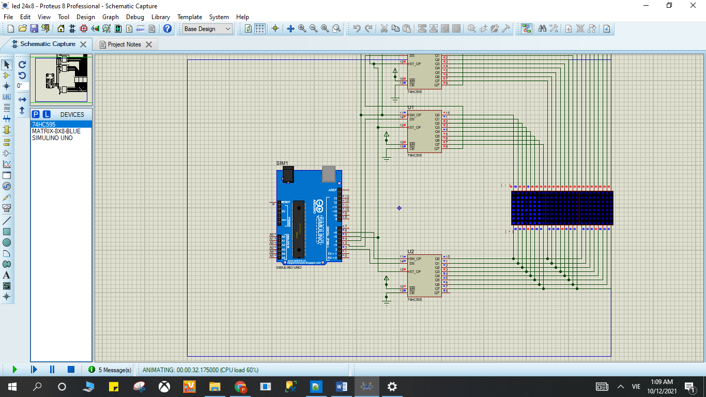

LED 24x8 KQ test 1

* Kết quả file Test 2

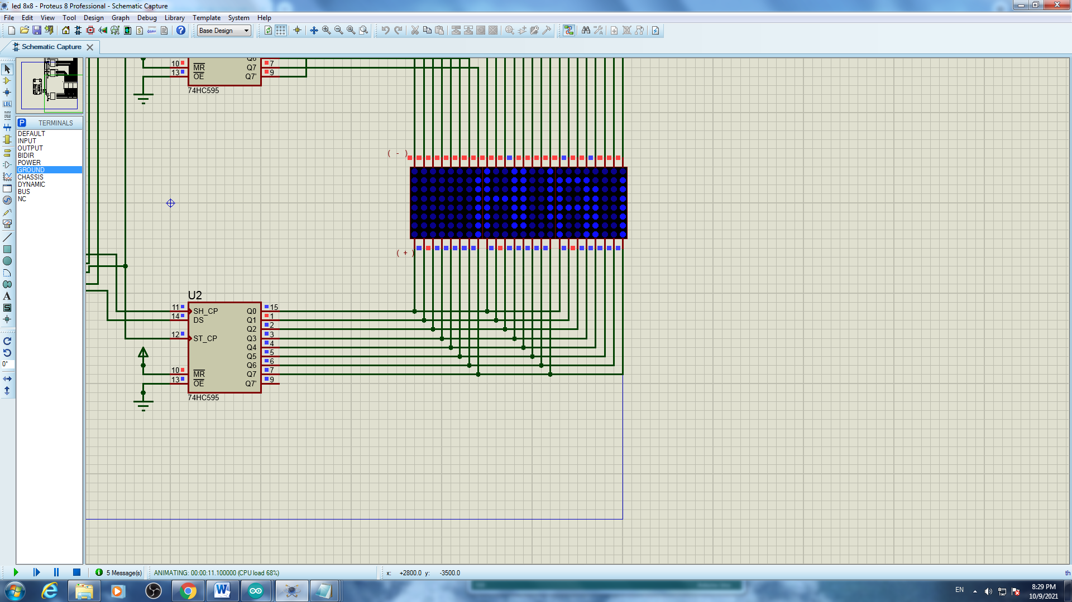

LED 24x8 KQ test 2

* Kết quả file Test 3

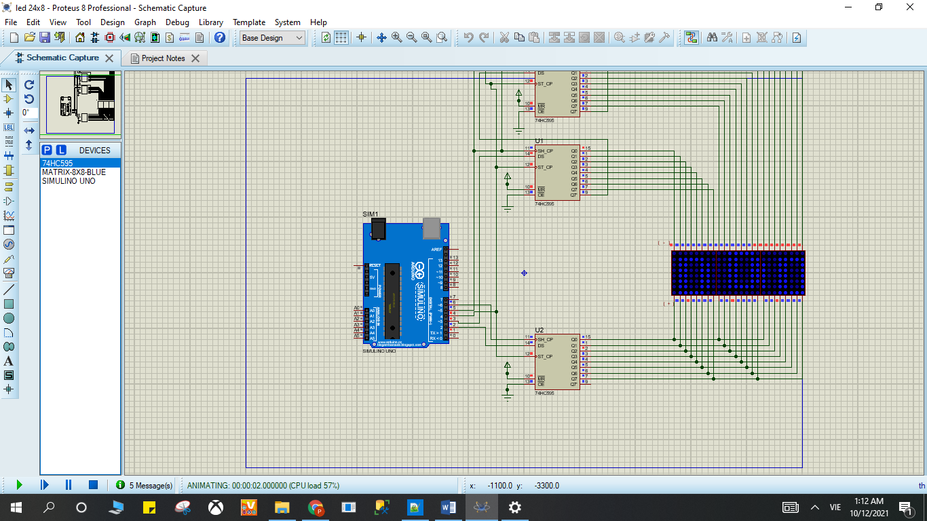

LED 24x8 KQ test 3

* Kết quả file Test 4

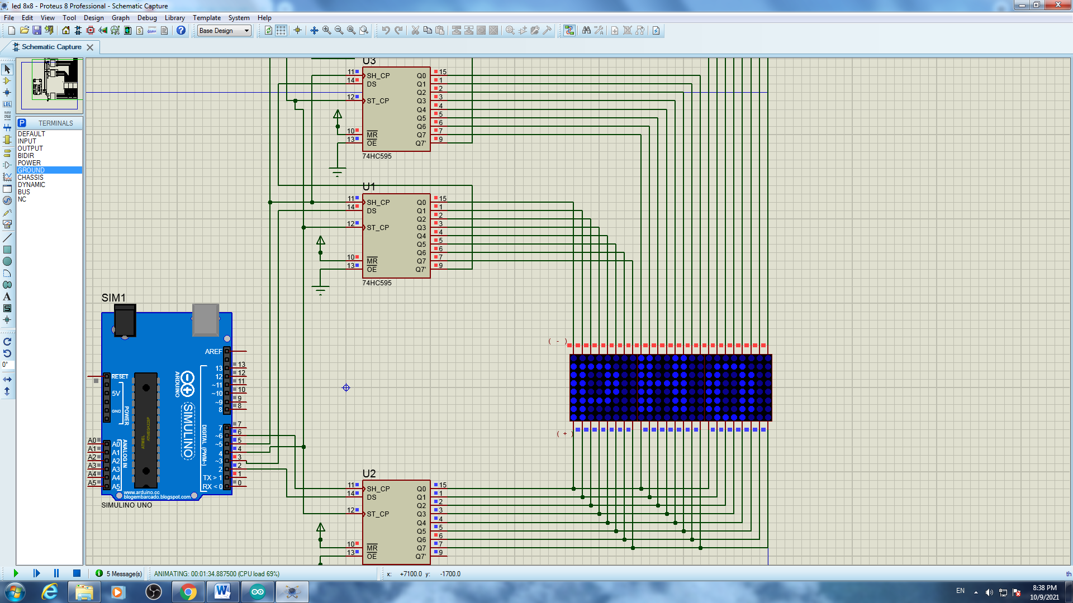

LED 24x8 KQ test 4

# Các bài làm thêm

Bài 1T. Bật tắt đèn LED bằng 2 button

## Mô tả

* Bài này thực hiện việc bật/tắt 1 đèn LED bằng 2 button, đèn LED được kết nối vào chân số 13 của board mạch, button thứ 1 trạng thái ON được kết nối vào chân số 3 của board mạch, button thứ trạng thái OFF được kết nối vào chân số 2 của board mạch, khi không bật button nào thì đèn tắt.

## Sơ đồ mạch và kết quả chạy chương trình

## 

## Linh kiện

#### 1 mạch Arduino Uno

#### 1 đèn LED-RED

#### 1 điện trở 220V

#### 2 Button

## Code chương trình

|  |
| --- |
| #define ON 3  #define OFF 2  #define led 13  // setup  void setup() {  pinMode(ON, INPUT_PULLUP);  pinMode(OFF, INPUT_PULLUP);  pinMode(led,OUTPUT);  }  void loop()  {  if(digitalRead(ON)==0){digitalWrite(led,1);}  if(digitalRead(OFF)==0){digitalWrite(led,0);}  } |

# Link liên kết các kho lưu trữ

Kho tinkercad : https://www.tinkercad.com/users/kUFa3qBF6IZ-toan-phong?category=circuits&sort=likes&view_mode=default

Kho GitHub: https://github.com/phongctt60cntt/ProjectLapTrinhNhung/tree/master

# Mục Lục

Bài 1: Blinking LED 2

❖ Mô tả 2

❖ Sơ đồ mạch 2

Figure 1.Sơ đồ kết nối của hệ thống 2

❖ Linh kiện 2

❖ Code chương trình 2

❖ Kết quả chạy chương trình 3

Figure 2 3

Bài 2: Turn on LED with button 3

❖ Mô tả 3

❖ Sơ đồ mạch 4

Figure 3 Sơ đồ kết nối của hệ thống 4

❖ Linh kiện 4

❖ Code chương trình 4

❖ Kết quả chạy chương trình 5

Figure 4 5

Bài 3. LED RGB 5

❖ Mô tả 5

❖ Sơ đồ mạch 5

Figure 5 : Sơ đồ kết nối của hệ thống 6

❖ Linh kiện 6

❖ Code chương trình 6

❖ Kết quả chạy chương trình 7

Figure 6 7

Bài 4. LED 7-Segment 7

❖ Mô tả 7

❖ Sơ đồ mạch và kết quả chạy chương trình 7

Figure 7 8

❖ Linh kiện 8

❖ Code chương trình 8

Bài 8. LED MATRIX 8x8 11

❖ Mô tả 11

❖ Sơ đồ mạch 11

❖ Linh kiện 12

❖ Code chương trình 12

❖ Kết quả chạy chương trình 21

Bài 9 : LED MATRIX 24x8 25

❖ Mô tả 25

❖ Linh kiện 26

❖ Code chương trình 26

❖ Kết quả chạy chương trình 74

Các bài làm thêm 76

Bài 1T. Bật tắt đèn LED bằng 2 button 76

❖ Mô tả 76

❖ Sơ đồ mạch và kết quả chạy chương trình 76

77

❖ Linh kiện 77

❖ Code chương trình 77

Link liên kết các kho lưu trữ 78

Mục Lục 78